
Minutes of the Meeting of Beith and District Community Council
Held in Beith Community Centre on Tuesday 12th November 2024 at 7:00pm
In Attendance:
Helen McNaughton HM Chair, Beith & District Community Council
James Waite JW Vice Chair, Beith & District Community Council
Cree Hylands CH Beith & District Community Council
Cllr John Bell Cllr JB Councillor
Cllr Donald Reid Cllr DR Councillor
Cllr Ronald Stalker Cllr RS Councillor
Christina Pieraccini CP Locality Officer
Public numbers: 5

 | AGM Meeting | Actions
1. | The chair welcomed all those in attendance.  Special thanks was given to Janet Barr who has resigned as at 12/11/2024.  Apologies: Cllr Margaret Johnson, Cllr Anthea Dickson, Robert Winning.  Note no police officer in attendance.
2. | Previous minutes from 2023 AGM 21/11/2023:  JW chaired this meeting and HM was unable to attend. We are therefore unable to propose and second.
3. | Matters arising:  N/A.
4. | Chairpersons Annual Report:  Please refer to Appendix 1. This report was handed our during the meeting to all attendees.
5. | Treasurers Annual Report:  A full accounts overview has been prepared and auditing complete for the 2023/2024 tax year.  Please refer to Appendix 2 for an overview.
6. | Secretary’s Annual Report:  As no secretary in post, no report available.
7. | Vacancies:  HM and JW noted that the council must maintain 5 members to continue and that the council are in need of volunteers.  CP agreed to obtain guidance on next steps for council to avoid the dissolution of the council. | CP
 | The next AGM meeting of Beith and District Community Council will take place in November the 11th 2025 at Beith Community Centre at 7pm.

Appendix 1

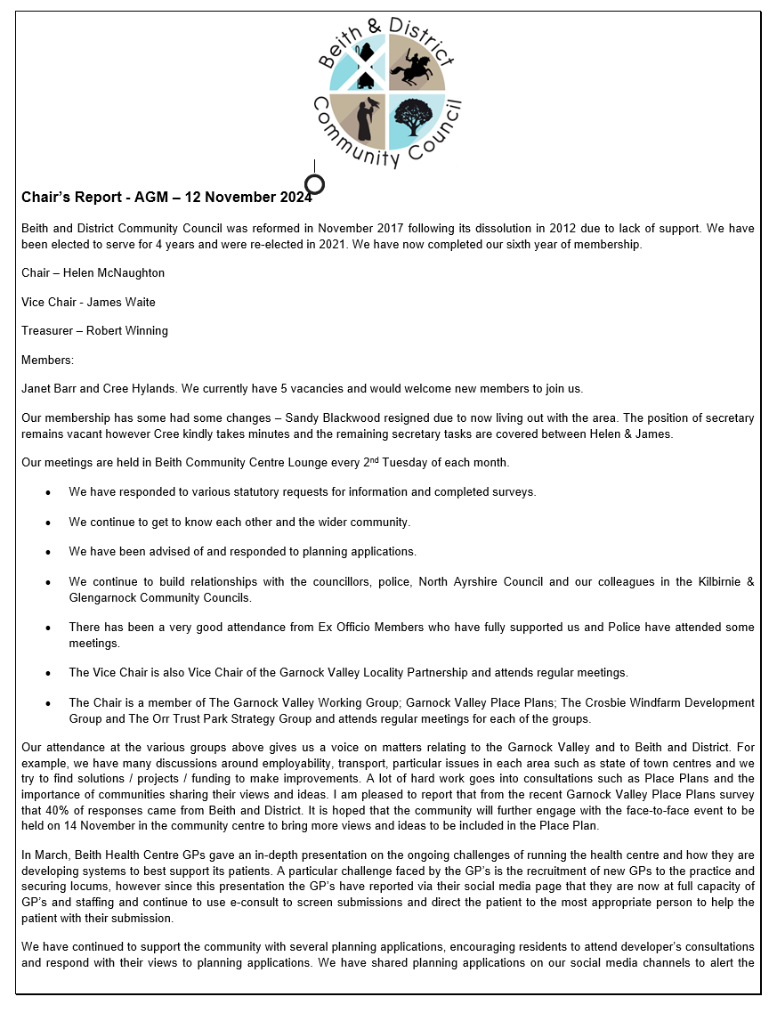

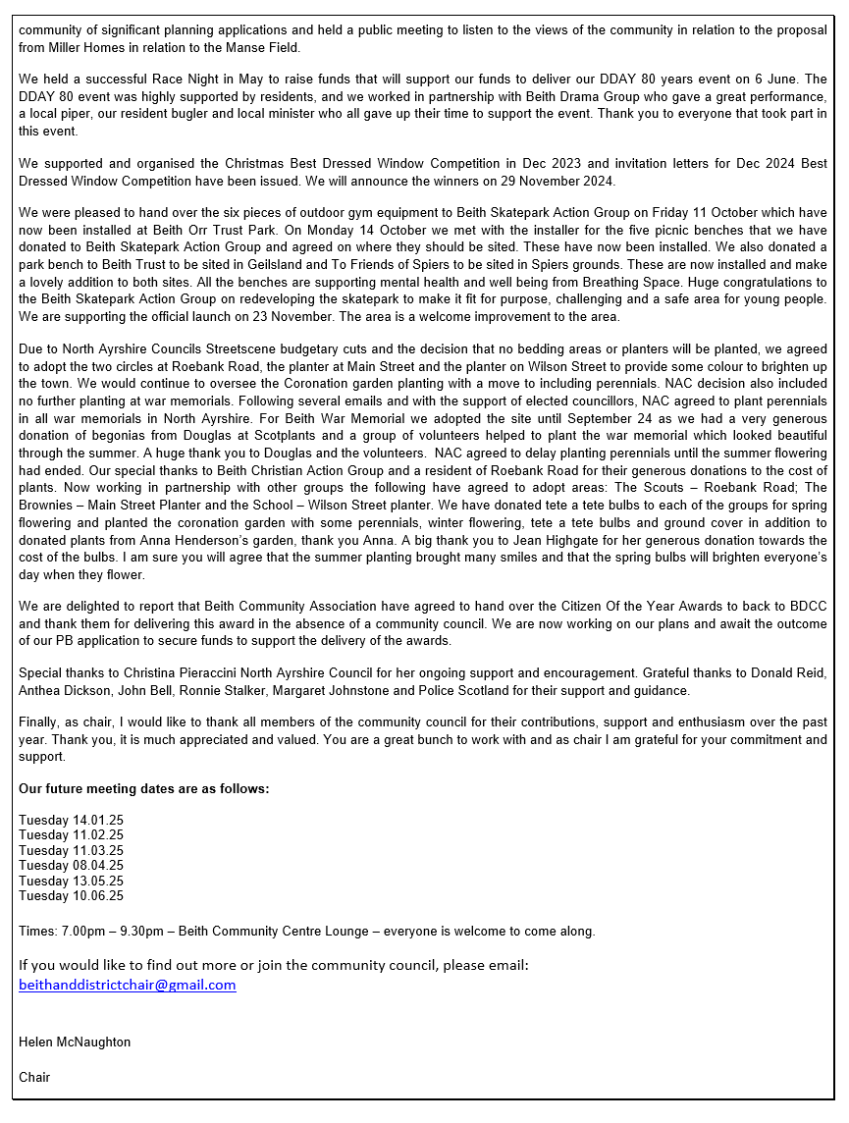

Appendix 2

