Needs Assessment
North Ayrshire HSCP
January 2022

Table of Contents
Summary Table 7
Notes for this profile: 10
Demographics 11
Summary: 11
Population 11
Figure 1: Population breakdown in North Ayrshire HSCP. 11
Figure 2: Population time trend and projection. 12
Figure 3: Change in population structure over the last five years. 13
Figure 4: Projected future change in population structure. 13
Dependency Ratio 14
Figure 5: Dependency ratio by geographical area, 2020 14
Figure 6: Projected dependency ratio 14
Deprivation 15
Table 1: Percentage population living in the 2016 and 2020 SIMD Datazone Quintiles 15
Figure 7: Map of Data Zones within North Ayrshire coloured by SIMD quintiles. 15
Figure 8: Proportion of the population that reside in each 2020 SIMD quintile by domain. 16
Figure 9: Percentage population living in the 2016 and the 2020 SIMD and Domain Quintiles 17
Households 18
Summary: 18
Figure 10: Number of dwellings time trend. 18
Table 2: Breakdown of dwelling types by year for North Ayrshire HSCP. 19
Figure 11. Household time trend and projection. 19
Figure 12: Breakdown of households by council tax band for North Ayrshire HSCP in 2020. 20
Table 3: Percentage of households by council tax band for North Ayrshire in 2020. 20
Services 21
Figure 13: Map of GP practices by locality in North Ayrshire HSCP². 21
Table 4: Number of each type of service in North Ayrshire HSCP². 21
General Health 22
Summary: 22
Life Expectancy 22
Figure 14: Average life expectancy in men and women over time. 22
Table 5: Average life expectancy in years for the latest time periods (2018-2020 aggregated years for all areas). 23
Figure 15: Average Healthy Life Expectancy at birth 24
Figure 16: Average Healthy Life expectancy in men and women over time 25
Deaths, aged 15-44 26
Figure 17: Deaths aged 15-44 years by geographical area and over time. 26
Figure 18: Deaths at ages 15-44 in all geographical areas. 26
Long-Term Physical Health Conditions and Multimorbidity 27
Figure 19: Multimorbidity of physical long-term conditions by age group in 2019/20. 28
Figure 20: Percentage people with each physical LTC, split by age group. 29
Figure 21: Projection of percentage people with each physical LTC, split by age group. 30
Table 6: Prevalence of the five most common physical LTCs as a percentage of the population across geographical areas (where 1 = most prevalent). 30
Cancer Registrations 31
Figure 22: Cancer registration rate over time and by geographical area. 31
Figure 23: Cancer registration rates by geographical area 31
Anxiety, Depression, and Psychosis Prescriptions 32
Figure 24: Percentage population prescribed ADP medication by geography. 32
Figure 25: ADP prescriptions over time and by geographical area. 32
Lifestyle and Risk Factors 33
Summary: 33
Drug-related Hospital Admissions 33
Figure 26: Trend of Drug-related Hospital Admission Rates by geographical area. 34
Figure 27: Comparison of Drug-related Hospital Admission Rates for the period 2015/16 - 2017/18. 34
Drug-Related Deaths 35
Figure 28: Trend of Drug-related Death Rates by geographical area. 35
Figure 29: Comparison of Drug-related Death Rates for the period 2020 35
Alcohol-related Hospital Admissions 36
Figure 30: Trend of Alcohol-related Hospital Admission Rates by geographical area. 36
Figure 31: Comparison of Alcohol-related Hospital Admission Rates for 2019/10. 36
Alcohol-Specific Deaths 37
Figure 32: Trend of Alcohol-Specific Death Rates by geographical area. 37
Figure 33: Comparison of Alcohol-related Death Rates for the period 2015 - 2019 (5 year aggregate). 37
Bowel Screening Uptake 38
Figure 34: Trend of Bowel Screening Uptake for eligible men and women, by geographical area. 38
Figure 35: Comparison of Bowel Screening Uptake for 2017 - 2019. 39
Smoking Prevalence 39
Figure 36: Smoking Prevalence by geographical area, 2017. 39
Unscheduled Care 40
Emergency Admissions 41
Figure 37: Emergency admissions by age group 41
Figure 38: Emergency admissions by geographical area 41
Figure 39: Projections of emergency admission for next 5 years 42
Unscheduled Bed Days 42
Figure 40: Unscheduled bed days by age group 42
Figure 41: Unscheduled bed days by geographical area 43
Figure 42: Projections of unscheduled bed days for next 5 years 43
A&E Attendances 44
Figure 43: A&E attendances by age group 44
Figure 44: A&E attendances by geographical area 44
Figure 45: Projections of A&E attendances for next 5 years 45
Delayed Discharges 45
Figure 46: Delayed discharges by age group 45
Figure 47: Delayed discharges by geographical area 46
Figure 48: Projections of delayed discharges for next 5 years 46
Emergency Admissions from a Fall 47
Figure 49: Falls by age group 47
Figure 50: Falls by geographical area 47
Emergency Readmissions (28 days) 48
Figure 51: Emergency readmissions by age group 48
Figure 52: Emergency readmissions by geographical area 48
Potentially Preventable Admissions (PPAs) 49
Figure 53: PPAs by age group 49
Figure 54: PPAs by geographical area 49
% Last 6 months in a Community Setting 50
Figure 55: Last 6 months in a community setting by geographical area 50
Unscheduled Care in Mental Health (MH) Hospitals 51
Emergency Admissions (MH) 52
Figure 56: MH Emergency admissions by age group 52
Figure 57: MH Emergency admissions by geographical area 52
Unscheduled Bed Days (MH) 53
Figure 58: MH Unscheduled bed days by age group 53
Figure 59: MH Unscheduled bed days by geographical area 53
Delayed Discharges (MH) 54
Figure 60: MH Delayed discharges by geographical area 54
Figure 61: Projections of mental health emergency admissions for next 5 years 54
Figure 62: Projections of mental health unscheduled bed days for next 5 years 55
Children and Young People 56
Maternity Breastfeeding 56
Figure 63: Percentage of babies exclusively breastfed at 6-8 weeks by geographical area. 56
Figure 64: Percentage of babies exclusively breastfed at 6-8 week review by Locality (2017/18-2019/20) 57
Maternal Smoking 57
Figure 65: Percentage of women smoking during pregnancy by geographical area 58
Teenage Pregnancies 58
Figure 66: Percentage of Teenage Pregnancies by geographical area 58
6 in 1 Immunisation 59
Figure 67: Percentage uptake of 6 in 1 Immunisation by geographical area 59
24 Months MMR Immunisation 59
Figure 68: Percentage uptake of 24 months MMR Immunisation by geographical area 60
Dental Caries 60
Figure 69: Percentage of Primary 1 children with no obvious dental caries by geographical area 61
Healthy Weight 61
Figure 70: Percentage of Primary 1 children with healthy weight by geographical area 61
Child Protection Register 62
Figure 71: Children on the child protection register 62
Looked after by Local Authority 62
Figure 72: Children looked after by Local Authority 63
Crime and Fires 63
Figure 73: Crime Rate per 1,000 population (excludes miscellaneous offences and motor vehicle offences), 2020/21 63
Figure 74: Non-accidental fires per 100,000 population, 2020/21 64
Environment 65
Figure 75: Total CO2 Emissions by HSCP 65
Figure 76: Total CO2 Emissions by Source 66
Economic 67
Economic Activity 67
Figure 77: Percentage of Economic Activity for Over 16’s 67
Employment 68
Figure 78: Percentage of 16 years and Over in Employment 68
Benefits 69
Figure 79: Percentage of Attendance Allowance Entitlement Cases – As at May 21 69
Figure 80: Percentage of Carers Allowance Entitlement Cases - As at May 21 70
Figure 81: Percentage of Pension Credit Caseloads - As at May 21 70
Figure 82: Percentage of Personal Independence Payment - As at May 21 71
Footnotes 72
Appendices 74
Appendix 1: Indicator Definitions 74
Appendix 2: Conditions included as Potentially Preventable Admissions (PPAs) 78

Summary Table
Indicators | Data Type | Time Period | North Ayrshire | East Ayrshire | South Ayrshire | NHS Ayrshire & Arran | Scotland
Demographics
Total Populations | count | 2020 | 134,250 | 121,600 | 112,140 | 367,990 | 5,466,000
Gender ratio male to female | ratio | 2020 | 1:1.1 | 1:1.06 | 1:1.09 | 1:1.09 | 1:1.05
Population over 65 | % | 2020 | 23 | 21 | 26 | 23 | 19
Dependency Ratio | % | 2020 | 65 | 61 | 71 | 65 | 56
Population in least deprived SIMD quintile | % | 2020 | 10 | 11 | 20 | 30 | 20
Population in most deprived SIMD quintile | % | 2020 | 42 | 31 | 17 | 13 | 20
Housing
Total number of households | count | 2020 | 68,826 | 58,814 | 55,790 | 183,430 | 2,653,521
Households with a single occupant tax discount | % | 2020 | 40 | 39 | 36 | 38 | 38
Households in council tax A-C | % | 2020 | 70 | 69 | 52 | 64 | 59
Households in council tax F-H | % | 2020 | 7.8 | 7.8 | 16 | 10.2 | 13
General Health
Male average life expectancy in years | mean | 2018-2020* | 75.3 | 75.2 | 76.7 | 80.3 | 76.8
Female average life expectancy in years | mean | 2018-2020* | 80.1 | 79.8 | 81.1 | 75.7 | 81
Average Healthy life expectancy at birth - males | mean | 2017-2019 | 58.5 | 59.3 | 60 | 59.4 | 61.6
Average Healthy life expectancy at birth - females | mean | 2017-2019 | 56.3 | 58.2 | 63.3 | 59.1 | 61.9
Early mortality rate per 100,000 | rate | 2018-2020 | 164 | 159 | 149 | 157 | 116
Population with long term condition | % | 2019/20 | 27 | 26 | 27 |  | 19
Cancer registrations per 100,000 | rate | 2017-2019 | 654 | 608 | 607 | 624 | 644
Anxiety, depression & psychosis prescriptions per 100,000 | % | 2019/20 | 22 | 21 | 22 | 22 | 20

Indicators | Data Type | Time Period | North Ayrshire | East Ayrshire | South Ayrshire | NHS Ayrshire & Arran | Scotland
Lifestyle & Risk Factors
Drug-related hospital admissions per 100,000 | rate | 2017/18-2019/20 | 424 | 374 | 335 | 380 | 221
Drug-related deaths per 100,000 | Rate | 2020 | 35 | 32 | 32 | 33 | 25
Alcohol-related hospital admissions per 100,000 | rate | 2020/21 | 631 | 561 | 718 | 633 | 621
Alcohol specific mortality per 100,000 | rate | 2015-2019 | 25 | 18 | 15 | 20 | 20
Bowel Screening Uptake | % | 2017-2019 | 59 | 60 | 64 | 61 | 61
Hospital and Community Care
Emergency admissions per 100,000 | rate | 2020/21 | 12,012 | 11,808 | 12,833 | 12,195 | 9,368
Unscheduled acute bed days per 100,000 | rate | 2020/21 | 84, 702 | 73,683 | 92,950 | 83,574 | 61,622
A&E attendances per 100,000 | rate | 2020/21 | 22,104 | 22,988 | 21.612 | 22,246 | 20,422
Delayed discharge bed days per 100,000 | rate | 2020/21 | 7,696 | 3,897 | 17,797 | 9,568 | 8,080
Falls emergency admissions per 100,000 | rate | 2020/21 | 691 | 655 | 801 | 713 | 658
Emergency readmissions per 1,000 | rate | 2020/21 | 117 | 126 | 123 | 122 | 115
Last 6 months of life spent in community setting | % | 2020/21 | 89 | 91 | 89 | 90 | 90
Potentially Preventable Admissions per 100,000 | rate | 2020/21 | 1,577 | 1,616 | 1,788 | 1,654 | 1,181
Hospital Care
(Mental Health Specialty)
Emergency Admissions per 100,000 | rate | 2020/21 | 182 | 173 | 188 | 181 | 254
Unscheduled bed days per 100,000 | rate | 2020/21 | 22,736 | 15,518 | 14,930 | 17,972 | 18,507
Delayed Discharges per 100,000 | rate | 2019/20 | 2,349 | 733 | 4,069 | 2,349 | 1,910

Indicators | Data Type | Time Period | North Ayrshire | East Ayrshire | South Ayrshire | NHS Ayrshire & Arran | Scotland
Children and Young People
Babies exclusively breastfed at 6-8 week review | % | 2017/18-2019/20 | 18 | 18 | 22 | 19 | 31
Mothers smoking during pregnancy | % | 2017/18-2019/20 | 21 | 18 | 17 | 19 | 15
Teenage Pregnancies | % | 2017-2019 | 36 | 34 | 28 | 33 | 29
6 in 1 Immunisation Uptake | % | 2018-2020 | 97 | 98 | 98 | 98 | 97
24 Months MMR Immunisation Uptake | % | 2018-2020 | 94 | 96 | 96 | 95 | 94
Primary 1 Children with no obvious Dental caries | % | 2019/20 | 72 | 60 | 78 | 70 | 72
Primary 1 Children with Healthy Weight | % | 2019/20 | 73 | 73 | 81 | 77 | 76
Children on the protection register per 1,000 | rate | 2020 | 6.1 | 3.7 | 1.7 | - | -
Children looked after by local authority per 1000 | Rate | 2020 | 23 | 16 | 15 | - | -
Crime and Fires
Crime rate per 1,000 | rate | 2020/21 | 49.7 | 45 | 41 | - | 45
Non-accidental fires per 100,0000 | rate | 2020/21 | 359 | 487 | 240 | 365 | 265

Page break

Notes for this profile:

- All years shown are calendar years unless otherwise specified.
- Upper and lower confidence intervals are shown throughout this document where available. In charts, these are displayed as shaded areas either side of trend lines, or as black error bars in bar charts. Confidence intervals show the range of possible values and a certainty that the true value falls within them.
- Definitions for the indicators shown are available in Appendix 1.

Page break

Demographics

Summary:
For the most recent time periods available, North Ayrshire HSCP had:
- A total population of 134,250 people (52% female, 48% male), and 23% were aged over 65.
- A dependency ratio of 65%.
- 10% of people lived in the least deprived SIMD quintile, and 42% lived in the most deprived quintile.

Population
In 2020, the total population of North Ayrshire was 134,250. The graph below shows the population distribution of the partnership.

Figure 1: Population breakdown in North Ayrshire HSCP.

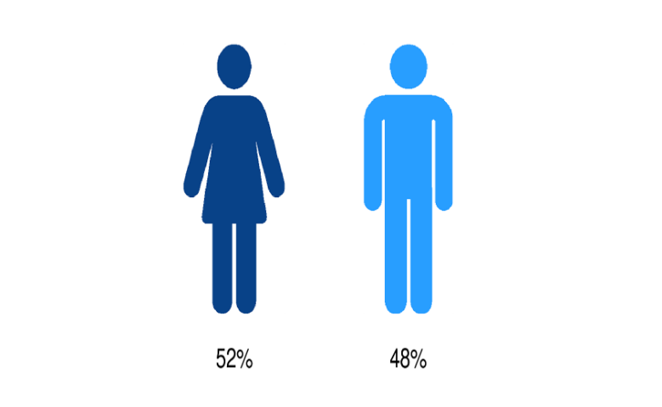
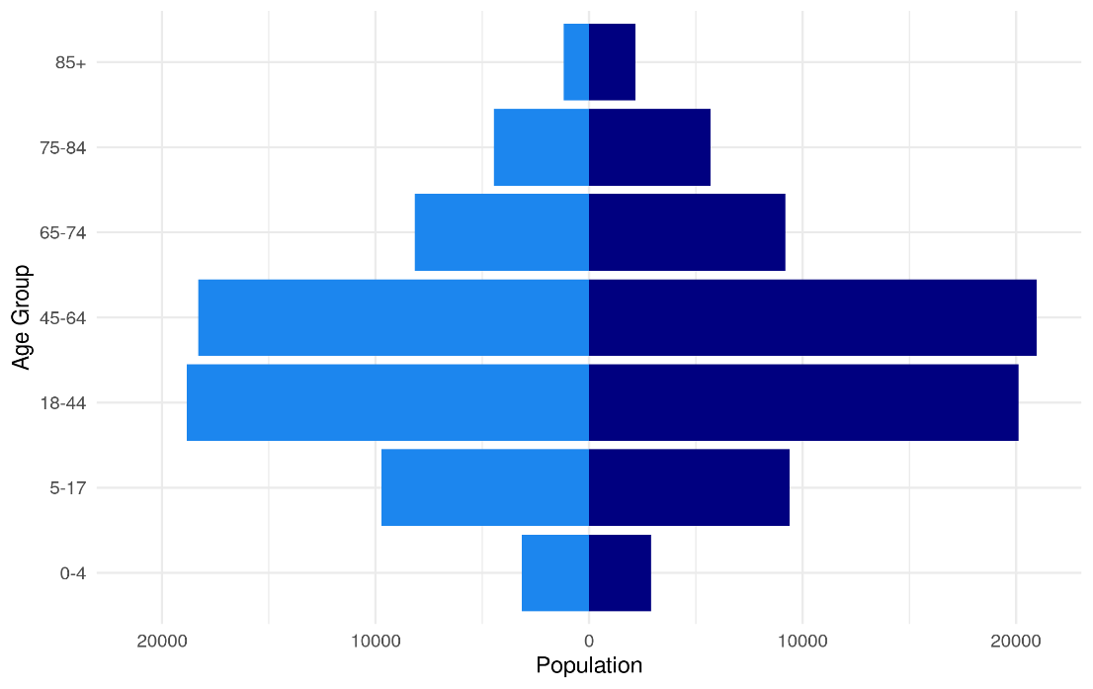
Figure 2 shows the historical population of North Ayrshire HSCP, along with the NRS population projections. The population has been falling. The population in North Ayrshire is estimated to decrease by 1.6% from 2020 to 2025. Please see the footnotes for more information on how the population projections were calculated¹.

Figure 2: Population time trend and projection.

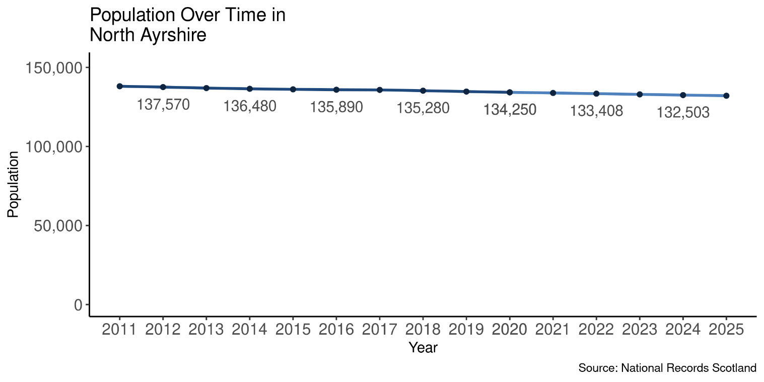

Page break
Figure 3 shows how population structure has changed between 2015 and 2020.

Figure 3: Change in population structure over the last five years.

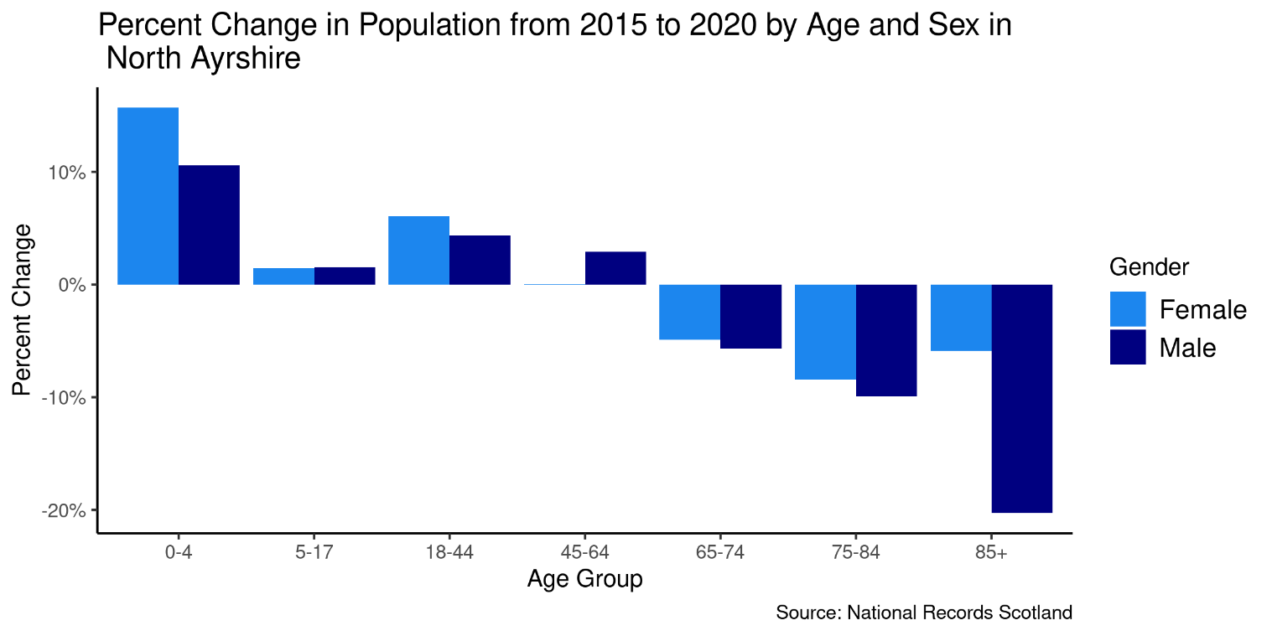

Figure 4 shows how the population structure is expected to change in the future between 2022 and 2027. This shows that although the overall population is projected to decrease (Figure 2), the older population of North Ayrshire is expected to increase, while the population aged under 65 is expected to decrease.

Figure 4: Projected future change in population structure.

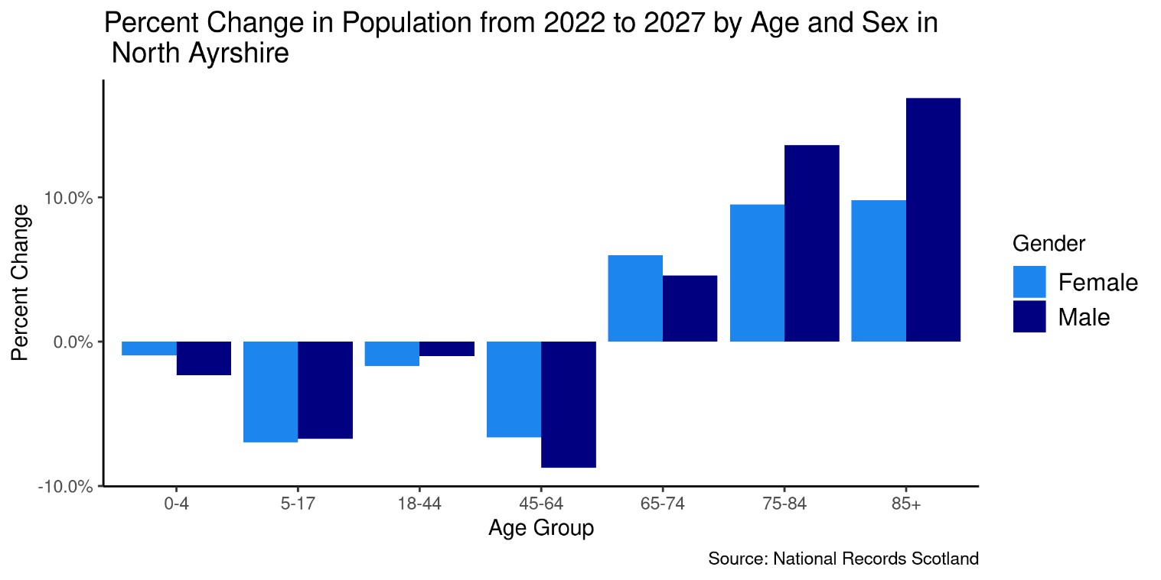

Dependency Ratio
The dependency ratio is the number of people aged number of people aged 0-15 and 65+ as a percentage of those aged 16-64. For North Ayrshire HSCP, the figure was 65% for the most recent year.

Figure 5: Dependency ratio by geographical area, 2020

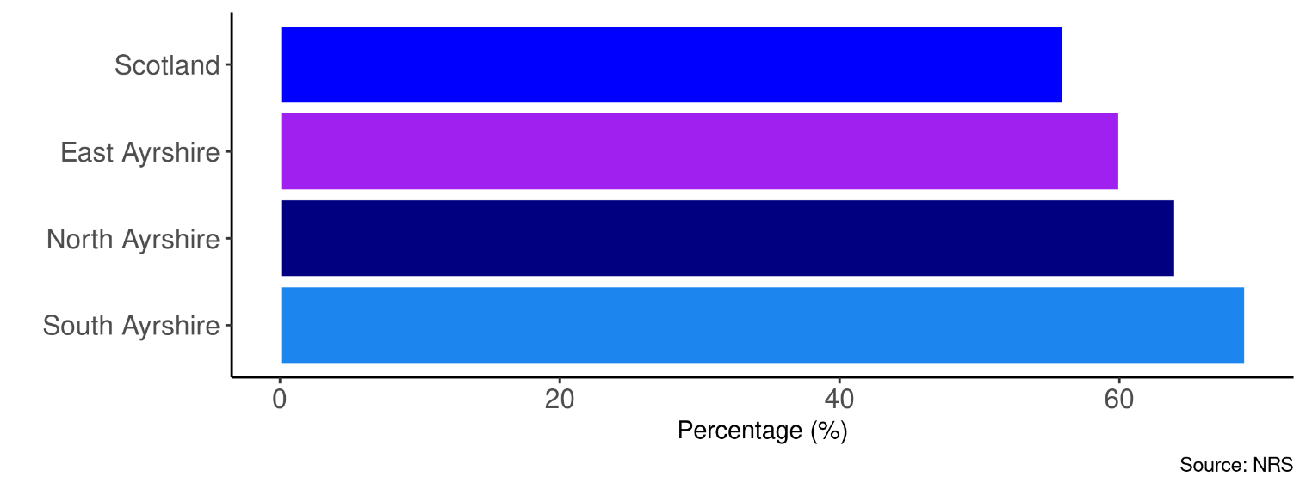
The chart below shows the projected change in the dependency ratio in the future. For North Ayrshire HSCP, the projected figure for 2031 is 77%. As shown in Figure 6, this is due to the expected increase in the older population with a decrease in the younger population.

Figure 6: Projected dependency ratio

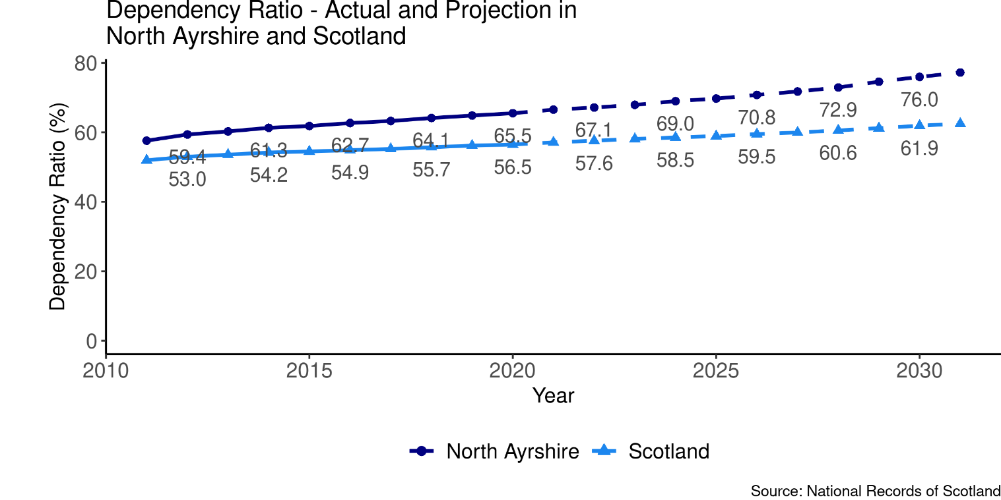

Deprivation
The following section explores the deprivation structure of North Ayrshire HSCP through the Scottish Index of Multiple Deprivation (SIMD). The SIMD ranks all datazones in Scotland by a number of factors; Access, Crime, Education, Employment, Health, Housing and Income. Based on these ranks, each datazone is then given an overall deprivation rank, which is used to split datazones into Deprivation Quintiles (Quintile 1 being the most deprived, and Quintile 5 the least). The most recent SIMD ranking was carried out in 2020. This section mainly focuses on the SIMD 2020 classifications, however the 2016 classifications are used to assess how deprivation has changed in North Ayrshire when compared to the rest of Scotland.
Of the 2018 population in North Ayrshire, 42% live in the most deprived SIMD Quintile, and 10% live in the least deprived SIMD Quintile. The following table details the percent of the population living in the 2016 SIMD Quintiles, the percent living in the 2020 SIMD Quintiles, and their difference for comparison.

Table 1: Percentage population living in the 2016 and 2020 SIMD Datazone Quintiles

Quintile | Percent of Pop (2016) | Percent of Pop (2020) | Difference
SIMD 1 | 40.9% | 41.6% | 0.7%
SIMD 2 | 20.0% | 18.6% | -1.3%
SIMD 3 | 14.1% | 15.3% | 1.2%
SIMD 4 | 15.9% | 15.0% | -0.9%
SIMD 5 | 9.2% | 9.5% | 0.3%

Figure 7: Map of Data Zones within North Ayrshire coloured by SIMD quintiles.

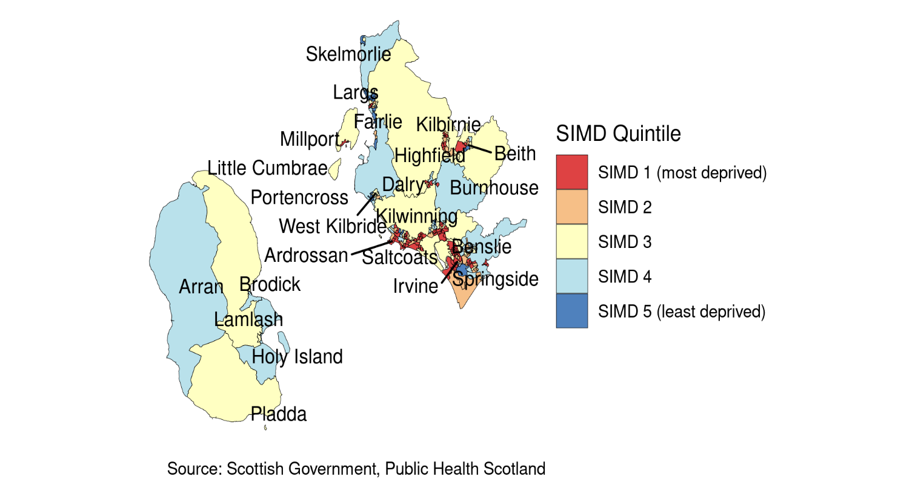

Figure 8: Proportion of the population that reside in each 2020 SIMD quintile by domain.

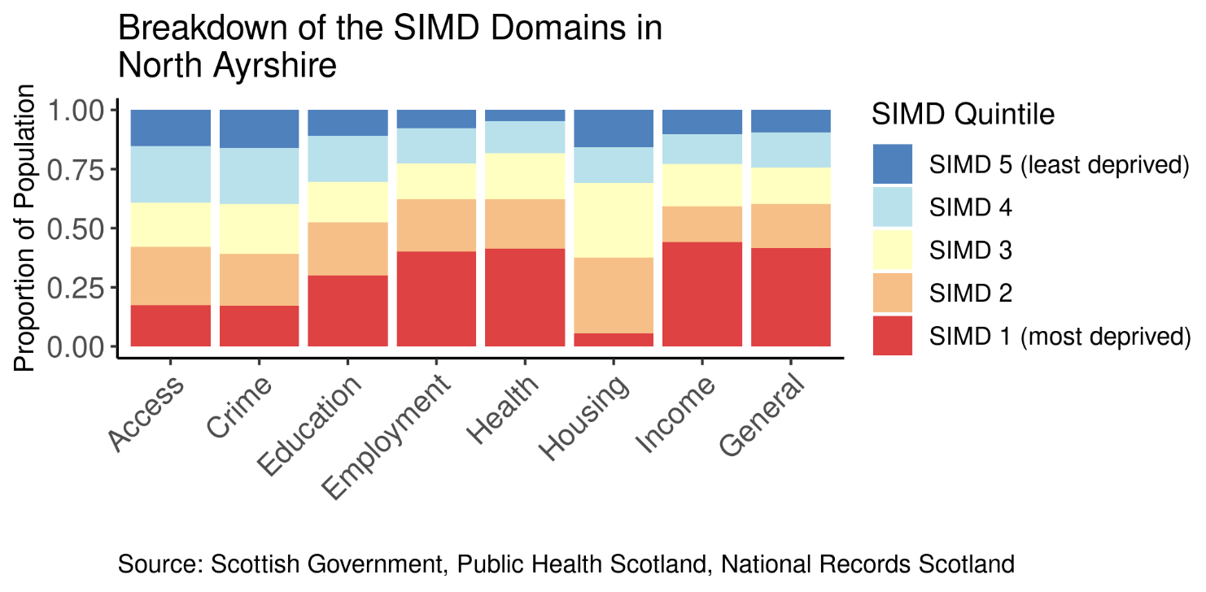

Page Break
Figure 9 presents a comparison between the 2016 Scottish Index of Multiple Deprivation figures, and the new 2020 SIMD figures. The percentages of the population living within each SIMD quintile and domain quintile were calculated first using the 2016 SIMD datazone classifications, and then the 2020 SIMD classifications. The differences in these percentages are plotted in Figure 7. Negative values on the y axis indicate a decrease in percent of the population living within a quintile, while positive values indicate an increase in percent of the population living within a quintile. Please note that quintiles have been weighted by the Scottish population so, any local changes in SIMD quintile do not necessarily indicate a difference in deprivation, but rather a difference in deprivation in comparison to the rest of Scotland.

Figure 9: Percentage population living in the 2016 and the 2020 SIMD and Domain Quintiles

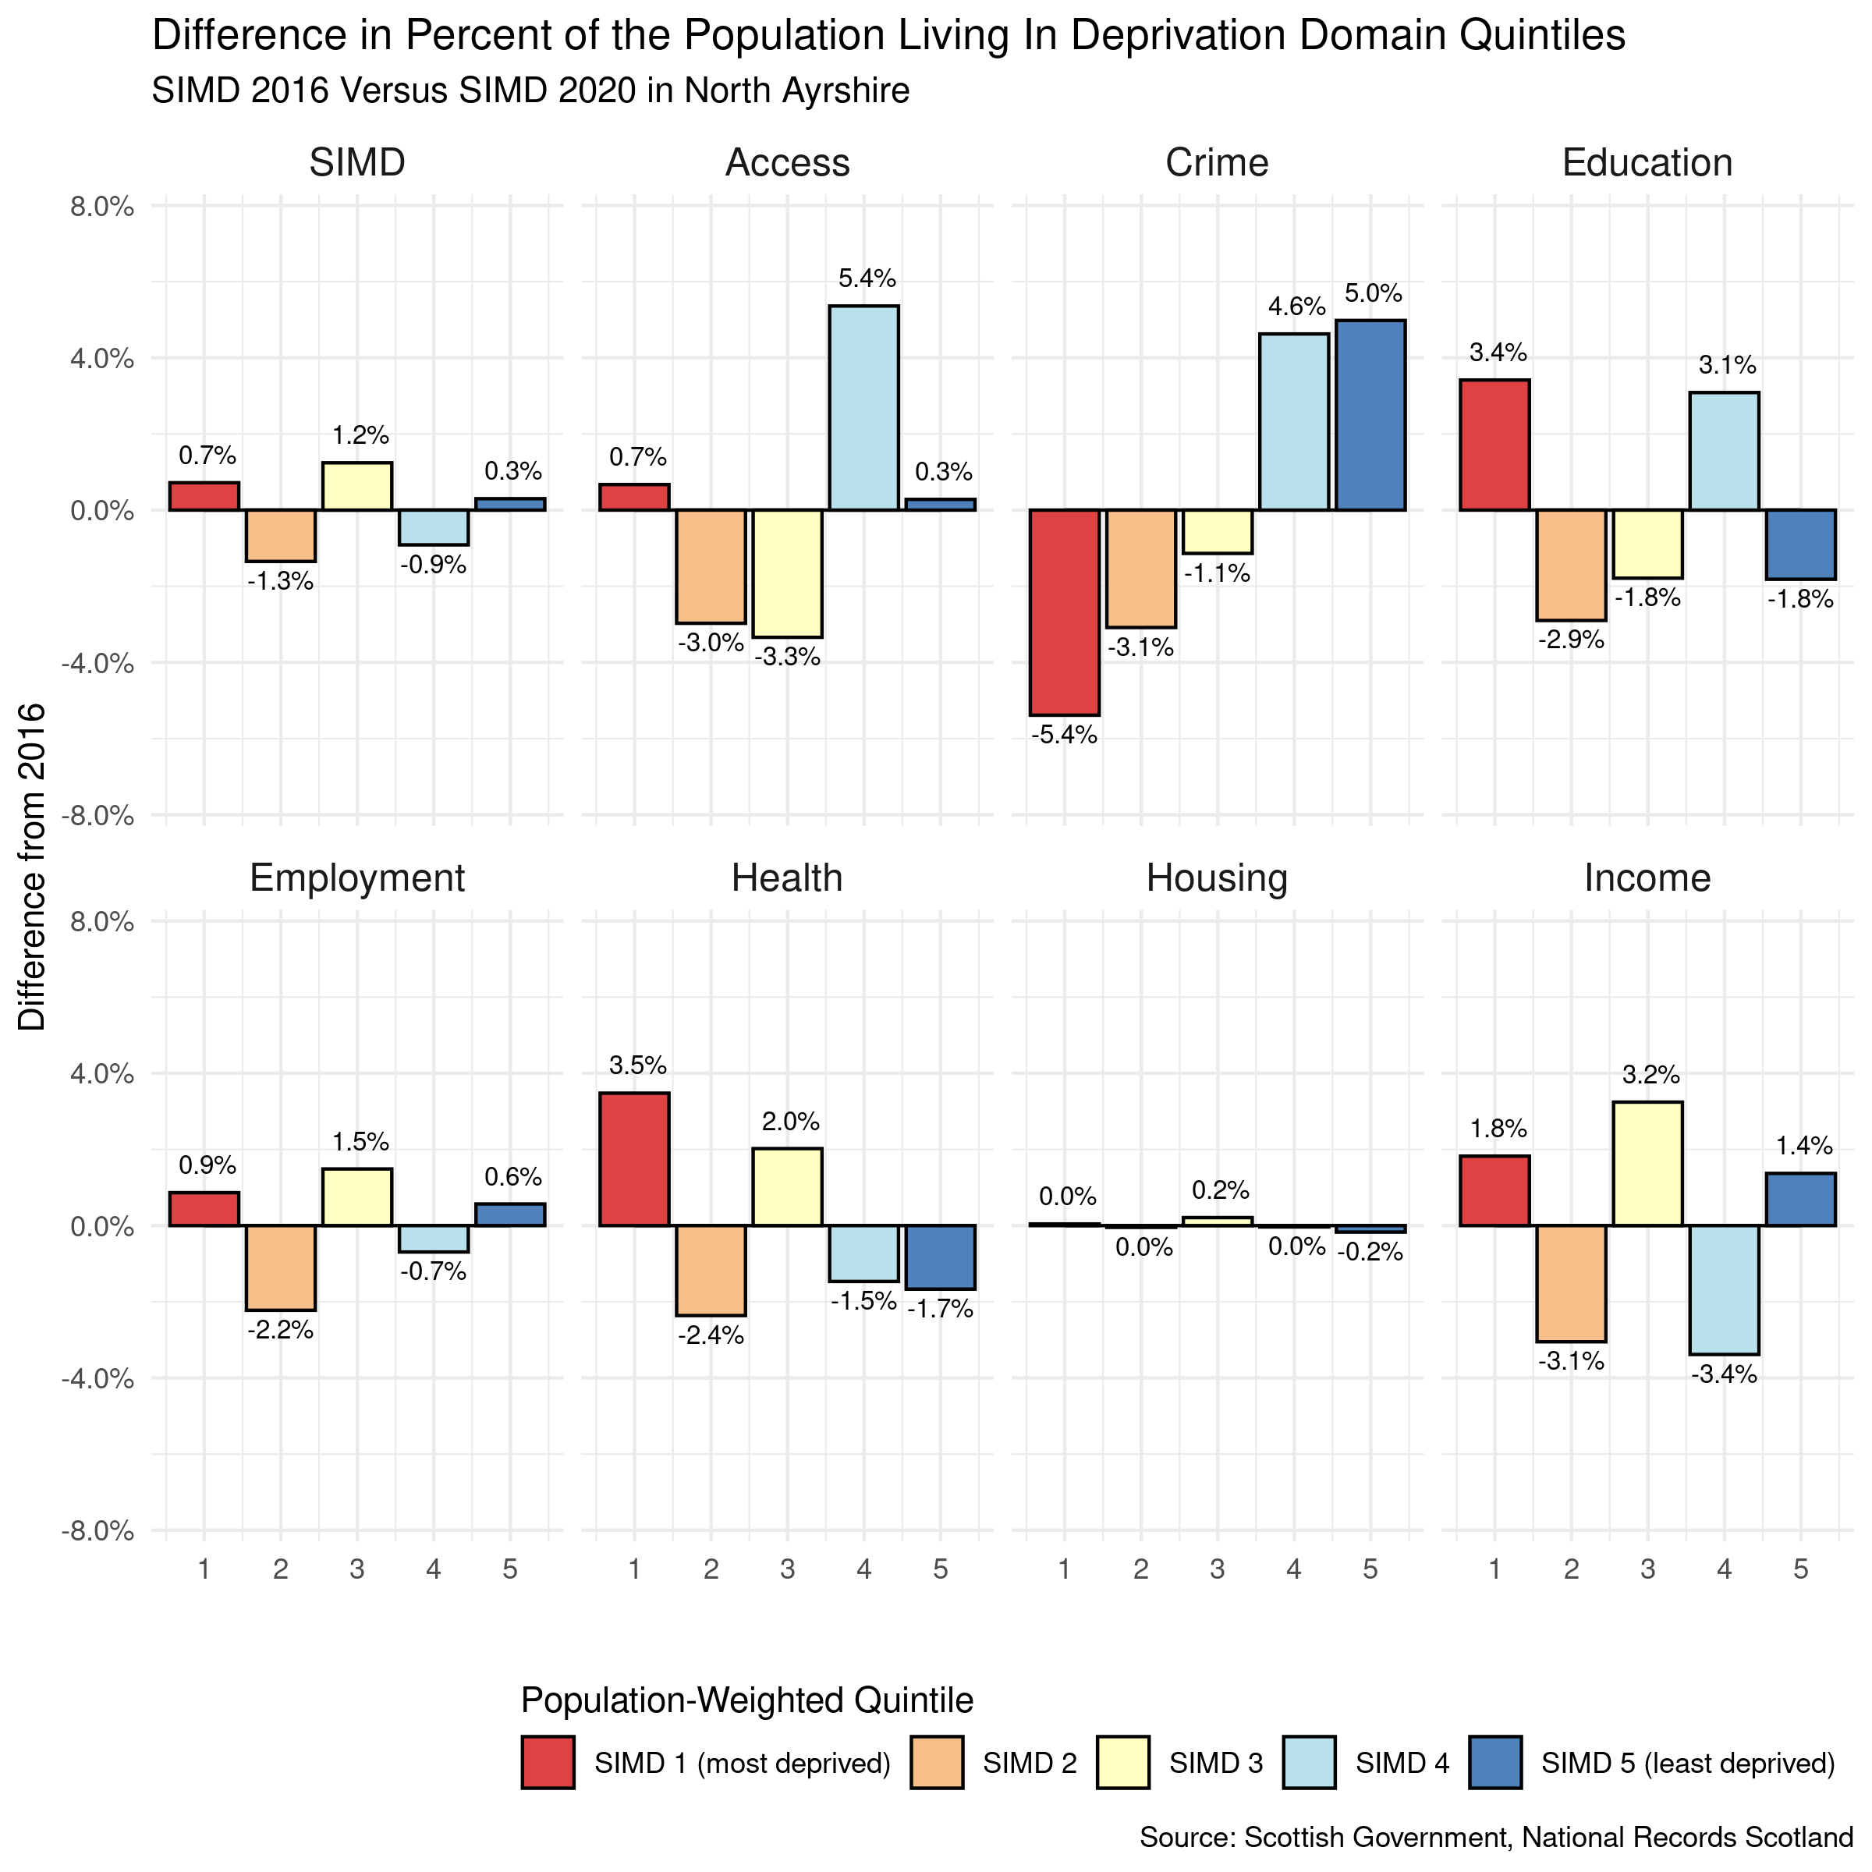

Page BreakHouseholds

Households

Summary:
For the most recent time periods available, North Ayrshire HSCP had:
- 68,826 dwellings, of which: 94% were occupied and 2.2% were second homes.
- 40% of dwellers received a single occupant council tax discount, and 1.4% were exempt from council tax entirely.
- 70% of houses were within council tax bands A to C, and 7.8% were in bands F to H.

The graph below shows the number of dwellings in North Ayrshire HSCP from 2014 to 2020.

Figure 10: Number of dwellings time trend.

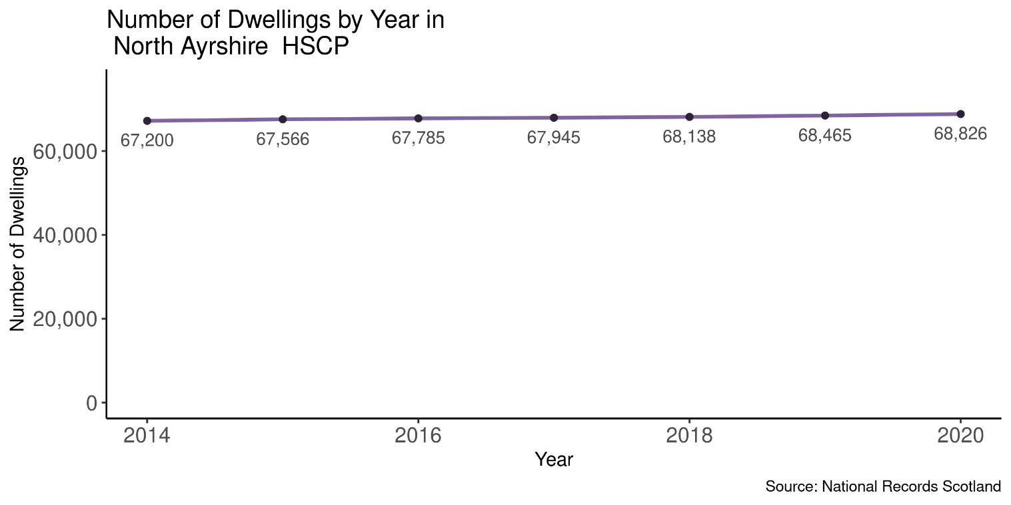

Of the total number of dwellings in 2020, 40% (27,854 households) were occupied by an individual receiving a single occupant council tax discount. Furthermore, 1.4% (951 households) were occupied and exempt from council tax.
There were 1,539 dwellings classed as a second home in 2020, these dwellings made up 2.2% of the households in North Ayrshire.

Page break

Table 2: Breakdown of dwelling types by year for North Ayrshire HSCP.

Year | Total Dwellings | Occupied Dwellings | Vacant Dwellings | Single Occupant Tax Discount | Council Tax Exempt Dwellings | Second Homes
2014 | 67,200 | 63,314 | 2,394 | 26,709 | 678 | 1,492
2015 | 67,566 | 63,732 | 2,301 | 26,931 | 706 | 1,533
2016 | 67,785 | 63,944 | 2,158 | 27,174 | 735 | 1,683
2017 | 67,945 | 64,288 | 2,047 | 27,408 | 747 | 1,610
2018 | 68,138 | 64,413 | 2,156 | 27,333 | 849 | 1,569
2019 | 68,465 | 64,663 | 2,270 | 27,576 | 909 | 1,537
2020 | 68,826 | 64,940 | 2,347 | 27,854 | 951 | 1,539

A ‘dwelling’ refers to the accommodation itself, e.g. a house or a flat. A ‘household’ refers to the people living together in a dwelling. The number of dwellings will not necessarily equal the number of households in an area, because some dwellings are vacant or second homes, and some dwellings contain more than one household.

Figure 11. Household time trend and projection.

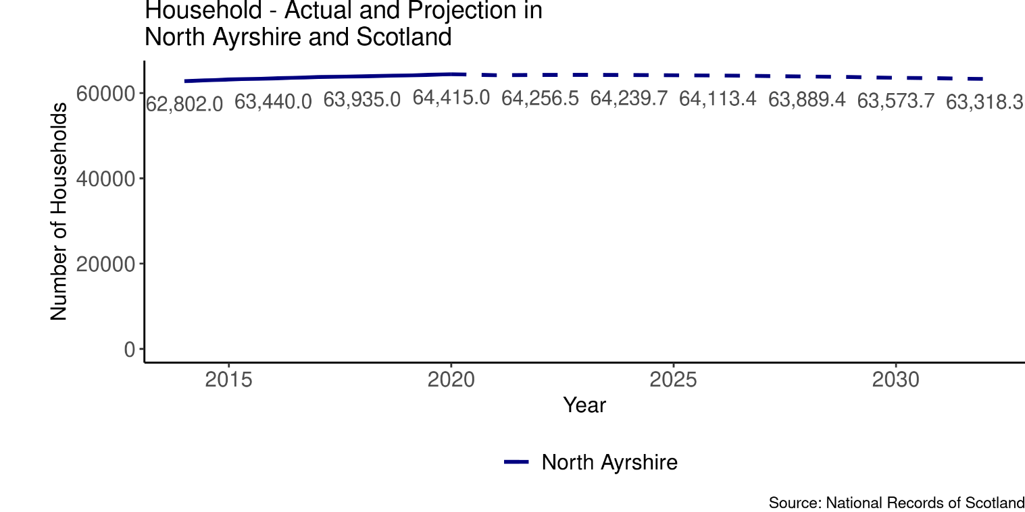
Figure 11 shows the historical number of households of North Ayrshire HSCP, along with the NRS household projections. The projected number of households in North Ayrshire is estimated to decrease by 0.96% from 2018 to 2032.

The proportion of households within each council tax band are displayed in the chart below, figures are shown in Table 3.

Figure 12: Breakdown of households by council tax band for North Ayrshire HSCP in 2020.

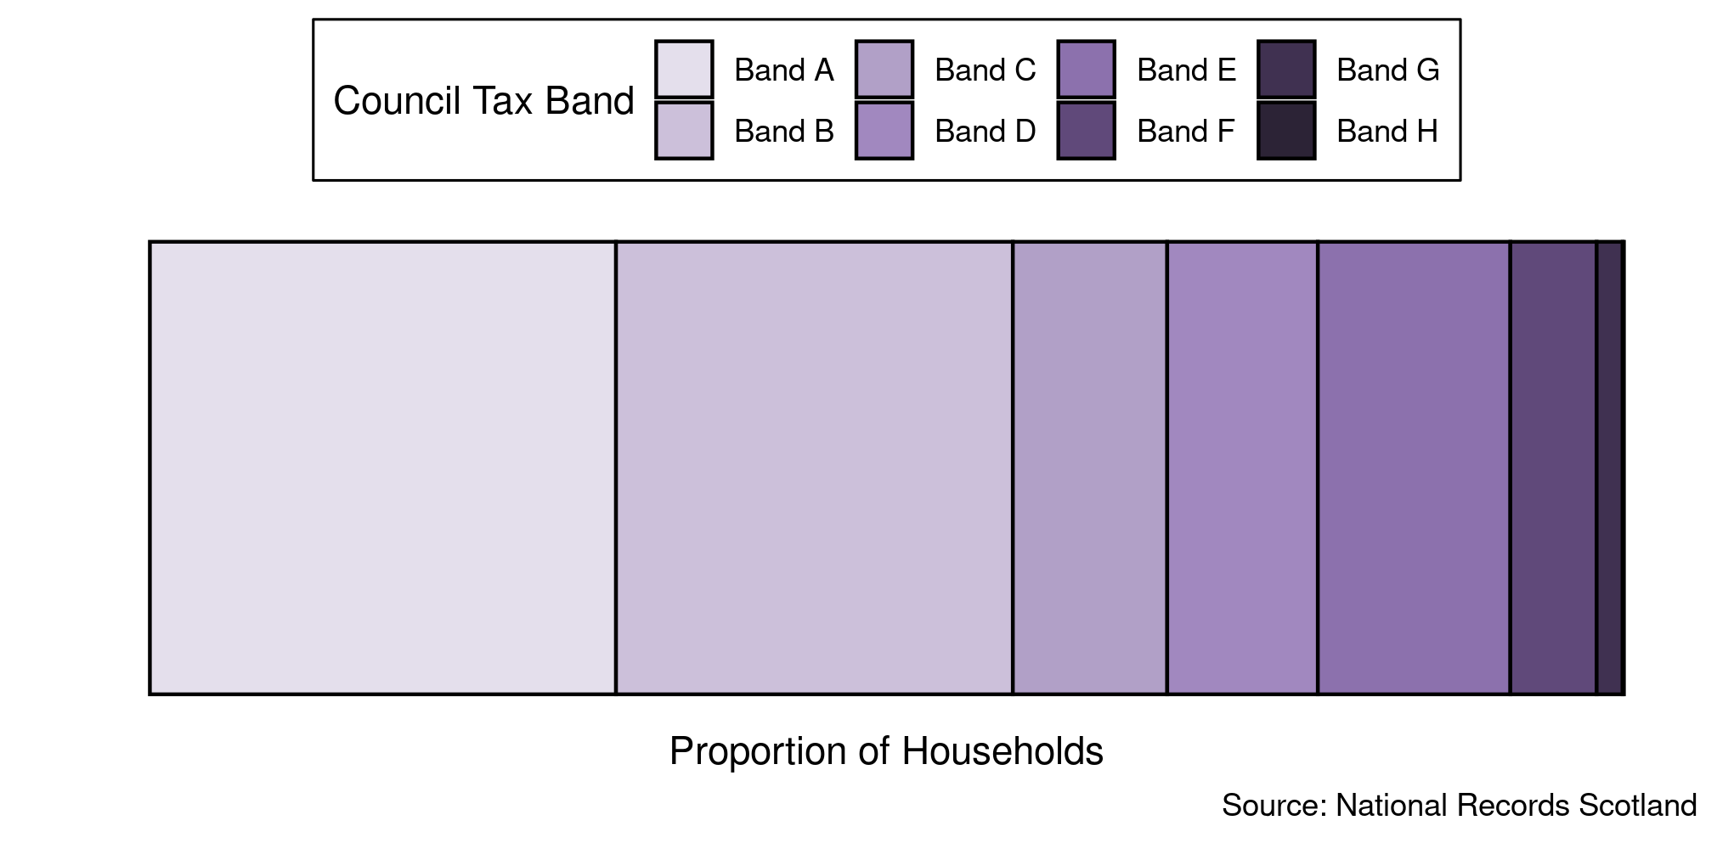

Table 3: Percentage of households by council tax band for North Ayrshire in 2020.

Tax Band | A | B | C | D | E | F | G | H
Percent of households | 32% | 27% | 11% | 10% | 13% | 5.9% | 1.8% | 0.08%

Pagebreak

Services

Figure 13: Map of GP practices by locality in North Ayrshire HSCP².

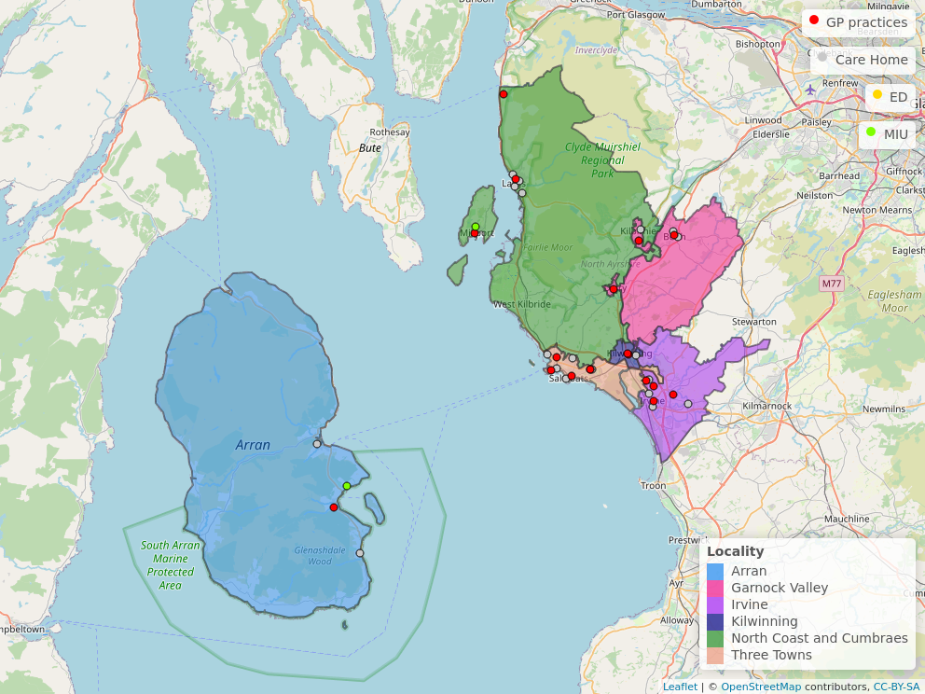

ED = Emergency Department, MIU = Minor Injuries Unit (or other)

Table 4: Number of each type of service in North Ayrshire HSCP².

Service Type | Service | Number
Primary Care | GP Practice | 18
A&E | Emergency Department | 0
 | Minor Injuries Unit | 2
Care Home | Elderly Care | 19
 | Other | 17

Pagebreak

General Health

Summary:

For the most recent time periods available³, North Ayrshire HSCP had:
- An average life expectancy of 75.3 years for males and 80.1 years for females.
- An average healthy life expectancy at birth of 58.5 years for males and 56.3 years for females.
- A death rate for ages 15 to 44 of 164 deaths per 100,000 age-sex standardised population⁴.
- 27% of the partnerships population with at least one long-term physical health condition.
- A cancer registration rate of 654 registrations per 100,000 age-sex standardised population⁴
- 22% of the population being prescribed medication for anxiety, depression, or psychosis.

Life Expectancy
In the latest time period available from 2018-2020 (3-year aggregate), the average life expectancy in North Ayrshire was 75.3 years old for men, and 80.1 years old for women. A time trend since 2009-2011 is shown below in Figure 14.

Figure 14: Average life expectancy in men and women over time.

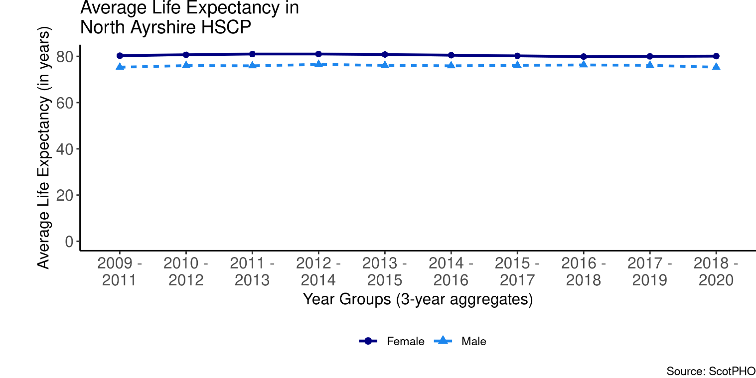

Page break
Table 5 shows the average life expectancy for men and women in different areas for the latest time period available. Please note that these are 3 year aggregates from 2018-2020 at partnership, Health Board, and Scotland level.

Table 5: Average life expectancy in years for the latest time periods (2018-2020 aggregated years for all areas).

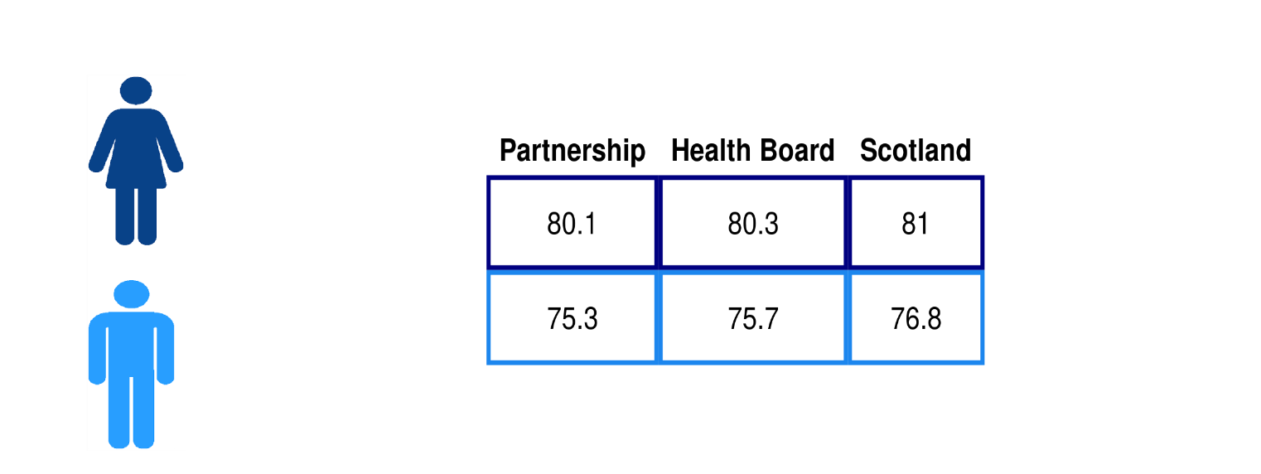

Where Partnership = North Ayrshire HSCP, Health Board = NHS Ayrshire & Arran.

Healthy Life Expectancy

In the latest time period available from 2017-2019 (3-year aggregate), the average healthy life expectancy in North Ayrshire was 58.5 years old for men, and 56.3 years old for women. Figure 15 shows the average healthy life expectancy for North Ayrshire in comparison to South Ayrshire, East Ayrshire and Scotland over a 3-year period.

Figure 15: Average Healthy Life Expectancy at birth
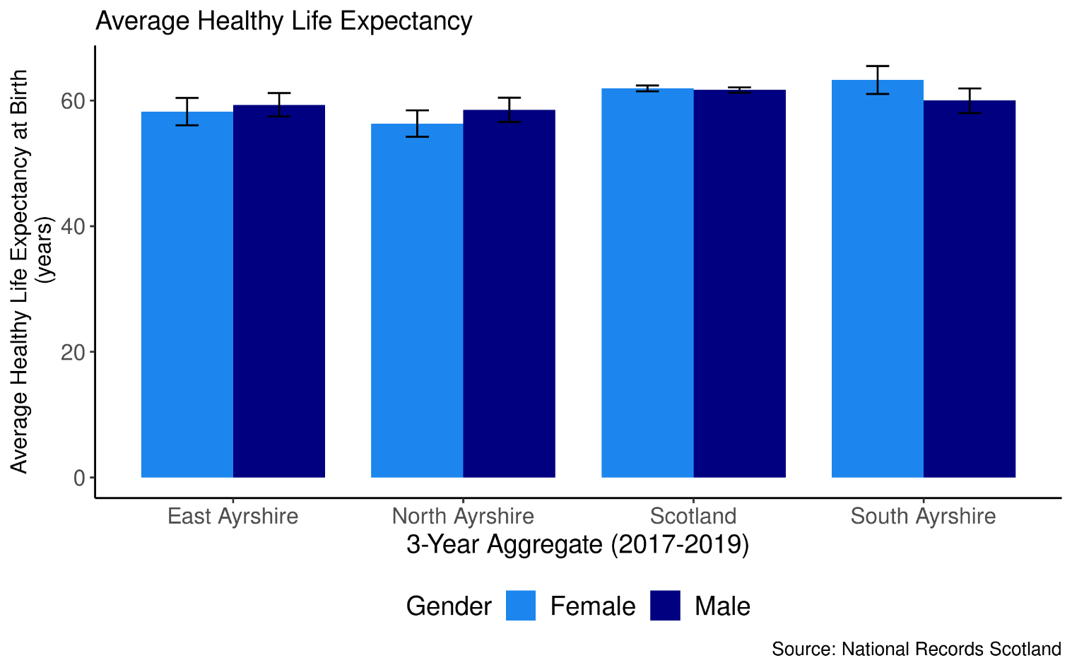

The following chart shows a trend of the average healthy life expectancy at birth for men in women in North Ayrshire from 2015-2017 to 2017- 2019 (3-year aggregate). From 2015-2017 to the latest time period available (2017-2019), the average healthy life expectancy at birth in North Ayrshire increased by 2.5 years for men, and decreased by 0.8 years for women.

Figure 16: Average Healthy Life expectancy in men and women over time

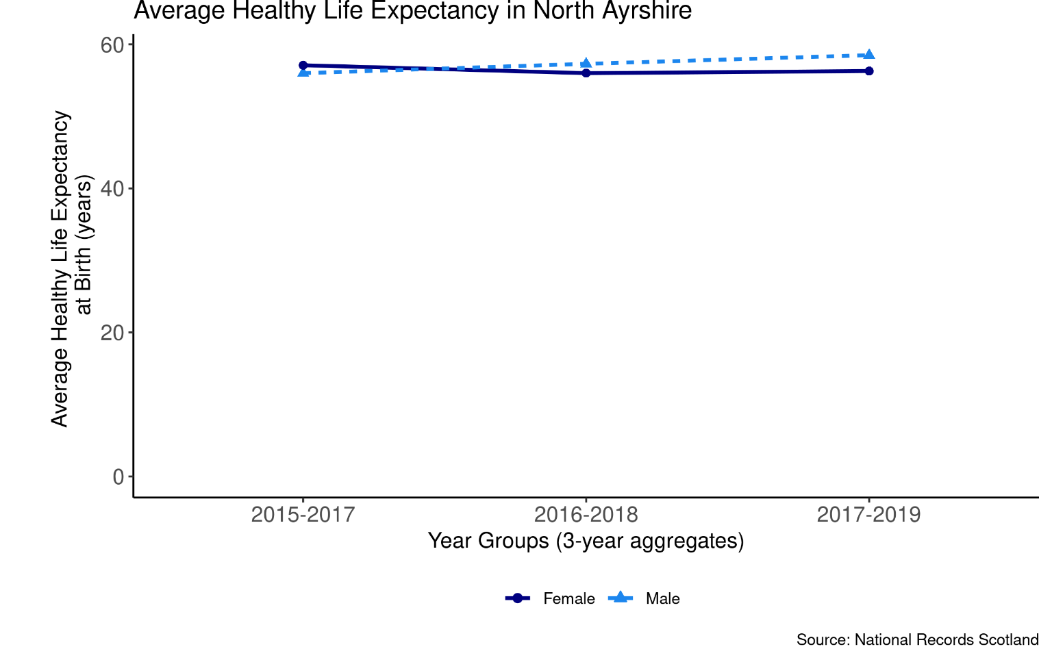

Page break

Deaths, aged 15-44
The following chart shows a trend of death rates among 15-44 year olds per 100,000 age-sex standardised population⁴ by area (i.e. Early mortality rate per 100,000). In the most recent aggregate time period available (from 2018-2020), the mortality rate in North Ayrshire was 164 deaths per 100,000 population. Figure 17 shows deaths for North Ayrshire compared with Scotland, East Ayrshire and South Ayrshire HSCP for the two latest time aggregates available.

Figure 17: Deaths aged 15-44 years by geographical area and over time.

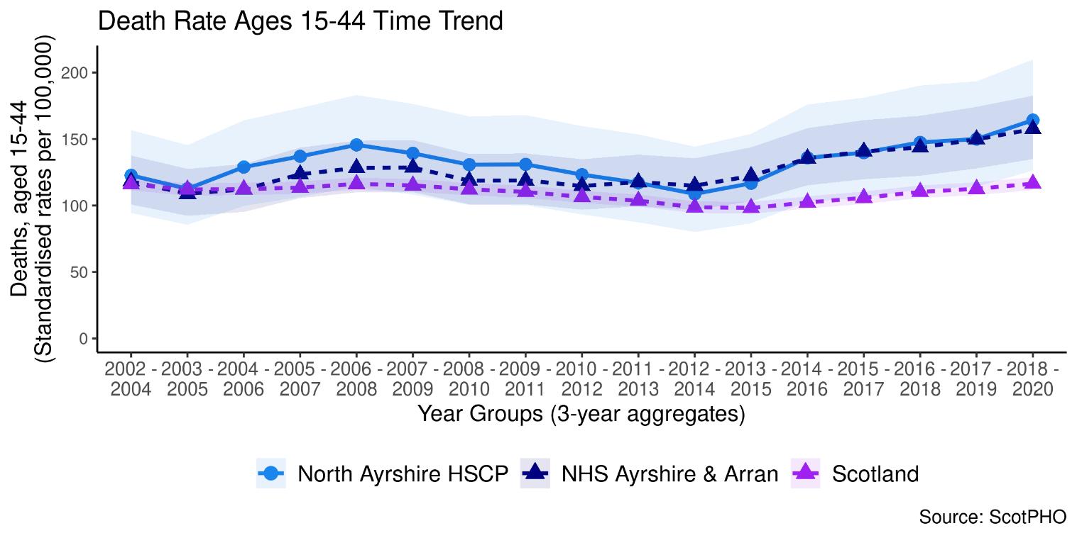

Figure 18: Deaths at ages 15-44 in all geographical areas.

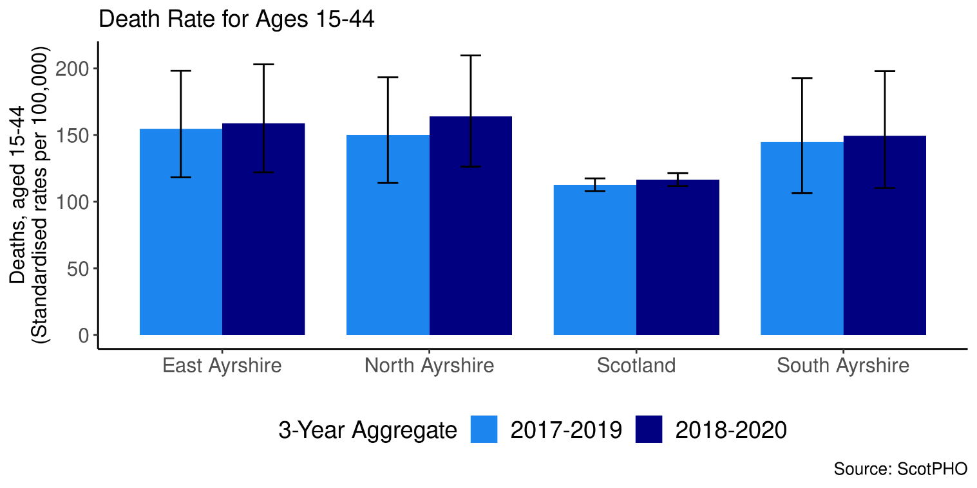

Page break

Long-Term Physical Health Conditions and Multimorbidity

In the financial year 2019/20, in North Ayrshire HSCP, 27% of the total population had at least one physical long-term condition (LTC). These include: cardiovascular, neurodegenerative, and respiratory conditions, as well as other organ conditions (namely liver disease and renal failure), arthritis, cancer, diabetes, and epilepsy. Please see footnotes for information and caveats on identifying LTCs.⁵
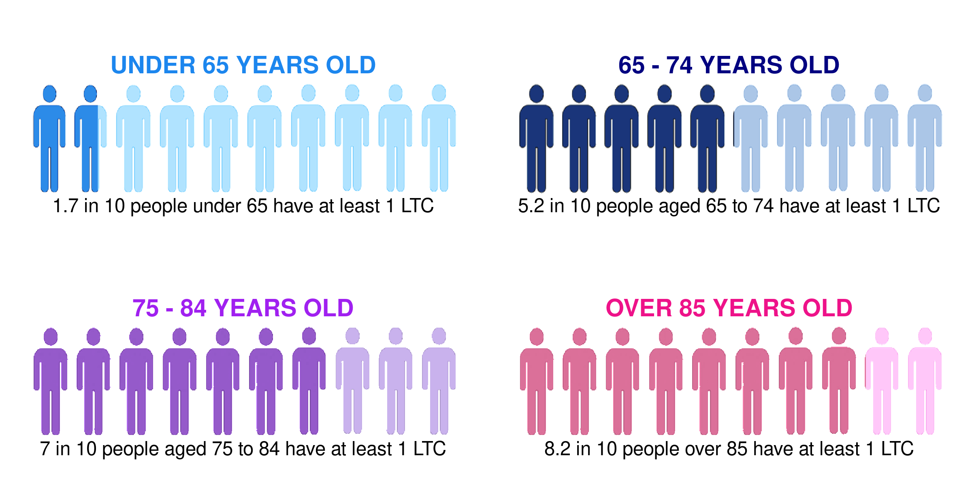
Based on the historical trends in long-term conditions, the figure below shows the projected prevalence by the 2025/26. These are only projections, but there are expected to be gradual increases in prevalence in the older age groups.

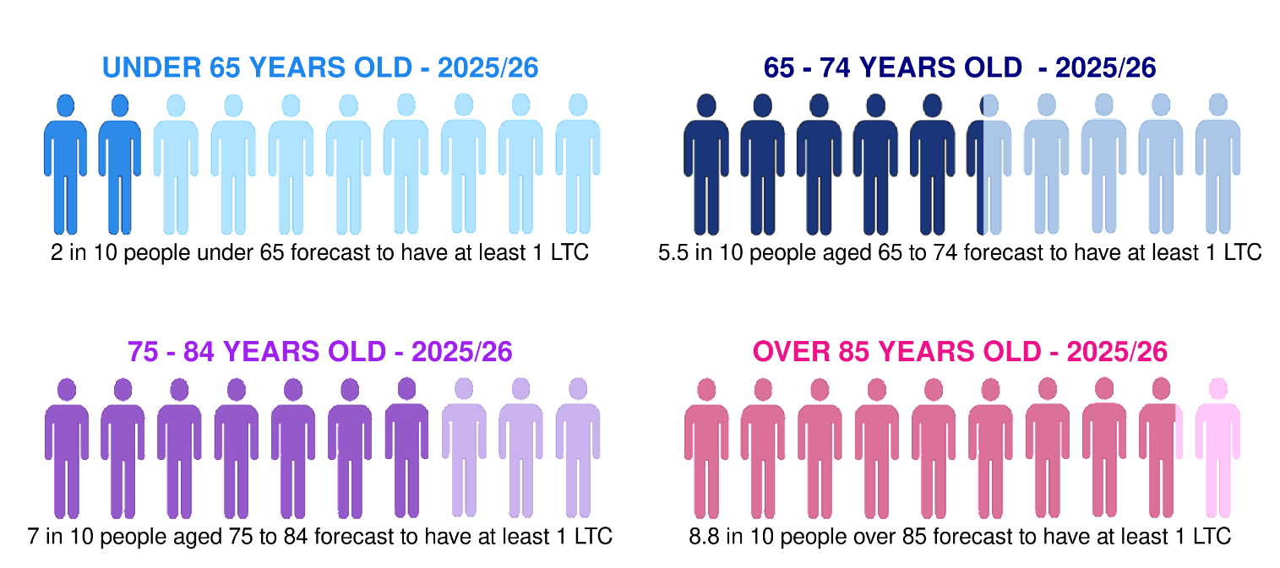

The co-occurrence of two or more conditions, known as multimorbidity, is broken down in Figure 14, distinguishing between age groups. Note that this chart excludes the population in the partnership who do not have any physical long-term conditions. Figure 19 therefore shows that among the people who have a LTC, 24% of those under the age of 65 have more than one, compared to 57% of those aged over 65.

Figure 19: Multimorbidity of physical long-term conditions by age group in 2019/20.

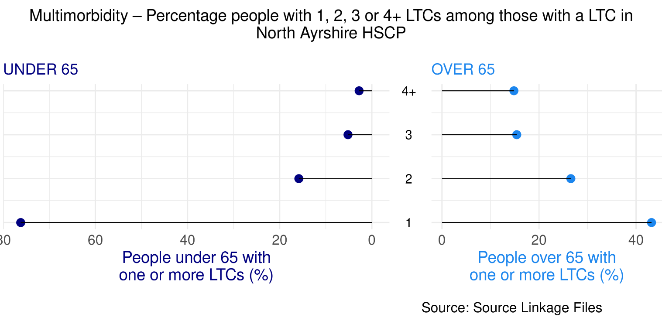

Page breakMost common physical Long-Term Conditions (LTCs)
Below is a breakdown of the physical LTCs, for the financial year 2019/20. Figure 20 shows the prevalence of different LTCs in each age group in North Ayrshire, and Table 6 illustrates the top 5 physical LTCs across all ages at partnership, and Scotland level.

Figure 20: Percentage people with each physical LTC, split by age group.

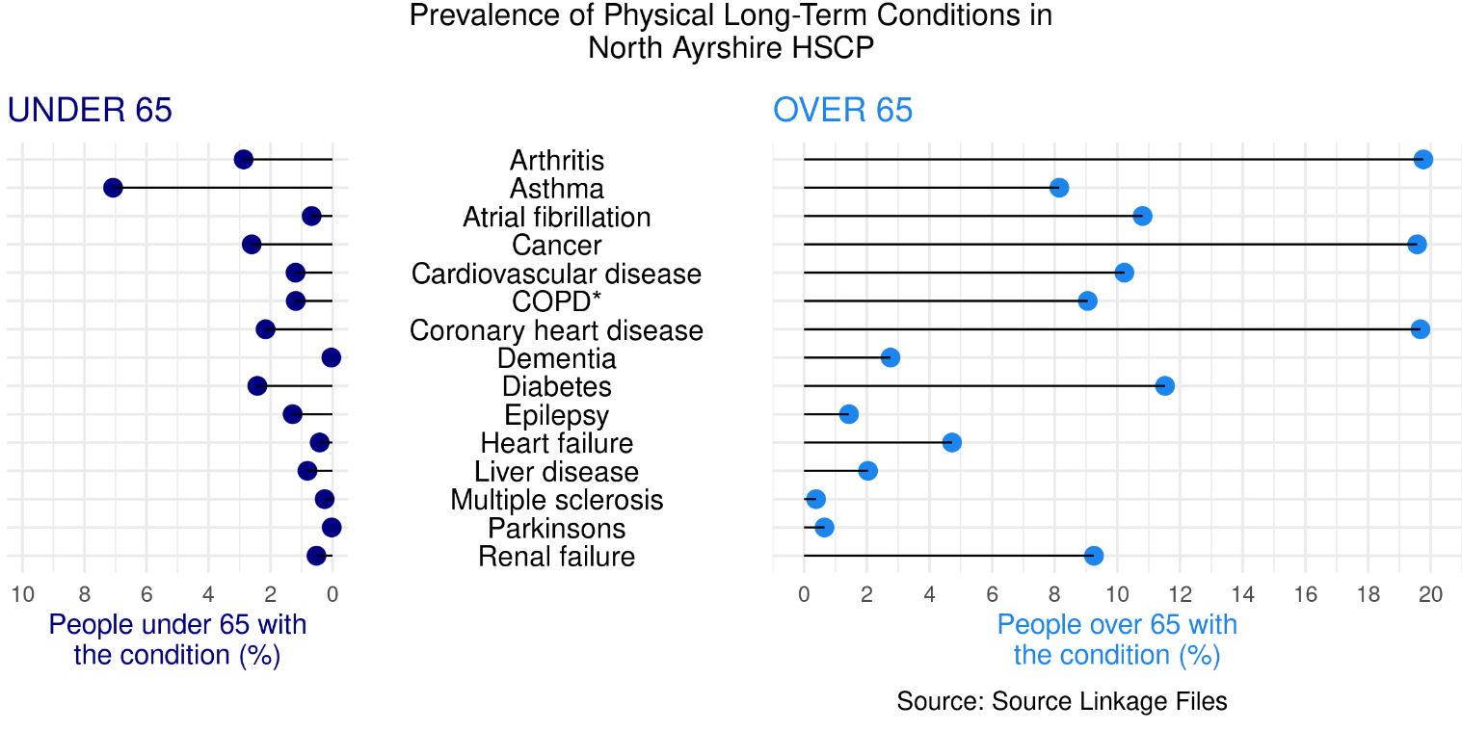

*COPD: Chronic Obstructive Pulmonary Disease

Based on the historical trends in long-term conditions, the figure below shows the projected prevalence of long-term conditions by the year 2025/26. This is for illustration, since there are many factors that will influence disease prevalence and historic trends may not continue into the future.

Figure 21: Projection of percentage people with each physical LTC, split by age group.

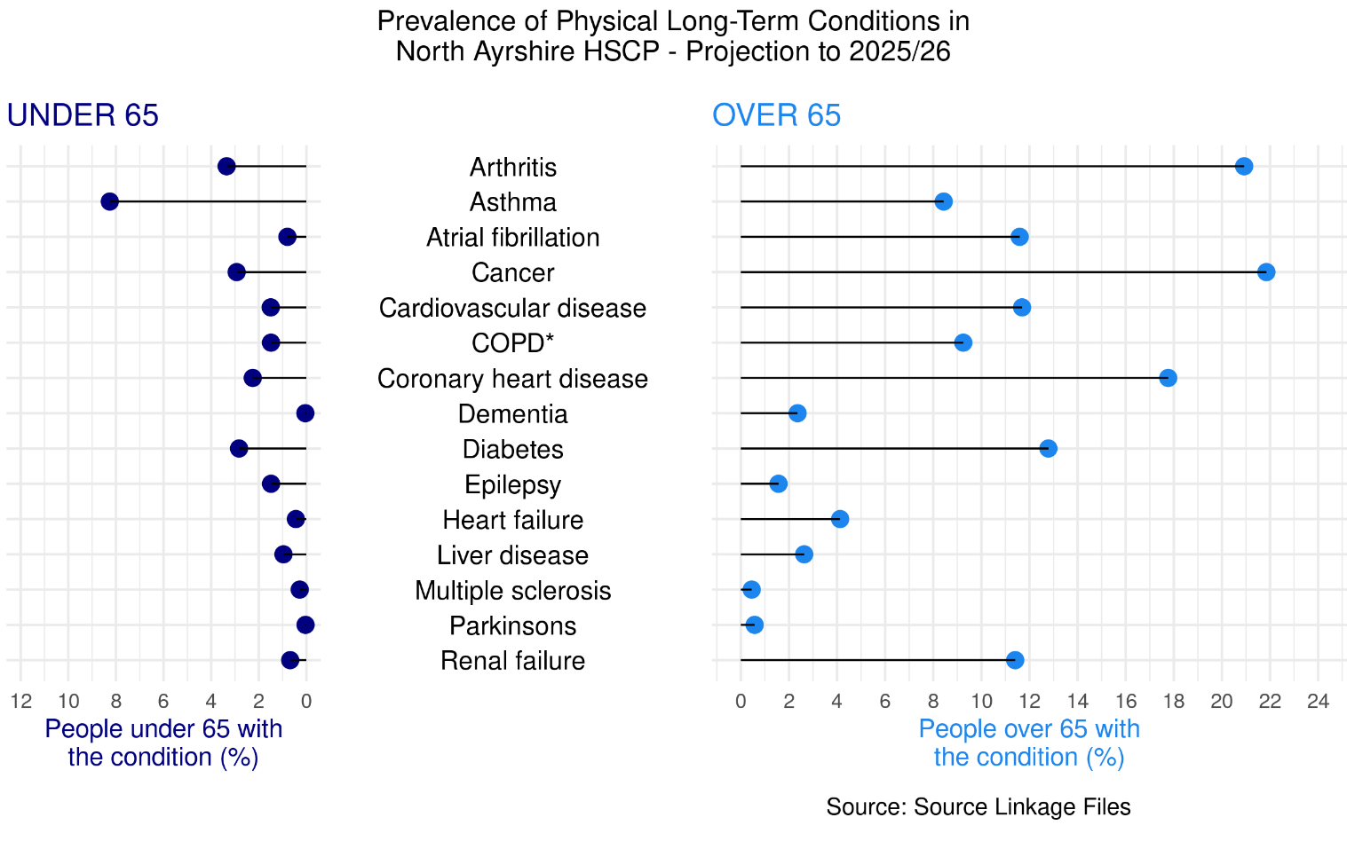

Table 6: Prevalence of the five most common physical LTCs as a percentage of the population across geographical areas (where 1 = most prevalent).

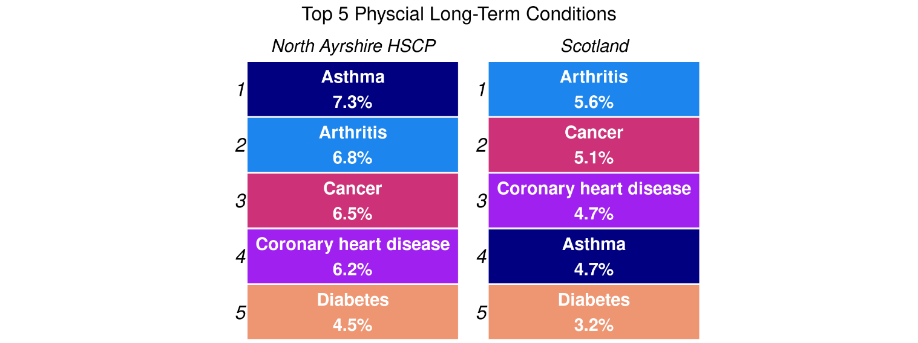

Cancer Registrations
For the period 2017-2019, there were 974 new cancer registrations per year on average (654 registrations per 100,000 age-sex standardised population) in North Ayrshire. This is a 0.2% increase in the rate of cancer registrations from the period 2006-2008. Figure 22 shows changes over time since 2002-2004, and Figure 22 compares the rates in North Ayrshire HSCP with East Ayrshire, South Ayrshire and Scotland for the two latest available time periods.

Figure 22: Cancer registration rate over time and by geographical area.

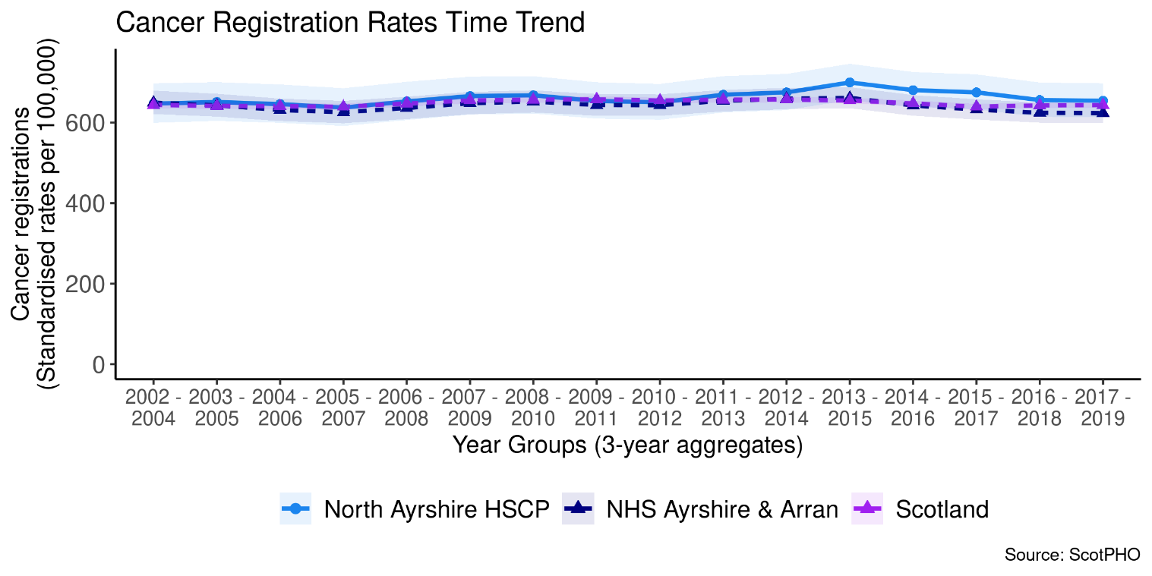

Figure 23: Cancer registration rates by geographical area

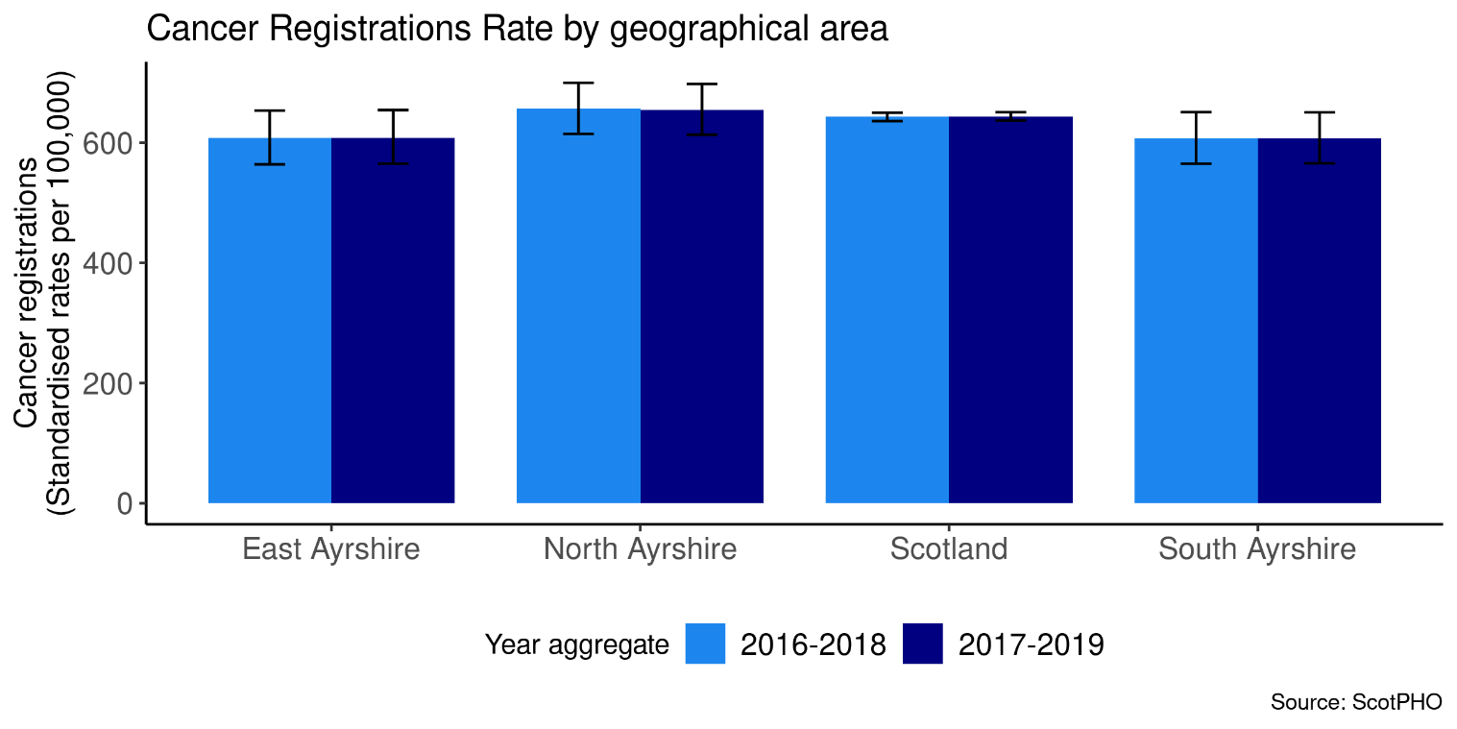

Page break

Anxiety, Depression, and Psychosis Prescriptions

In the 2019/20 financial year, 22% of people were prescribed medication for anxiety, depression, or psychosis (ADP) in North Ayrshire.

Figure 24: Percentage population prescribed ADP medication by geography.

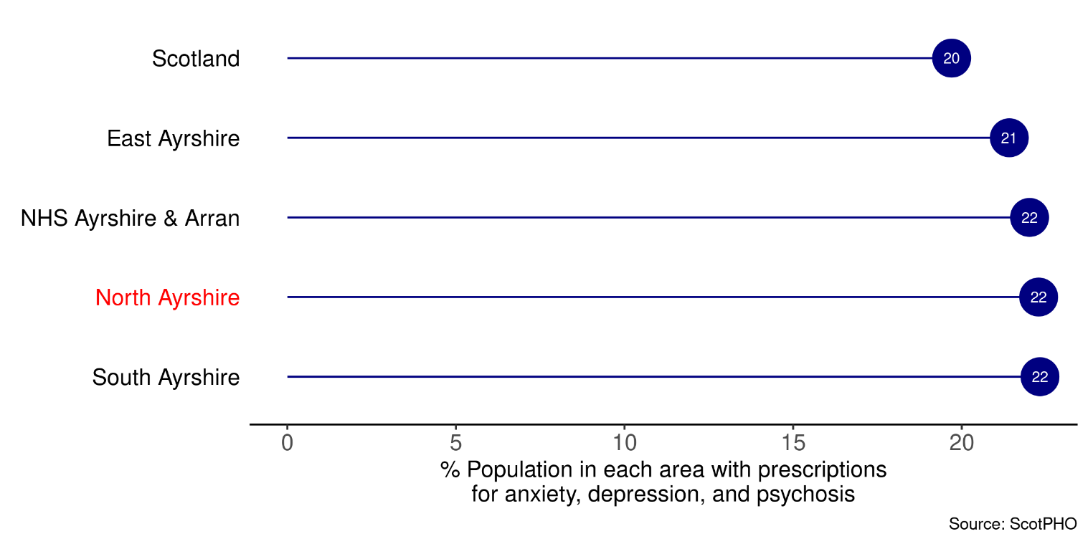

Figure 25: ADP prescriptions over time and by geographical area.

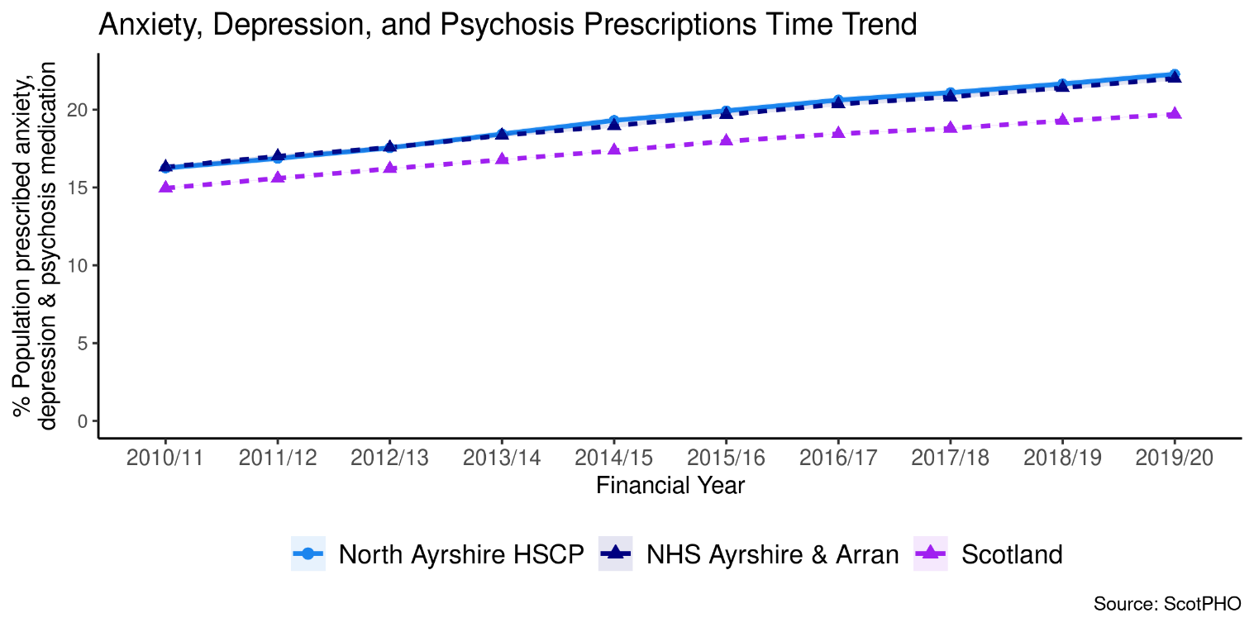

Pagebreak

Lifestyle and Risk Factors

Summary:

Mental and physical wellbeing has close ties with people’s lifestyles and behaviours. Financial security, employment and location are influences that often have a bearing on these choices. Issues can develop when alcohol, smoking or drug use shape lives. This section provides data on drug-related hospital admissions, alcohol-related hospital admissions, alcohol-specific mortality and bowel screening uptake, to give an overview of some of the lifestyles and behaviours for North Ayrshire HSCP. These can give an idea of quality of life and prosperity.

For the most recent time periods available³, North Ayrshire HSCP had:
- 424 drug-related hospital admissions per 100,000 age-sex standardised population⁴. This is a higher rate of admissions than for Scotland (221).
- 35 drug-related deaths per 100,000 age-sex standardised population
- 631 alcohol-related hospital admissions per 100,000 age-sex standardised population⁴.
- 25 alcohol-specific mortality per 100,000 age-sex standardised population⁴.
- a 59% uptake of bowel cancer screening for the eligible population.

Drug-related Hospital Admissions

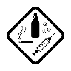
There were 424 drug-related hospital admissions per 100,000 age-sex standardised population⁴ in North Ayrshire for the most recent time period available (3 year financial year aggregate for 2017/18 - 2019/20).
This is a 57% increase since 2011/12 - 2013/14 (3 financial year aggregates).
A trend of the change in drug-related hospital admissions for North Ayrshire HSCP compared with Scotland and NHS Ayrshire & Arran is shown in the chart below from 2011/12 - 2013/14 onwards.

Figure 26: Trend of Drug-related Hospital Admission Rates by geographical area.

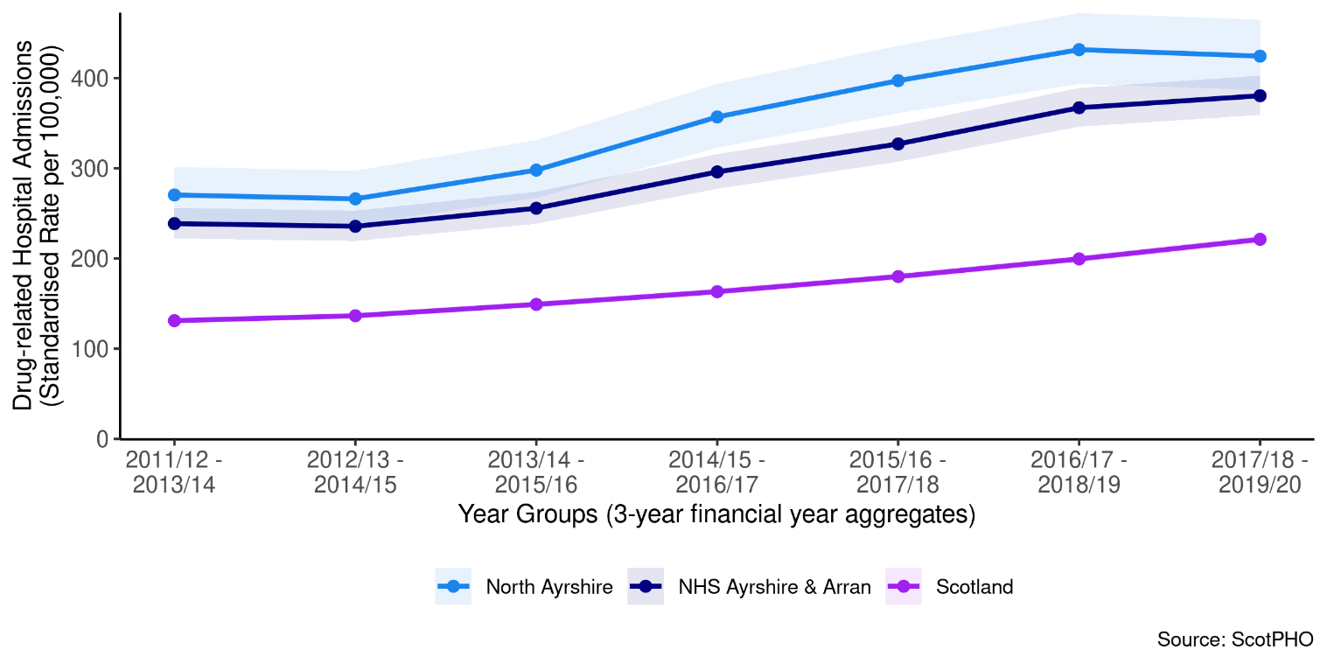

A comparison of areas at the most recent time period (2017/18 - 2019/20 aggregated financial years) is available below. This shows North Ayrshire HSCP has a higher rate of admissions (424) than Scotland (221) and NHS Ayrshire & Arran (380).

Figure 27: Comparison of Drug-related Hospital Admission Rates for the period 2015/16 - 2017/18.

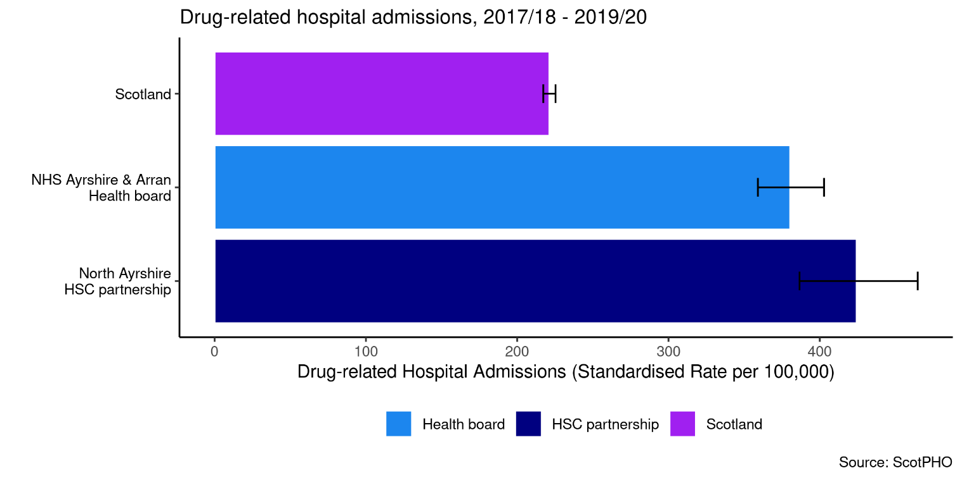

Page Break

Drug-Related Deaths
Data on drug-related deaths is available by calendar year. The rate of drug-related deaths is currently higher in North Ayrshire than the rate in 2010 (267% change).

Figure 28: Trend of Drug-related Death Rates by geographical area.
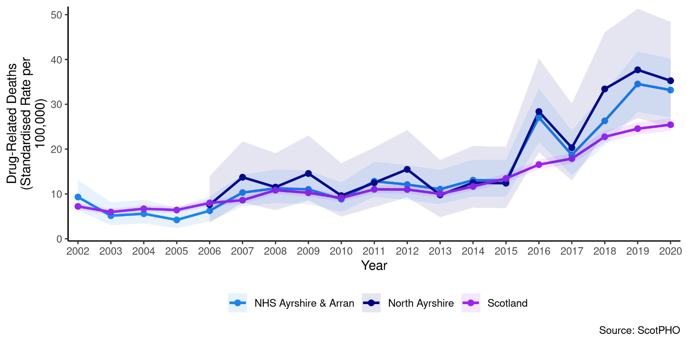
A comparison across different areas illustrates that North Ayrshire HSCP has a higher drug-related death rate compared to Scotland as a whole.

Figure 29: Comparison of Drug-related Death Rates for the period 2020

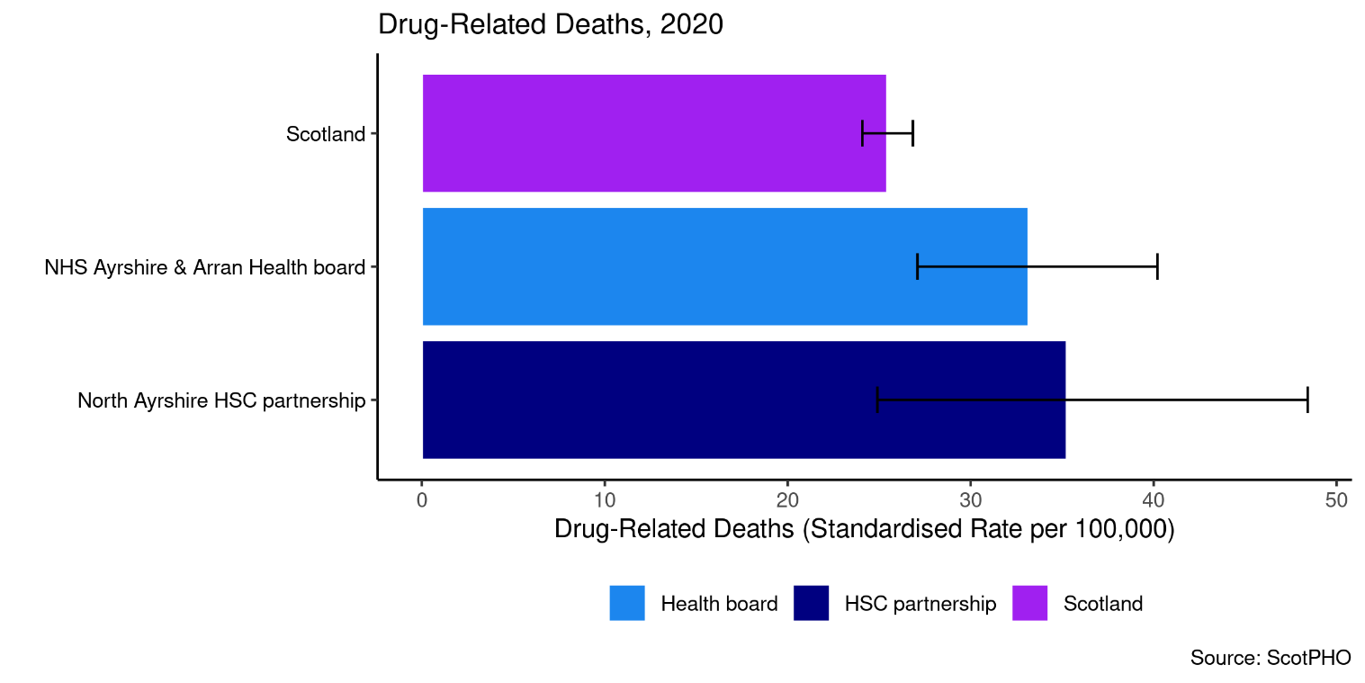

Alcohol-related Hospital Admissions

The 2020/21 alcohol-related admissions rate is 631 per 100,000 age-sex standardised population⁴, which is a 31% decrease overall since 2012/13.
The chart below shows a trend of alcohol-related hospital admissions for North Ayrshire HSCP compared with Scotland and NHS Ayrshire & Arran from financial year 2012/13 to 2020/21.

Figure 30: Trend of Alcohol-related Hospital Admission Rates by geographical area.

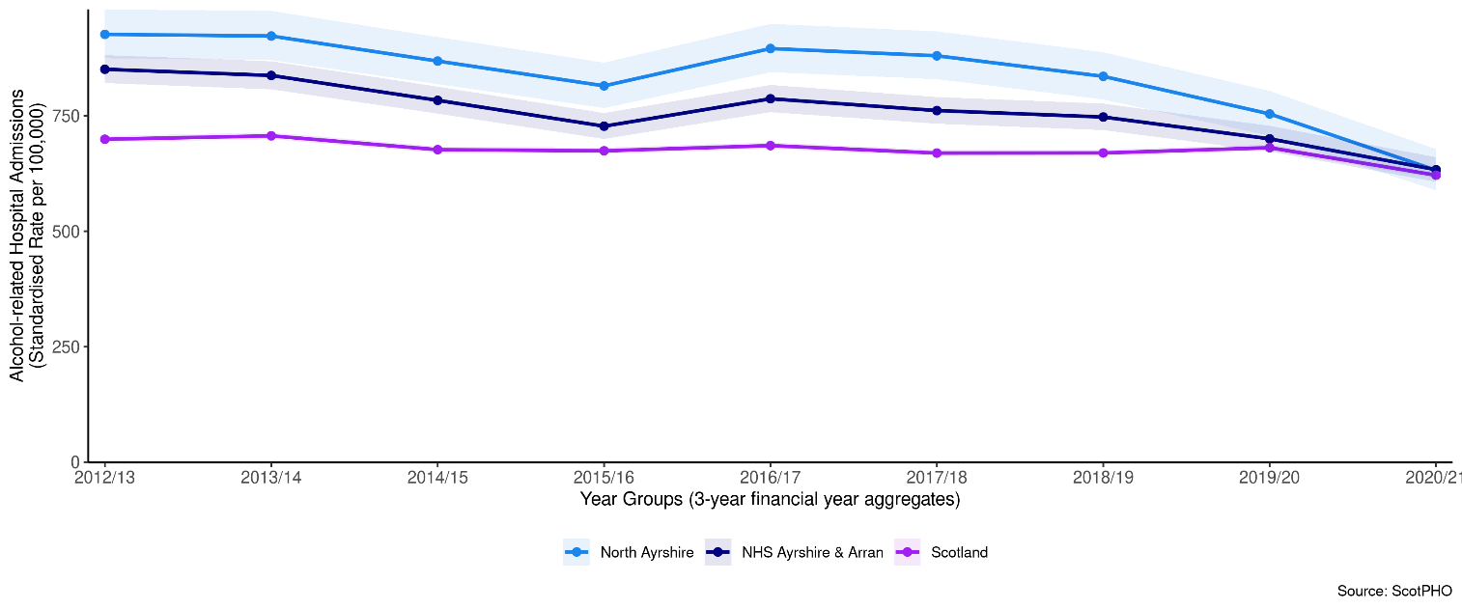
Comparison across different areas for 2019/20 is shown in Figure 31. This shows that North Ayrshire HSCP had a higher alcohol-related hospital admissions rate (631) compared to Scotland (621).

Figure 31: Comparison of Alcohol-related Hospital Admission Rates for 2019/10.

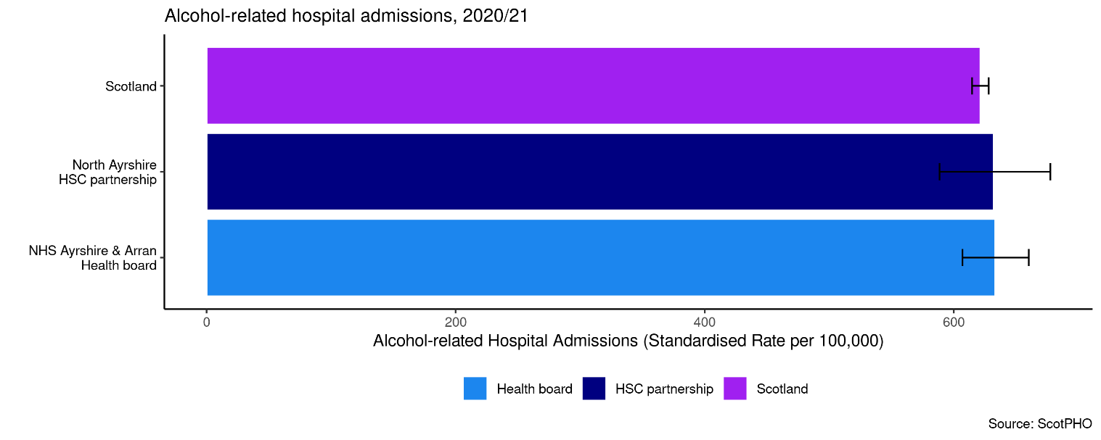

Alcohol-Specific Deaths
Data on alcohol-specific deaths is available as 5 year aggregates. The rate of alcohol-specific deaths is currently higher in North Ayrshire than the rate in 2009-2013 (18% change).

Figure 32: Trend of Alcohol-Specific Death Rates by geographical area.

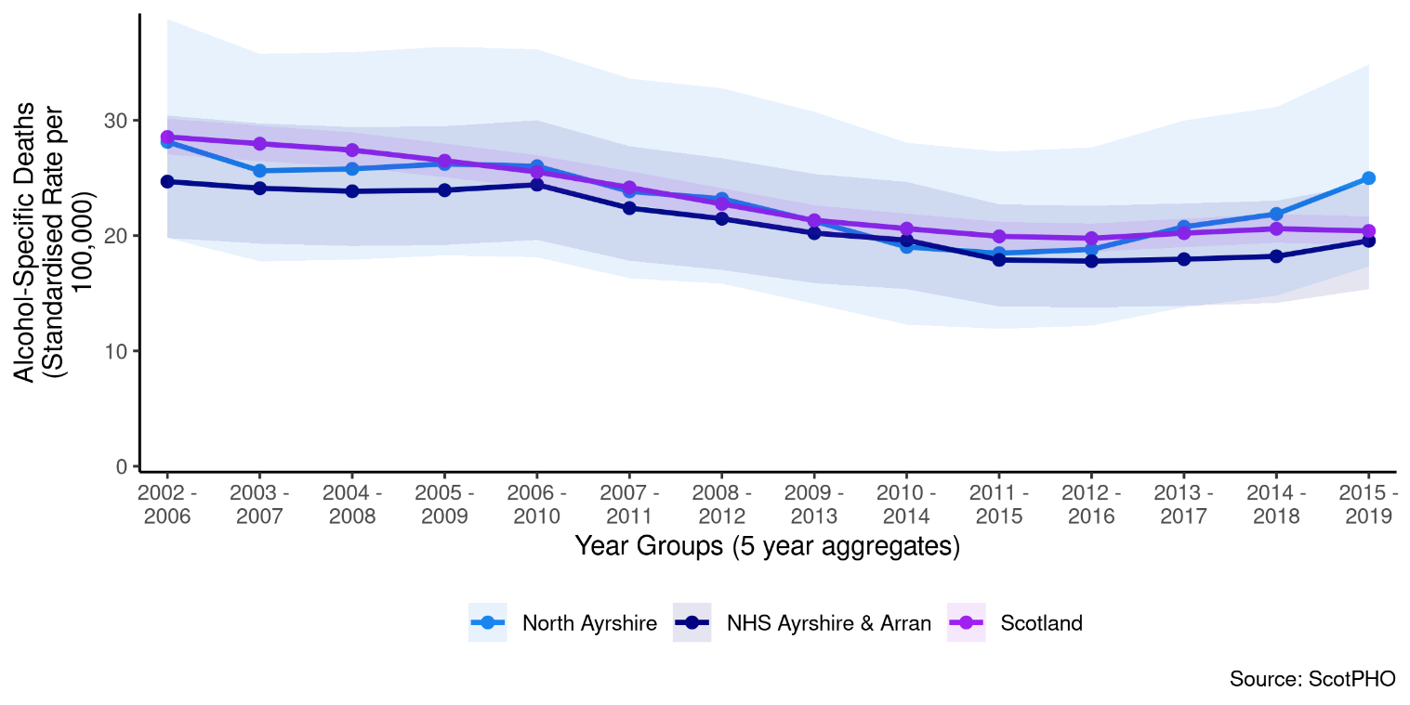
A comparison across different areas illustrates that North Ayrshire HSCP has a higher alcohol-specific death rate compared to Scotland as a whole.

Figure 33: Comparison of Alcohol-related Death Rates for the period 2015 - 2019 (5 year aggregate).

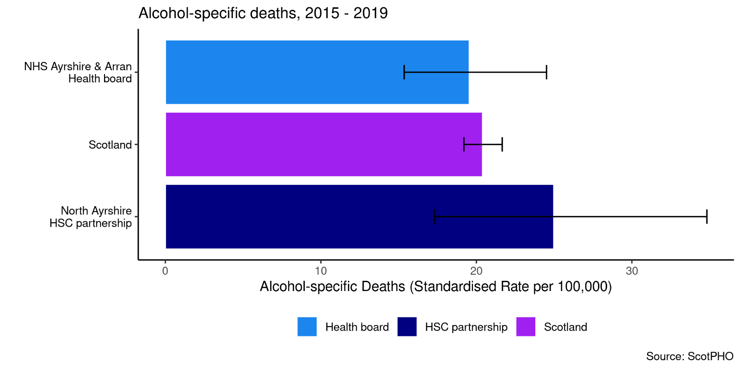

Bowel Screening Uptake
Bowel screening is offered every two years to eligible men and women aged between 50-74 years old. Eligible people are posted a test kit which is completed at home. Since 1st April 2013, those aged 75 and over can also self-refer and opt into screening.
A trend of the percentage uptake of bowel screening among the eligible population is shown below for North Ayrshire HSCP compared with Scotland and NHS Ayrshire & Arran. Data is suppressed into 3 year aggregates. The 2017 - 2019 uptake rate for North Ayrshire HSCP is 59%.

Figure 34: Trend of Bowel Screening Uptake for eligible men and women, by geographical area.

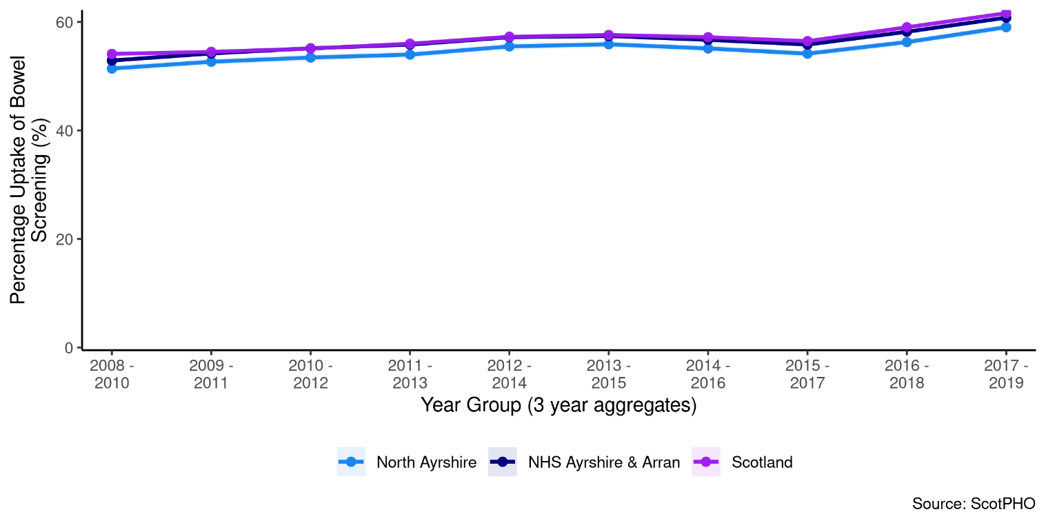
Compared with Scotland, North Ayrshire HSCP has a lower percentage uptake of bowel cancer screening for the period 2017 - 2019.

Figure 35: Comparison of Bowel Screening Uptake for 2017 - 2019.

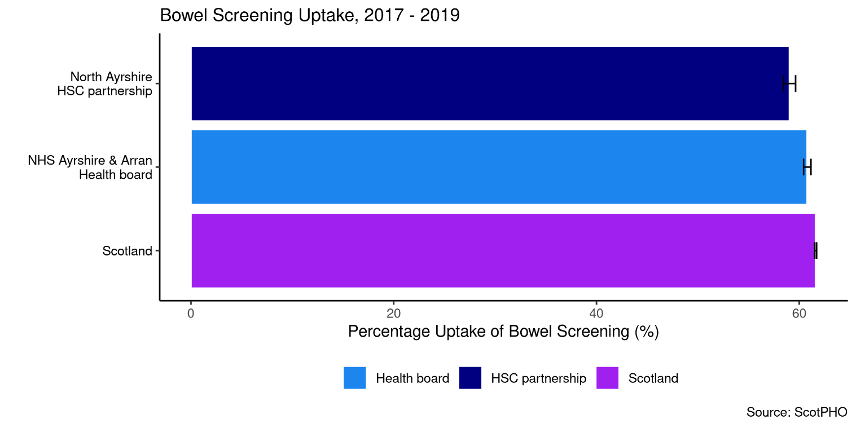

Smoking Prevalence

Data on smoking prevalence is available from the Scottish Survey Core Questions. For North Ayrshire HSCP, the prevalence is 22%.

Figure 36: Smoking Prevalence by geographical area, 2017.

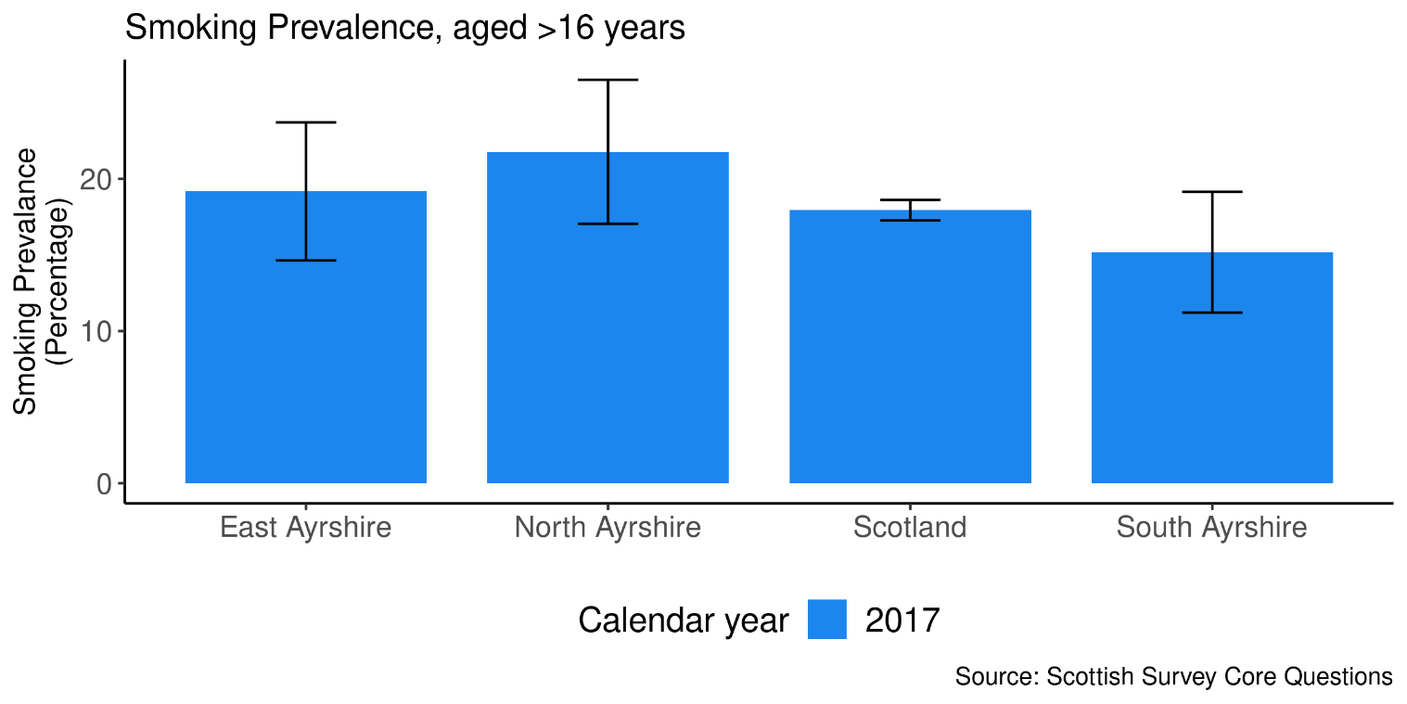

Pagebrea

Unscheduled Care
This section includes acute and mental health acute hospital data, delayed discharges and A&E attendances.
For the most recent time periods available, North Ayrshire had:
- 12,012 emergency health hospital admissions per 100,000 population.
- 84,702 unscheduled hospital bed days per 100,000 population.
- 22,104 A&E attendances per 100,000 population.
- 7,696 delayed discharges per 100,000 population.
- 691 falls admissions per 100,000 population.
- 117 readmissions (28 day) per 1,000 discharges.
- 1,577 potentially preventable hospital admissions per 100,000 population.
- 89% of people spent their last 6 months of life in a community setting.

Pagebreak

Emergency Admissions

Figure 37: Emergency admissions by age group

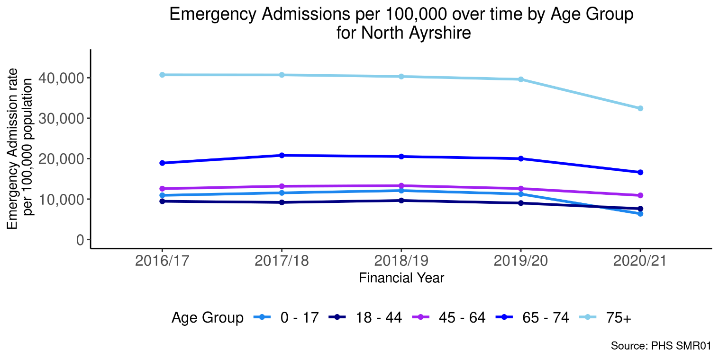

Figure 38: Emergency admissions by geographical area

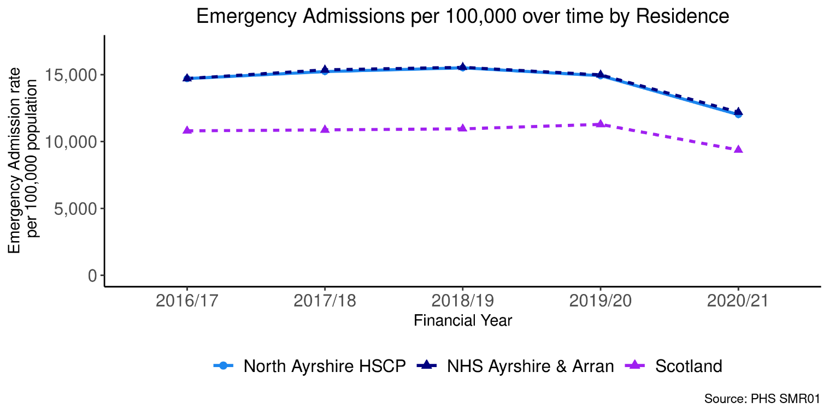

The chart below is a projection of future emergency admissions. It is calculated by applying the historic rates of emergency admissions prior to Covid-19 and applying those rates to the population projections for the next five years. These are projections and do not take into account any changes to services or potential impact of Covid-19 on future emergency admissions.

Figure 39: Projections of emergency admission for next 5 years

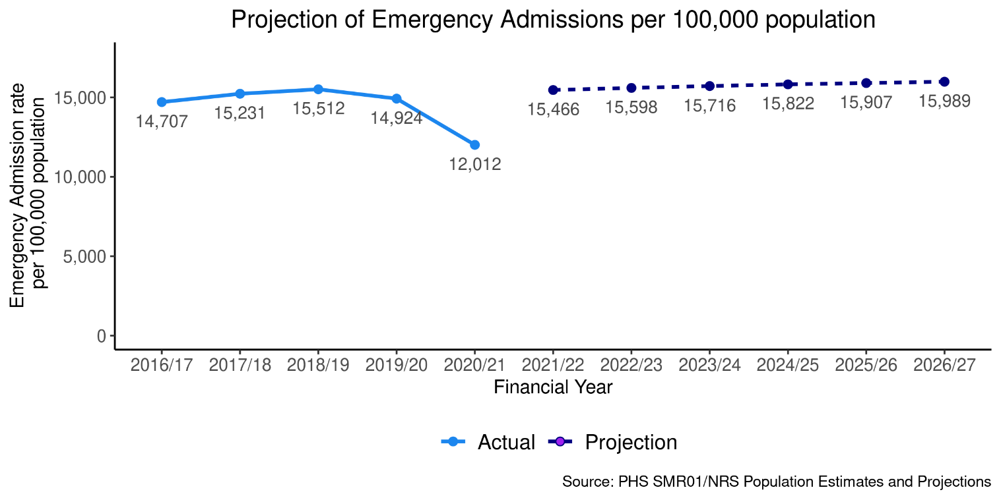

Unscheduled Bed Days

Figure 40: Unscheduled bed days by age group

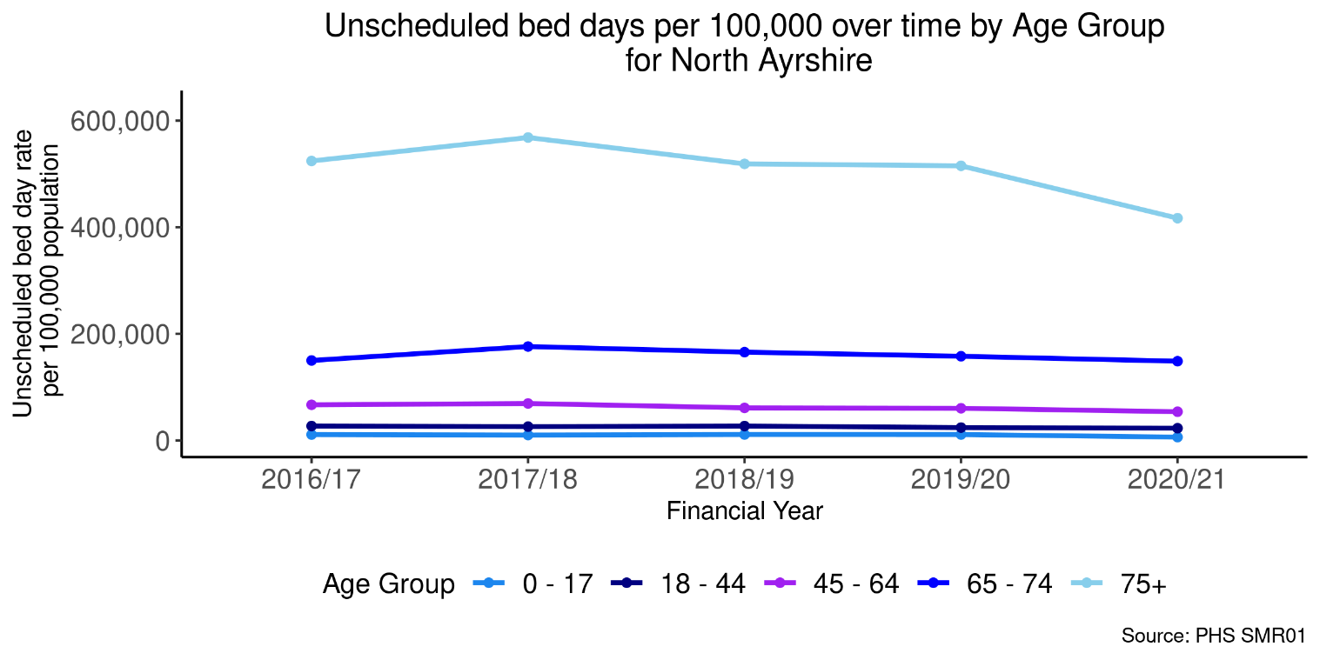

Figure 41: Unscheduled bed days by geographical area
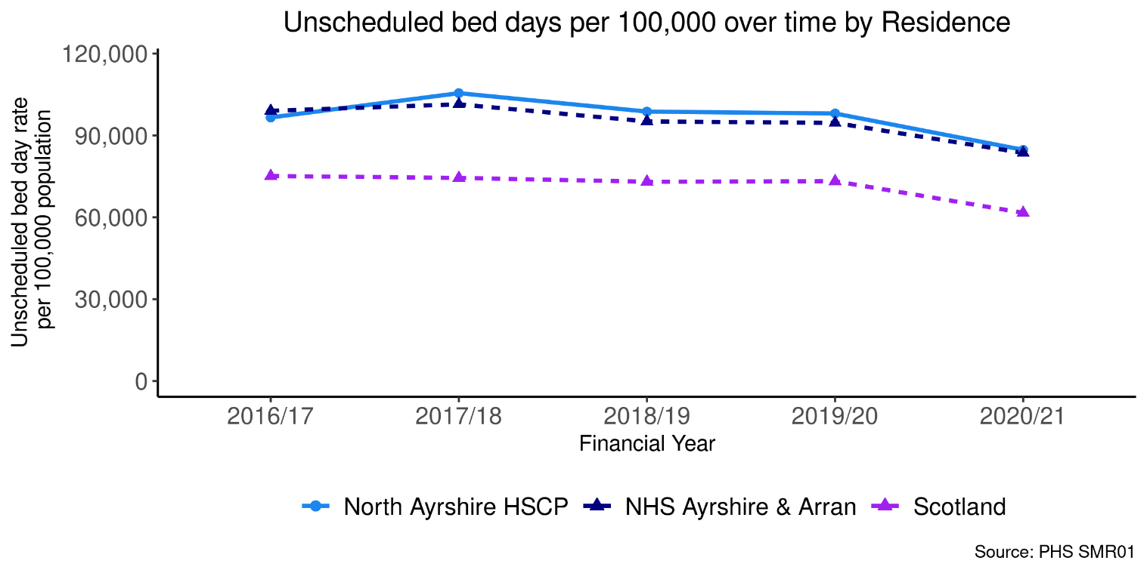

The chart below is a projection of future unscheduled bed days. It is calculated by applying the historic rates of unscheduled bed days prior to Covid-19 and applying those rates to the population projections for the next five years. These are projections and do not take into account any changes to services or potential impact of Covid-19 on future unscheduled bed days.

Figure 42: Projections of unscheduled bed days for next 5 years

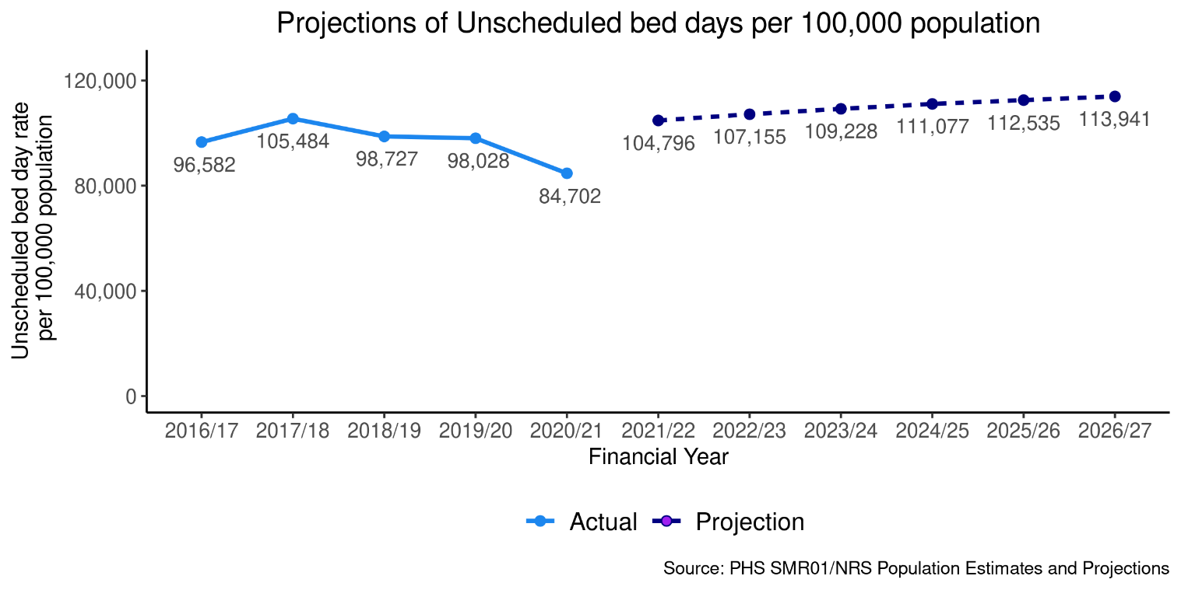

A&E Attendances

Figure 43: A&E attendances by age group

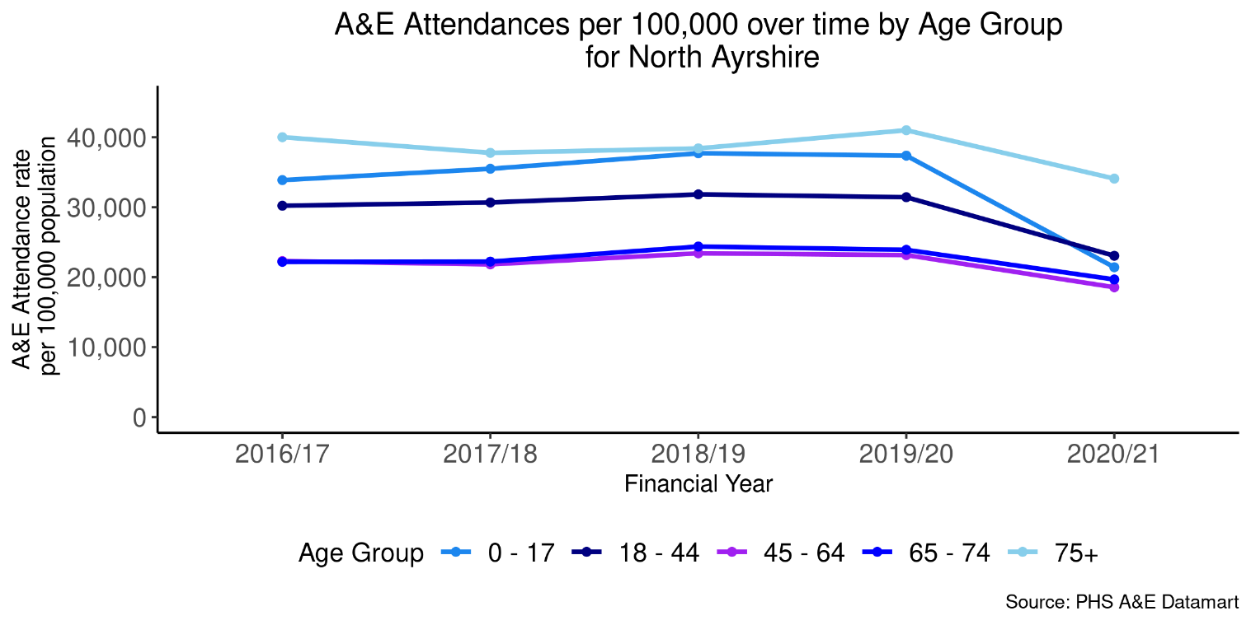

Figure 44: A&E attendances by geographical area

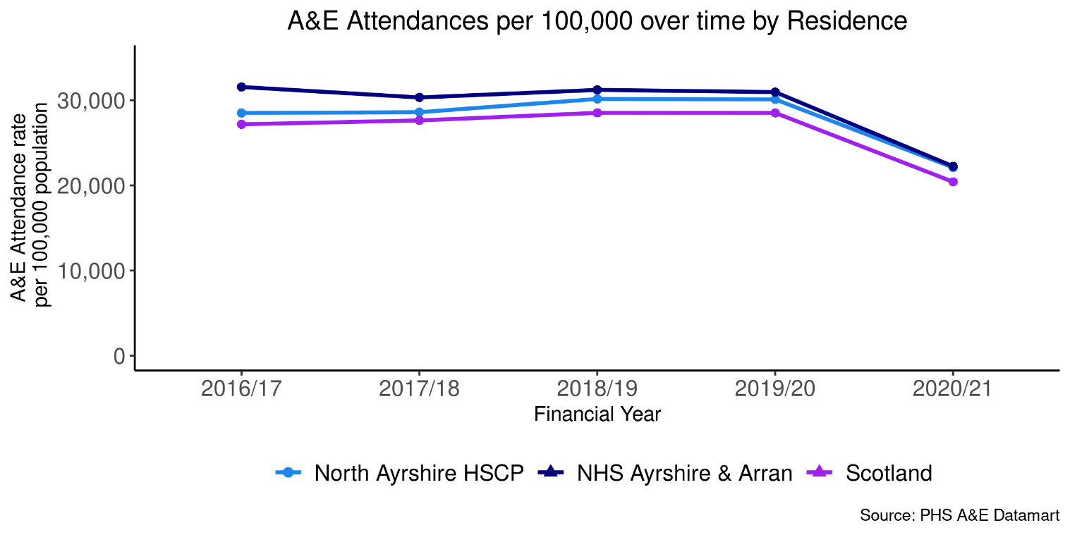

The chart below is a projection of future A&E attendances. It is calculated by applying the historic rates of A&E attendances prior to Covid-19 and applying those rates to the population projections for the next five years. These are projections and do not take into account any changes to services or potential impact of Covid-19 on future A&E attendances.

Figure 45: Projections of A&E attendances for next 5 years

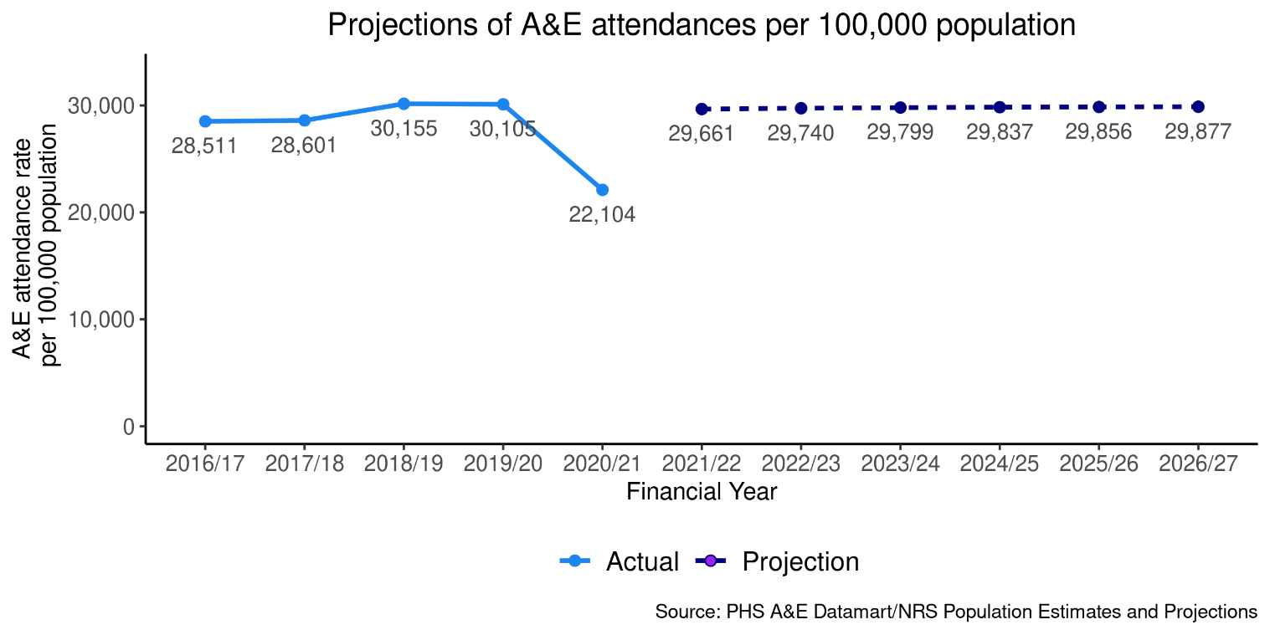

Delayed Discharges

Figure 46: Delayed discharges by age group

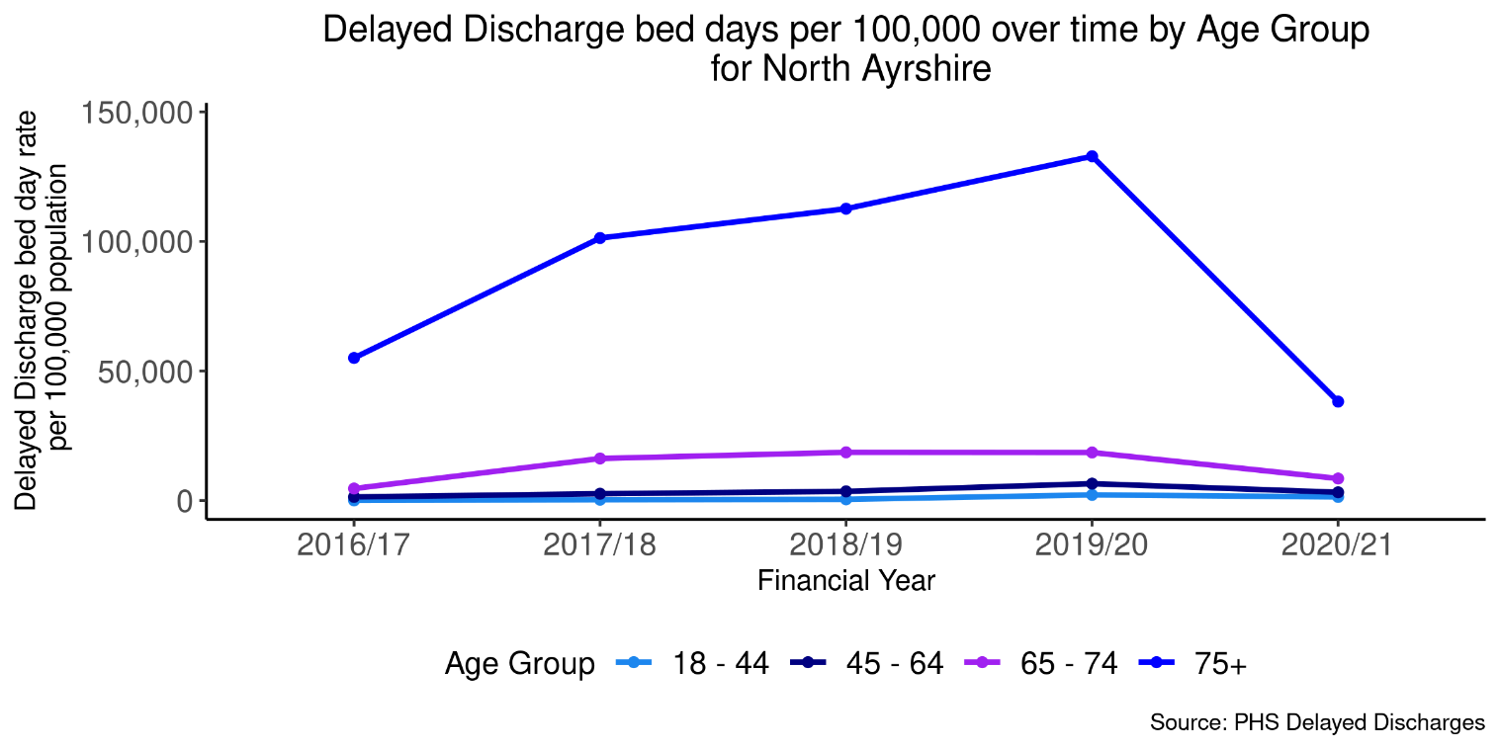

Figure 47: Delayed discharges by geographical area

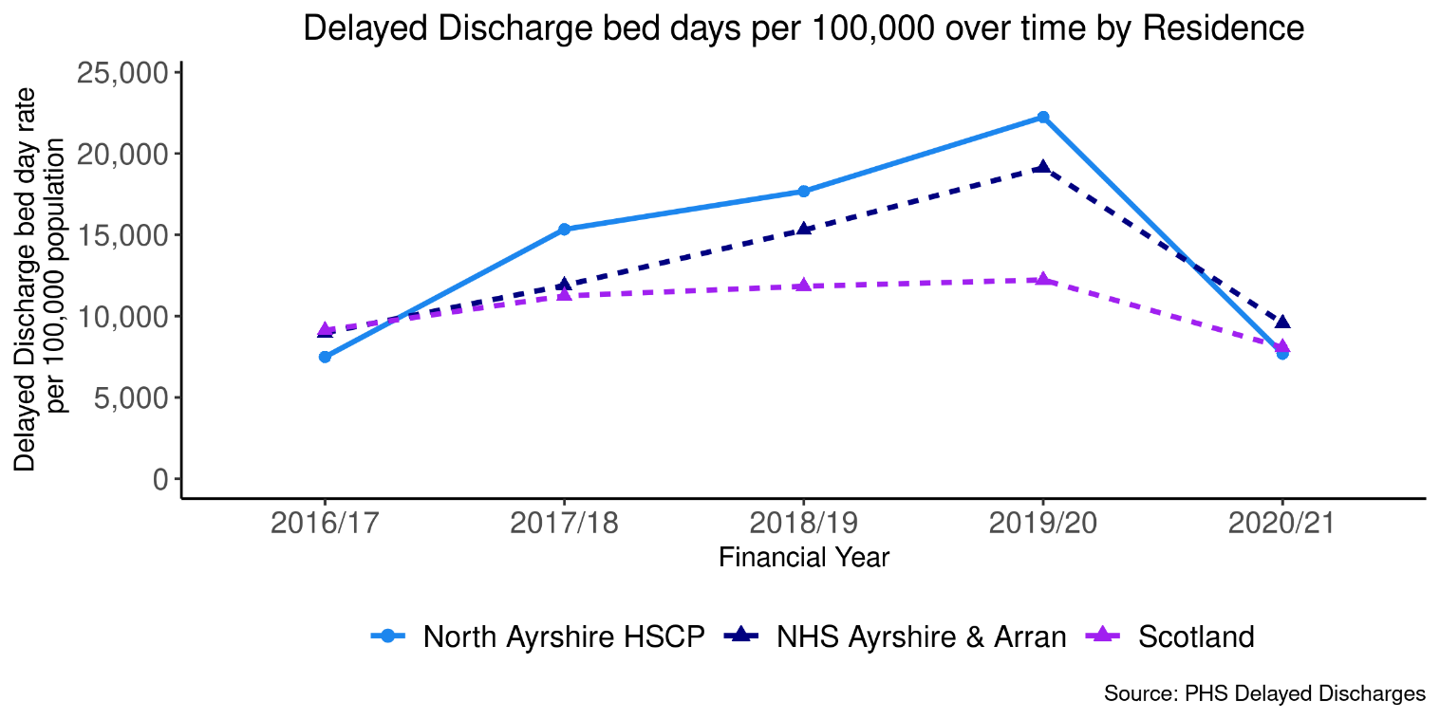

The chart below is a projection of delayed discharges. It is calculated by applying the historic rates of delayed discharges prior to Covid-19 and applying those rates to the population projections for the next five years. These are projections and do not take into account any changes to services or potential impact of Covid-19 on future delayed discharges.

Figure 48: Projections of delayed discharges for next 5 years

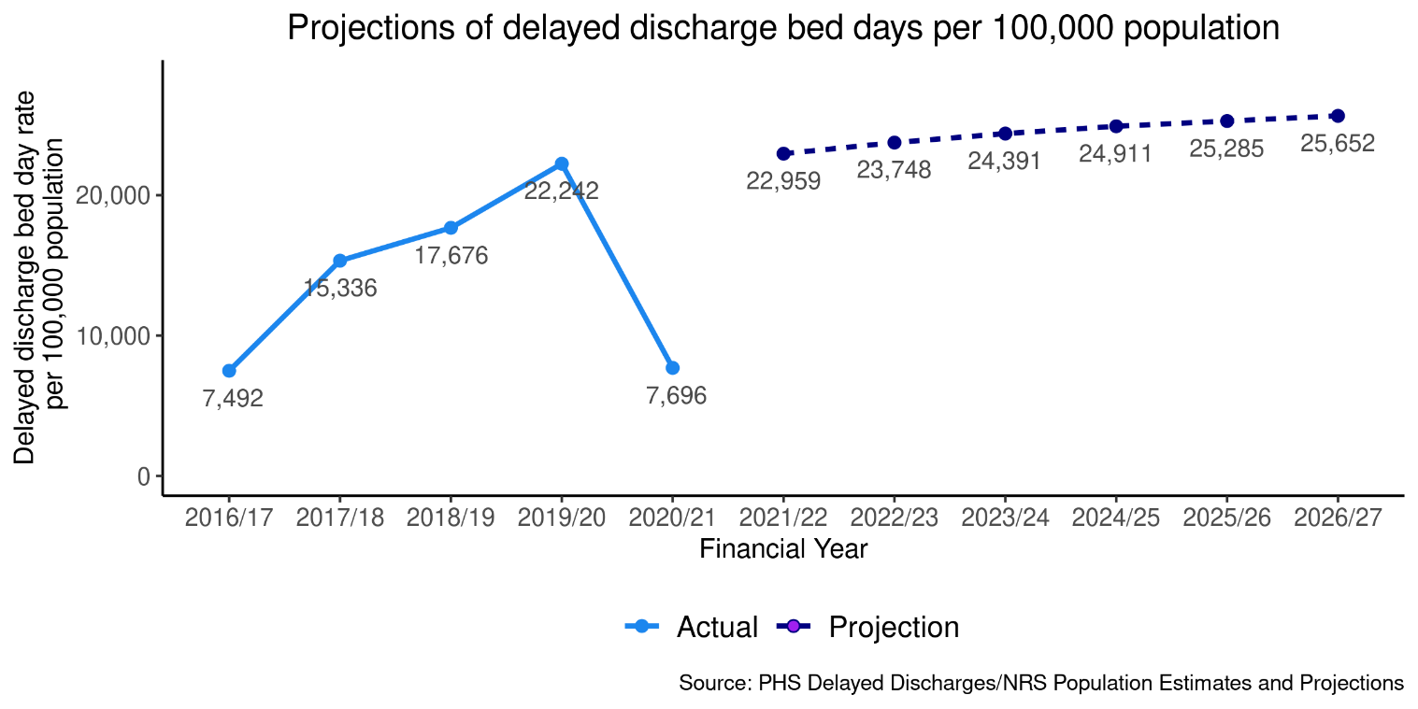

Emergency Admissions from a Fall

Figure 49: Falls by age group

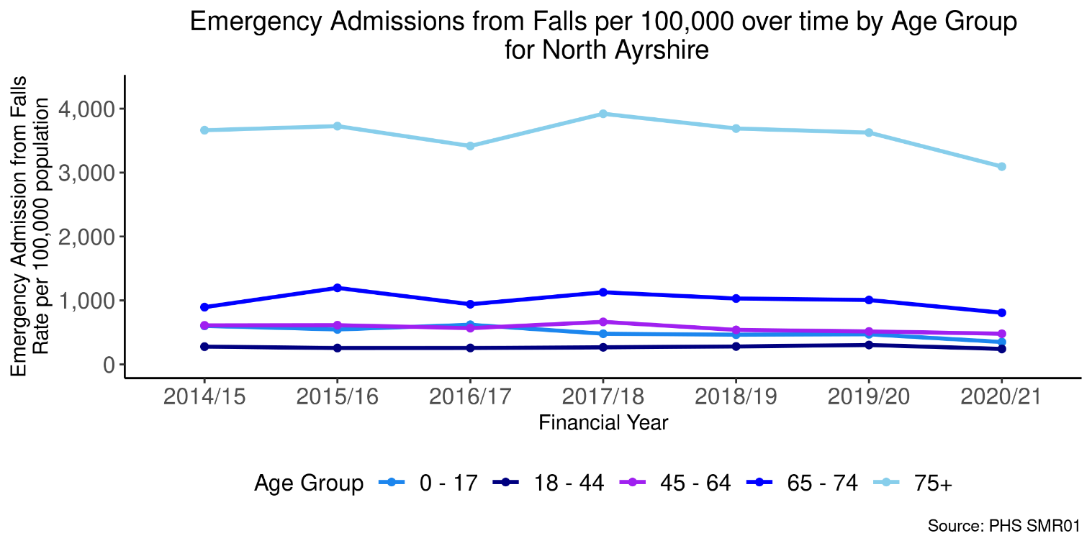

Figure 50: Falls by geographical area

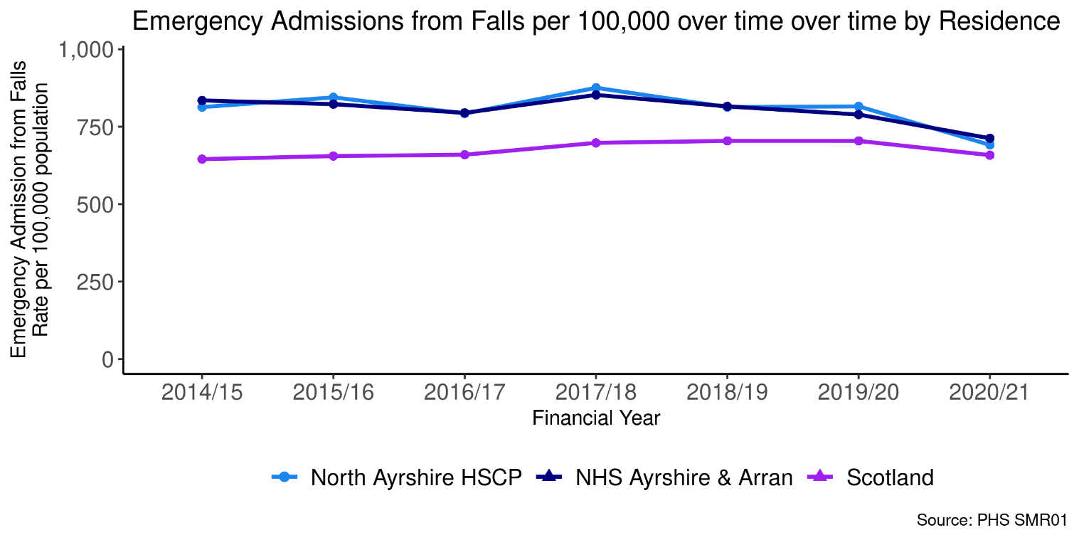

Emergency Readmissions (28 days)

Figure 51: Emergency readmissions by age group

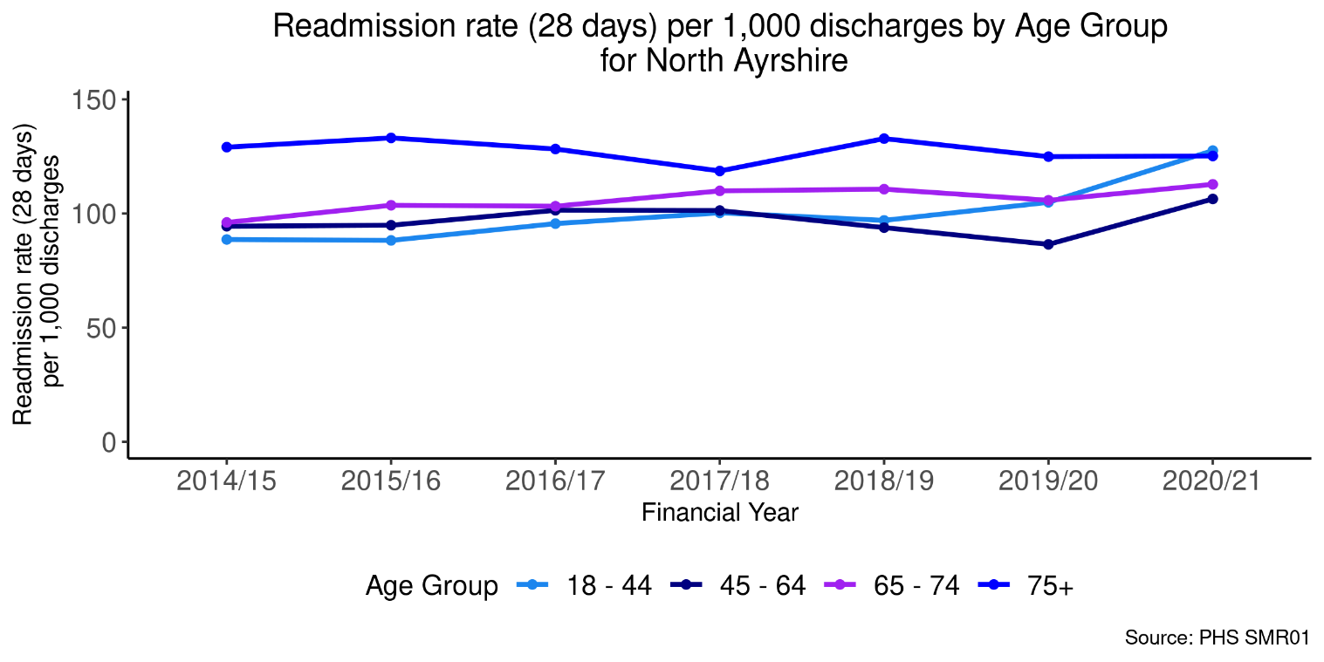

Figure 52: Emergency readmissions by geographical area

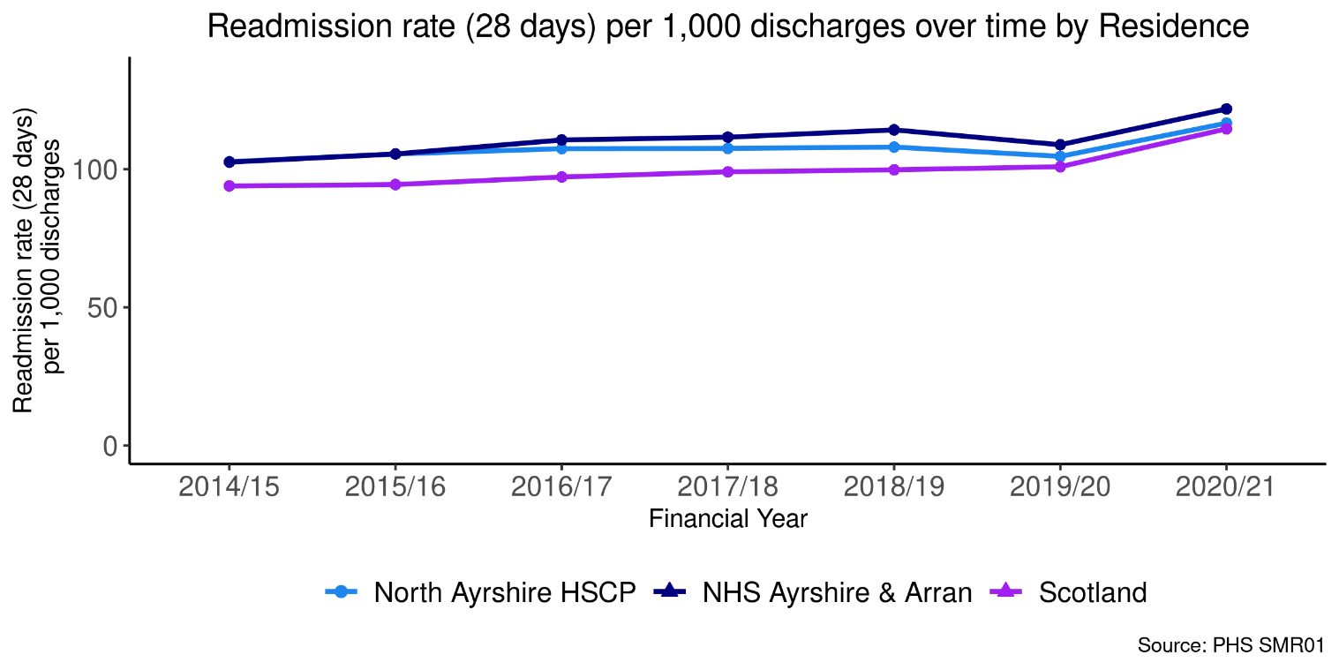

Potentially Preventable Admissions (PPAs)
Information on which conditions are counted as PPAs is available in Appendix 2.

Figure 53: PPAs by age group

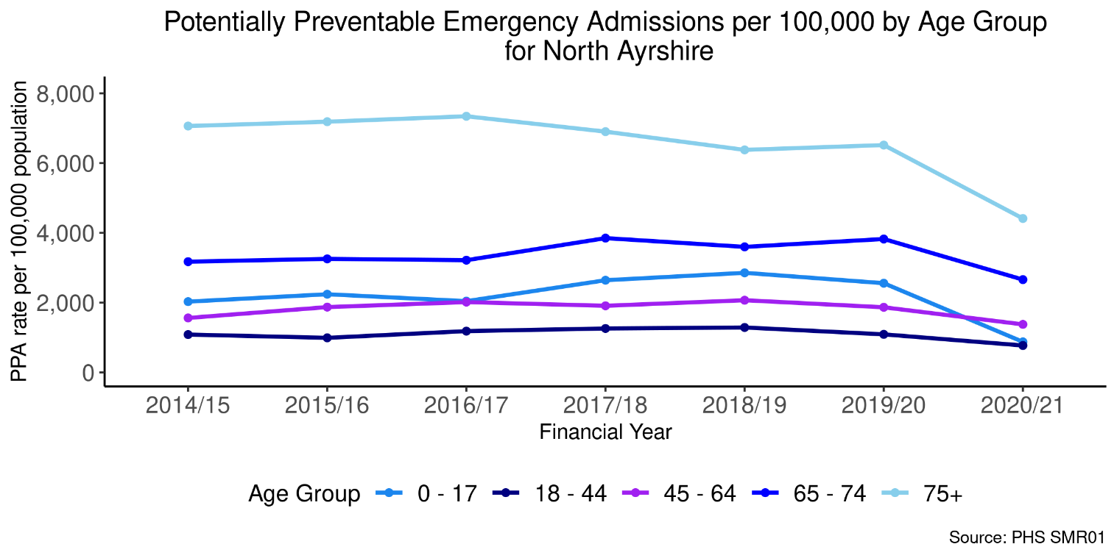

Figure 54: PPAs by geographical area

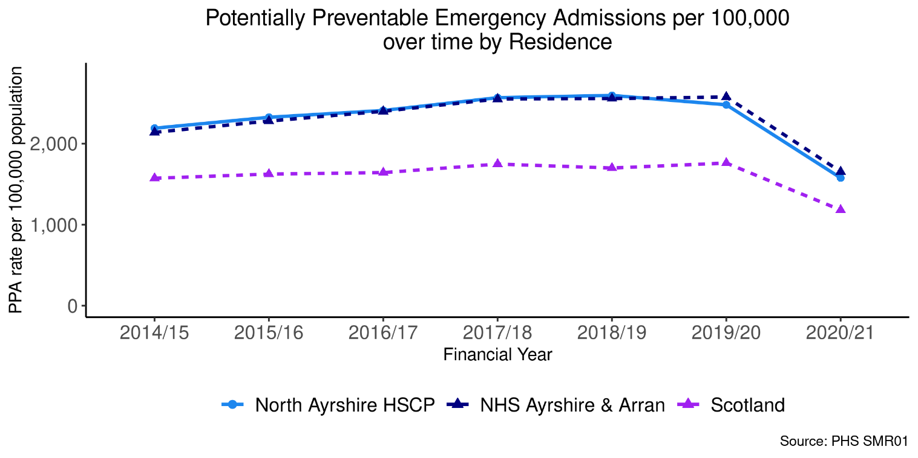

% Last 6 months in a Community Setting

Figure 55: Last 6 months in a community setting by geographical area

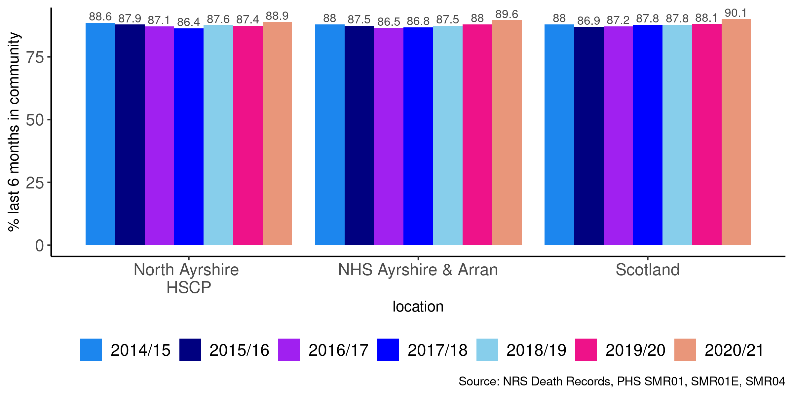

Pagebreak

Unscheduled Care in Mental Health (MH) Hospitals
This section looks at hospital admissions to mental health specialties.
For the most recent time periods available, North Ayrshire had:
- 182 emergency mental health hospital admissions per 100,000.
- 22,736 unscheduled mental health hospital bed days per 100,000.
- 2,349 delayed discharges per 100,000.

Pagebreak

Emergency Admissions (MH)

Figure 56: MH Emergency admissions by age group

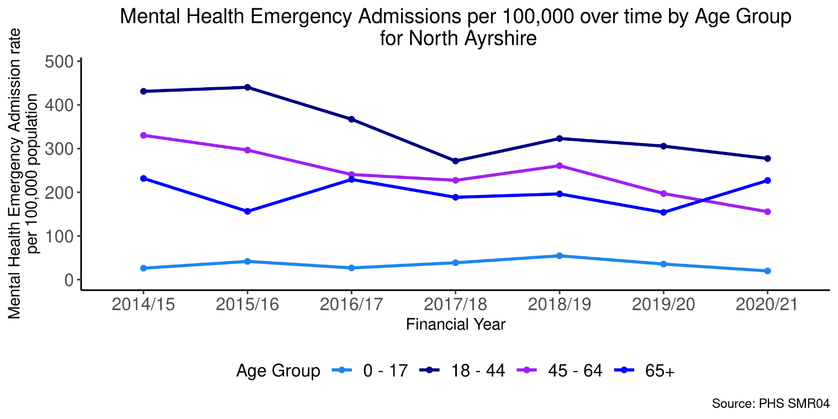

Figure 57: MH Emergency admissions by geographical area

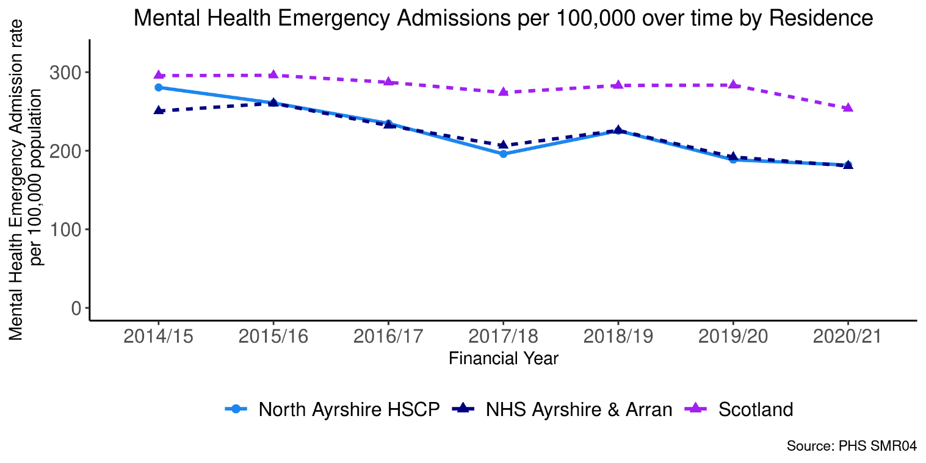

Unscheduled Bed Days (MH)

Figure 58: MH Unscheduled bed days by age group

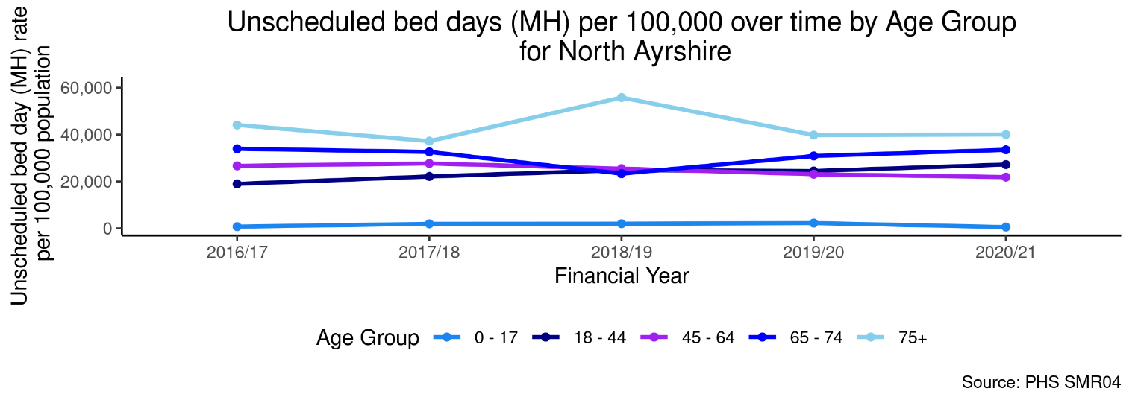

Figure 59: MH Unscheduled bed days by geographical area

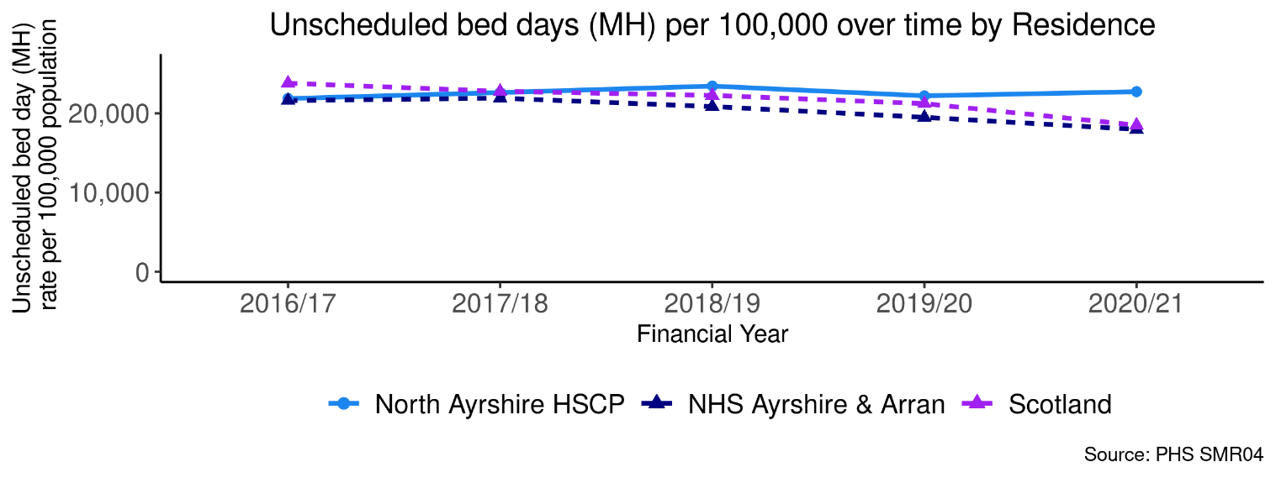

Delayed Discharges (MH)

Figure 60: MH Delayed discharges by geographical area

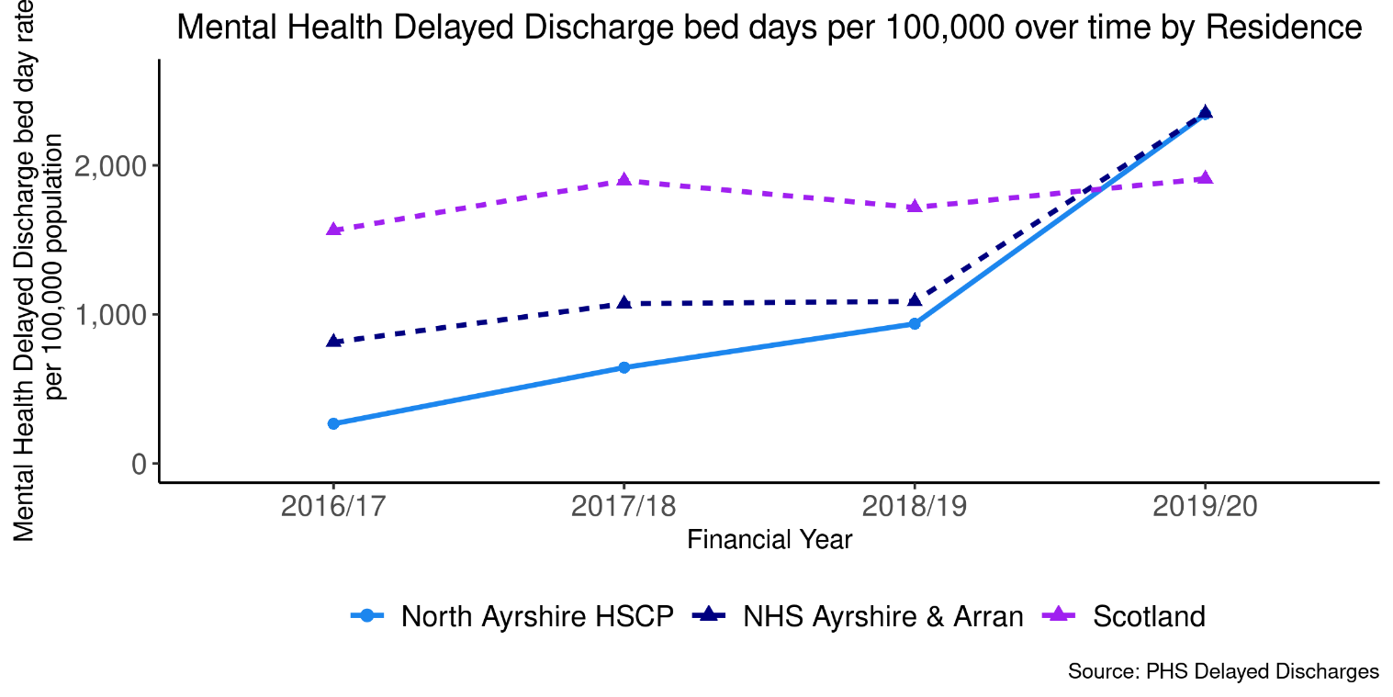

The chart below is a projection of mental health emergency admissions. It is calculated by applying the historic rates of emergency admissions prior to Covid-19 and applying those rates to the population projections for the next five years. These are projections and do not take into account any changes to services or potential impact of Covid-19 on future emergency admissions.

Figure 61: Projections of mental health emergency admissions for next 5 years

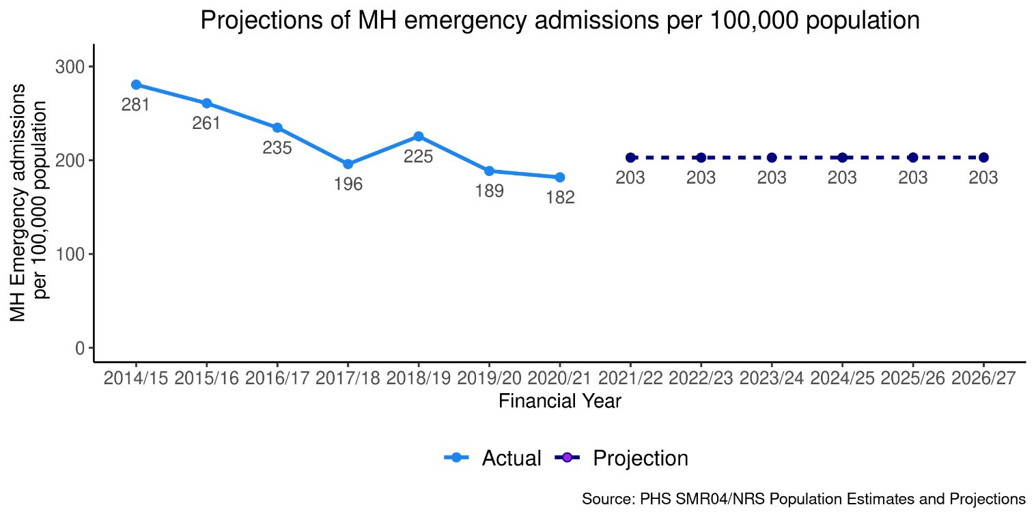
The chart below is a projection of mental health unscheduled bed days. It is calculated by applying the historic rates of unscheduled bed days prior to Covid-19 and applying those rates to the population projections for the next five years. These are projections and do not take into account any changes to services or potential impact of Covid-19 on future unscheduled bed days.

Figure 62: Projections of mental health unscheduled bed days for next 5 years

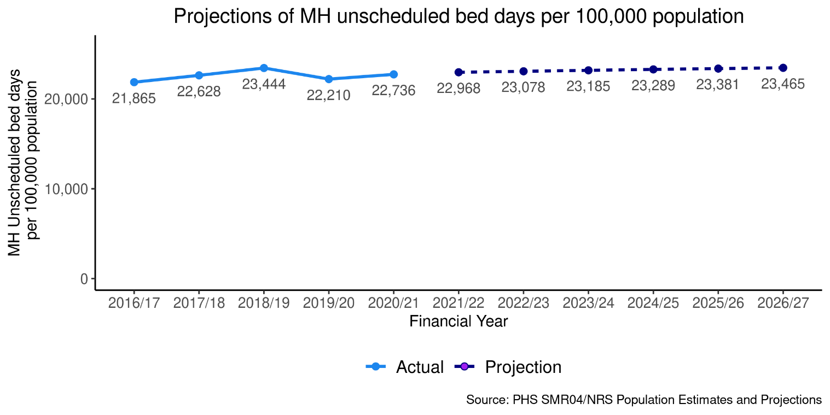

Children and Young People

For the most recent time periods available, North Ayrshire had:
18% of Mothers exclusively breastfeeding at 6-8 week review.
21% of Mothers smoking during first antenatal booking appointment.
36% of Teenage Pregnancies in Under 20s
a 97% uptake of 6 in 1 Immunisation for the eligible population.
a 94% uptake of 24 months MMR Immunisation for the eligible population
72% of Primary 1 Children with no dental caries
73% of Primary 1 children with healthy weight
6.1 (rate per 1000) Children on the protection register
23 (rate per 1000) Children looked after by local authority

Maternity Breastfeeding

A time trend from 2010/11 is shown in Figure 63 comparing North Ayrshire with Scotland and NHS Ayrshire & Arran. In the latest time period available from 2017/18-2019/20 (3-year financial aggregate), the percentage of babies exclusively breastfed at 6-8 weeks in North Ayrshire was 18% which was 13% below the percentage observed across the whole of Scotland (31%).

Figure 63: Percentage of babies exclusively breastfed at 6-8 weeks by geographical area.

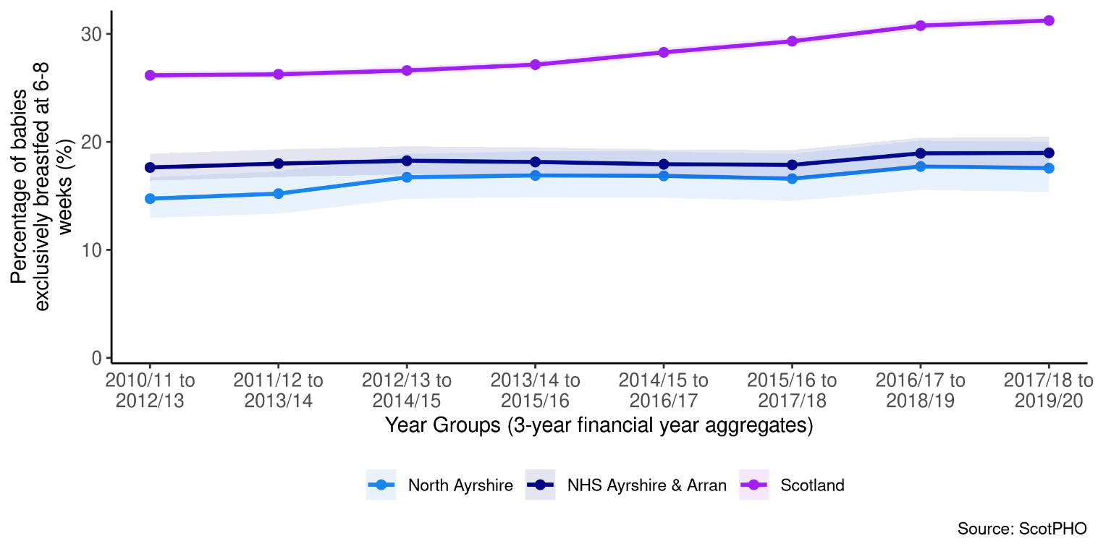

Figure 64: Percentage of babies exclusively breastfed at 6-8 week review by Locality (2017/18-2019/20)
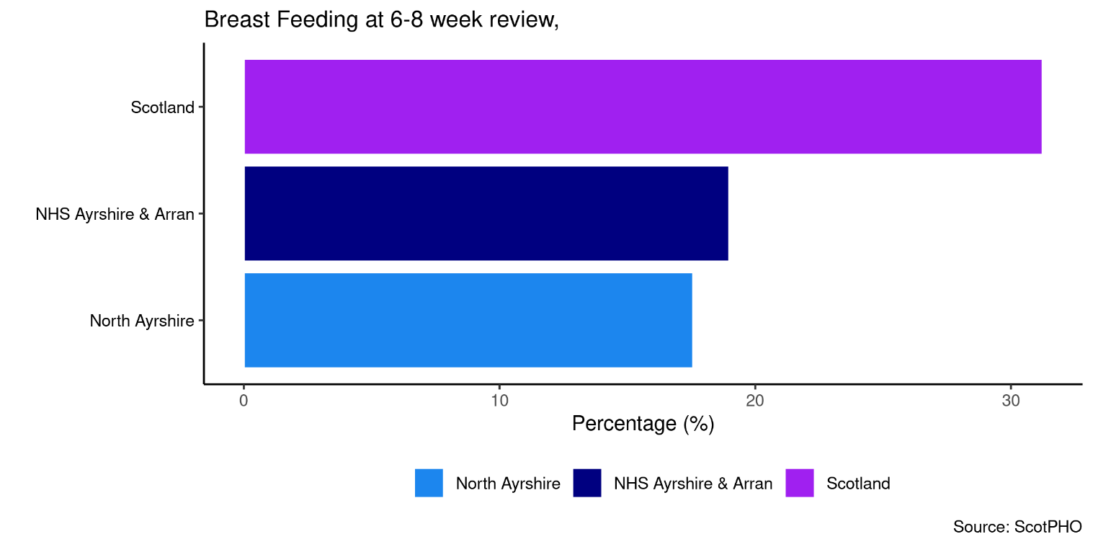

The percentage of babies exclusively breastfed at 6-8 weeks is currently lower in North Ayrshire than compared to other Scotland and NHS Ayrshire and Arran.

Maternal Smoking

In the latest time period available from 2017/18-2019/20 (3 financial year aggregate), the percentage of women smoking during pregnancy in North Ayrshire was 21%, which was 6% higher than that observed across the whole of Scotland. A time trend from 2011/12-2013/14 is shown below in Figure 65.

Figure 65: Percentage of women smoking during pregnancy by geographical area

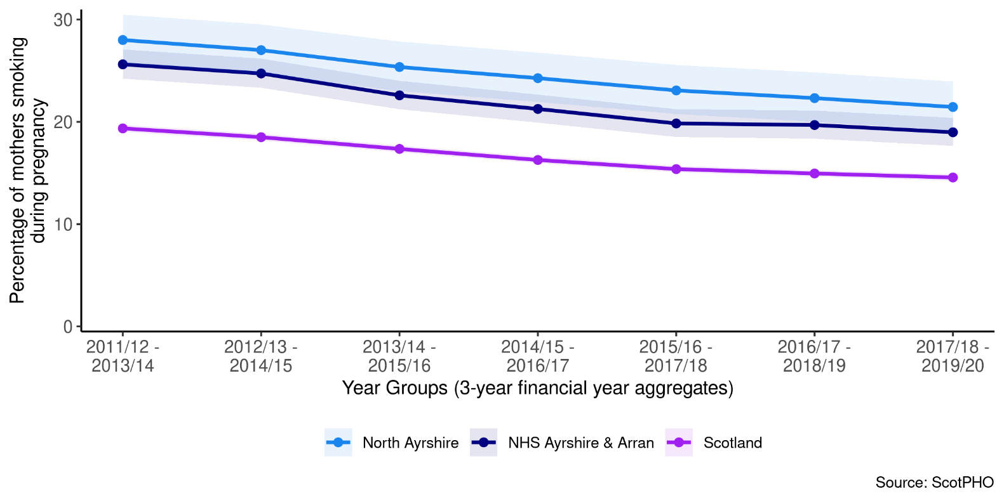

Teenage Pregnancies

A comparison of areas at the most recent time period (2017-2019 aggregated calendar years) is shown below in Figure 66. North Ayrshire had a higher percentage of teenage pregnancies (36%) in comparison to NHS Ayrshire & Arran (33%) and Scotland (29%).

Figure 66: Percentage of Teenage Pregnancies by geographical area

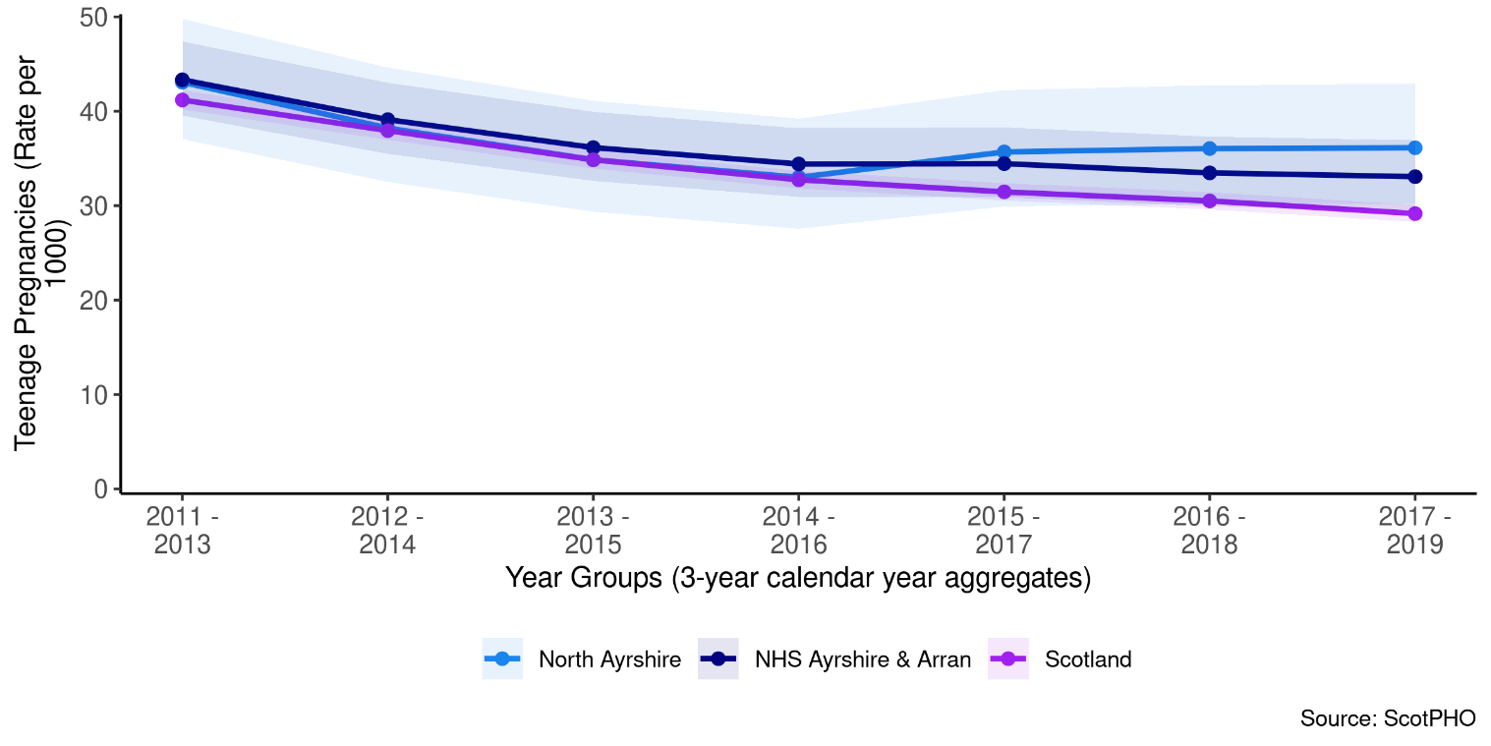

6 in 1 Immunisation

A trend of the percentage uptake of 6 in 1 Immunisation among the eligible population is shown below for North Ayrshire compared with Scotland and NHS Ayrshire & Arran, where data is suppressed into 3 year aggregates. The 2018 – 2020 uptake rate for North was 97%.

Figure 67: Percentage uptake of 6 in 1 Immunisation by geographical area

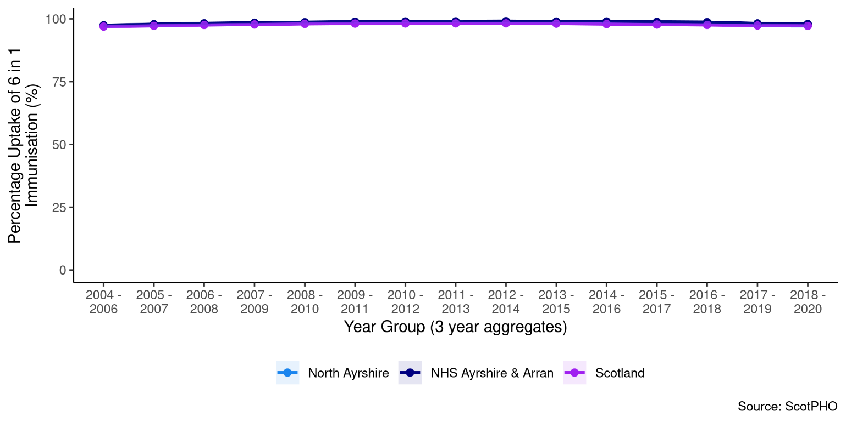

24 Months MMR Immunisation

A trend of the percentage uptake of 6 in 1 Immunisation among the eligible population is shown below for North Ayrshire compared with Scotland and NHS Ayrshire & Arran, where data is suppressed into 3 year aggregates. The 2018 – 2020 uptake rate for North Ayrshire is 94%, which is level with the rate across the whole of Scotland.

Figure 68: Percentage uptake of 24 months MMR Immunisation by geographical area

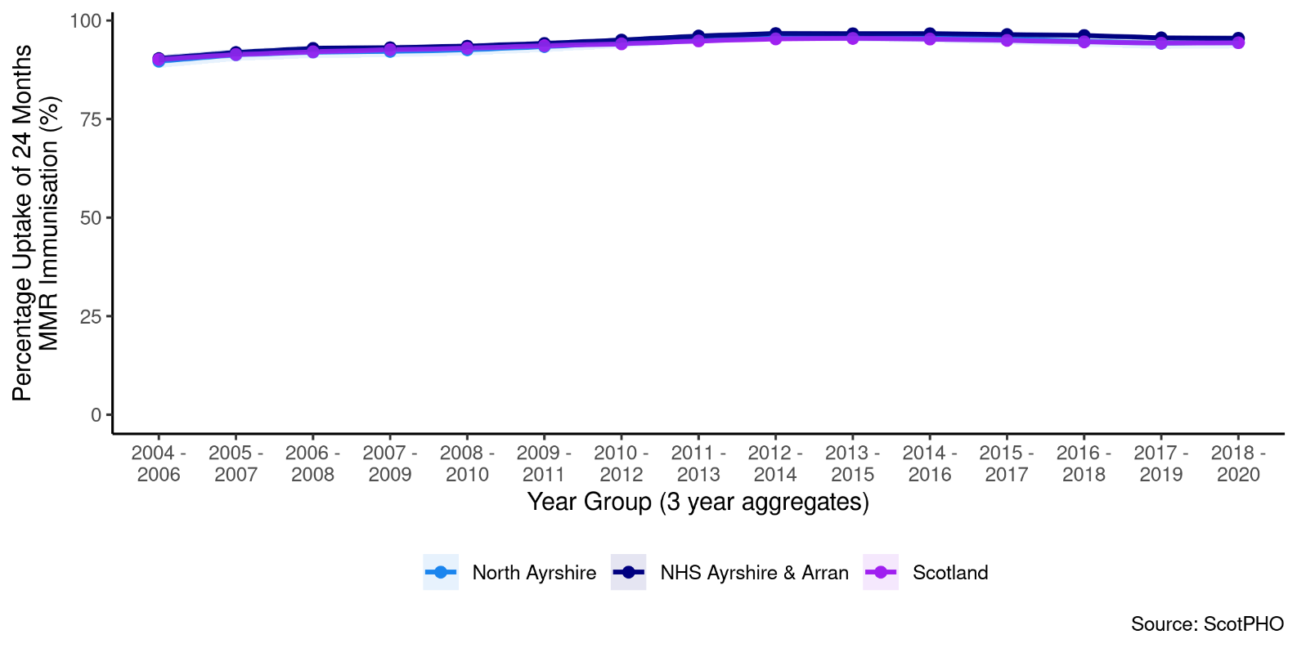

Dental Caries

In the latest time period available for North Ayrshire (2018/19, 3 financial year aggregate), the percentage of Primary 1 children with no obvious dental caries was 72%. In 2019/20, NHS Ayrshire & Arran had a lower percentage of Primary 1 children with no obvious dental caries at 70%, in comparison to the whole of Scotland (72%). A time trend from 2011/12-2013/14 is shown below in Figure 69.

Figure 69: Percentage of Primary 1 children with no obvious dental caries by geographical area

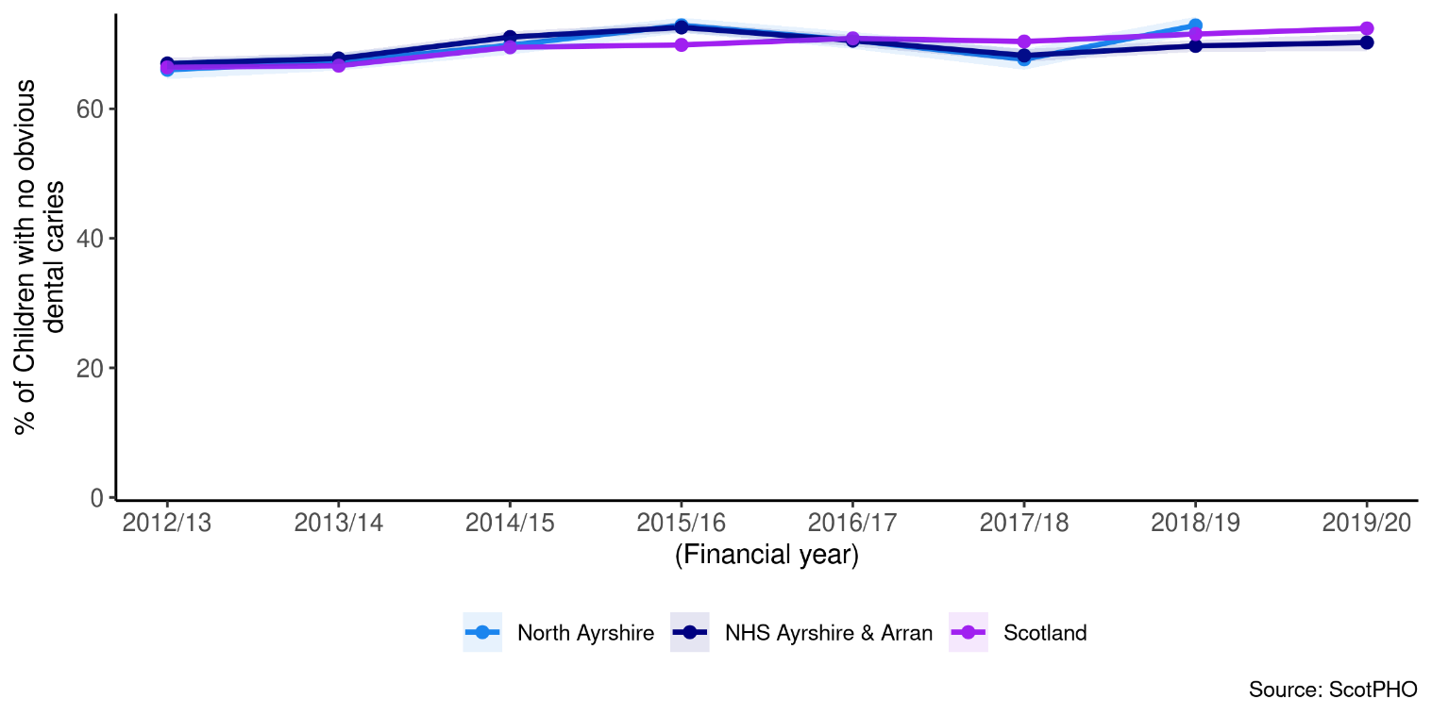

Healthy Weight

A trend of the percentage of Primary1 children with a healthy weight is shown below for North Ayrshire compared with Scotland and NHS Ayrshire & Arran. The 2019/20 percentage of children with a healthy weight in North Ayrshire was 73%, which was lower than both NHS Ayrshire & Arran (77%) and the whole of Scotland (76%).

Figure 70: Percentage of Primary 1 children with healthy weight by geographical area

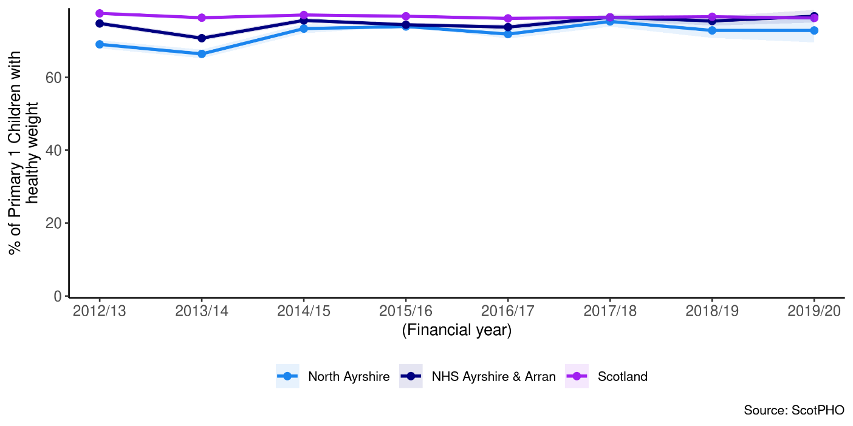

Child Protection Register

A trend of the number of children aged between 0 and 15 on the child protection register is shown below for North Ayrshire compared with Scotland and NHS Ayrshire & Arran. The number of children on the protection register in North Ayrshire increased by 57% over a 7-year period from 2013 to 2020. The 2020 figure for North Ayrshire was 6.1 (rate per 1000), which was more than double the rate observed across the whole of Scotland.

Figure 71: Children on the child protection register

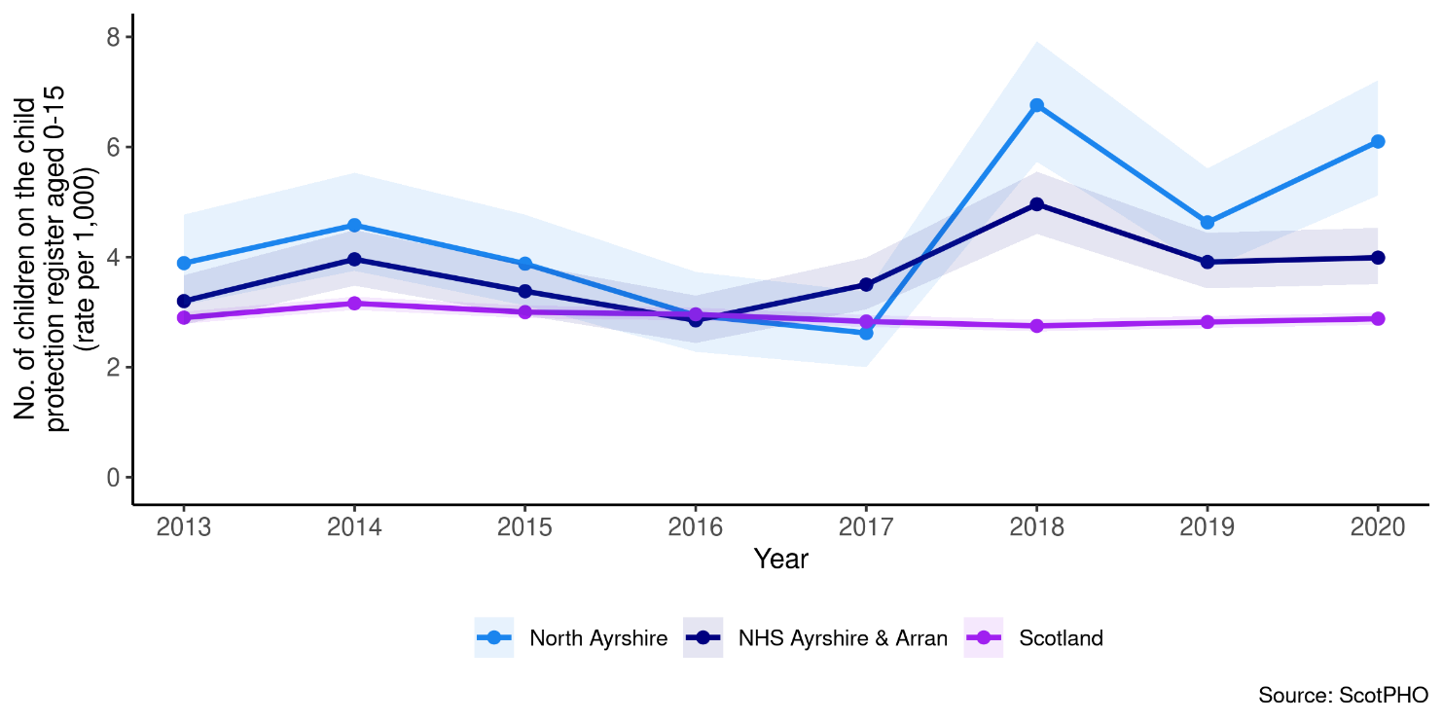

Looked after by Local Authority

A trend of the number of children aged 0-17 looked after by Local Authority is shown below in Figure 72 for North Ayrshire compared with Scotland and NHS Ayrshire & Arran. The number of children that were looked after in 2020 for North Ayrshire was 23 (rate per 1000), which was 64% higher than rates observed across the whole of Scotland.

Figure 72: Children looked after by Local Authority

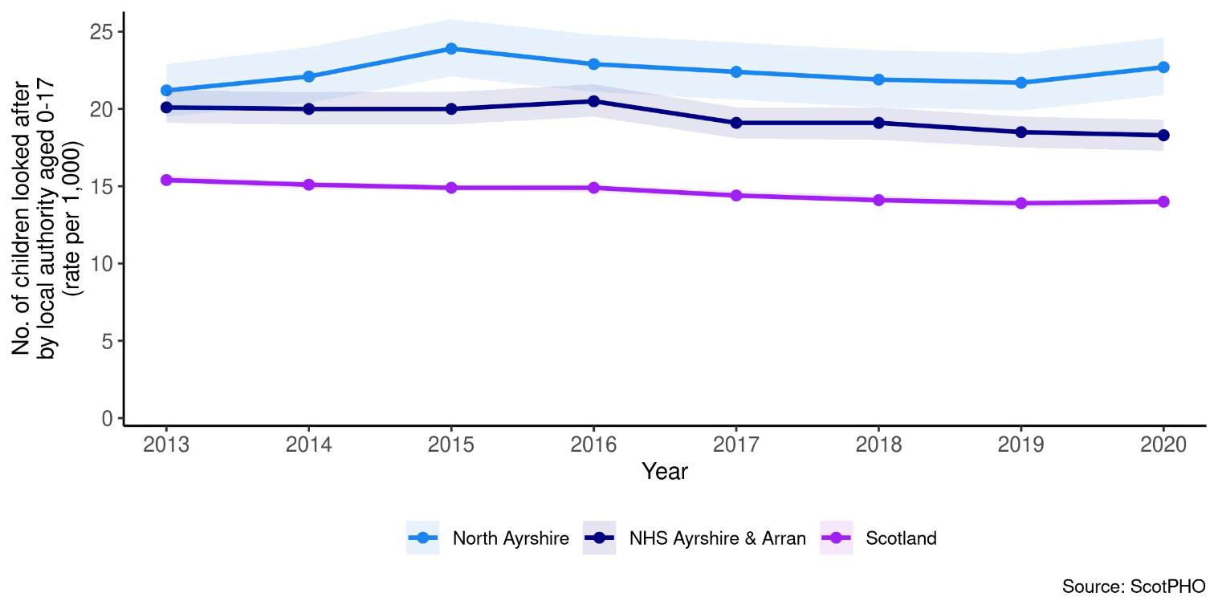

Crime and Fires

In 2020/21, the crime rate in North Ayrshire was 49.7 per 1,000 population. The chart below compares the rate by geography.

Figure 73: Crime Rate per 1,000 population (excludes miscellaneous offences and motor vehicle offences), 2020/21

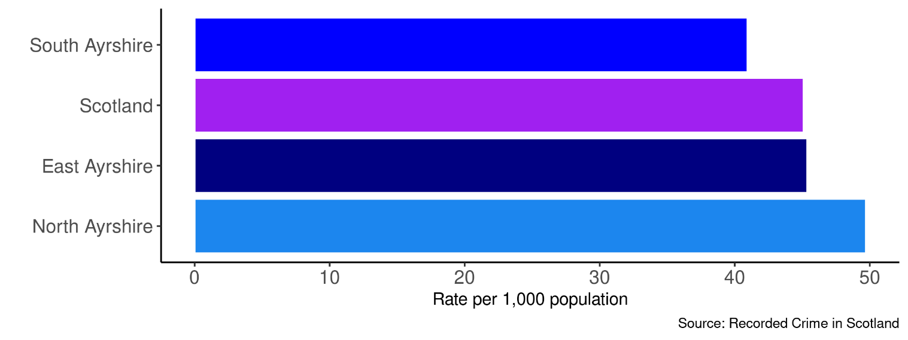

In 2020/21, the rate of non-accidental fires in North Ayrshire was 359 per 100,000 population. The chart below compares the rate by geography.

Figure 74: Non-accidental fires per 100,000 population, 2020/21

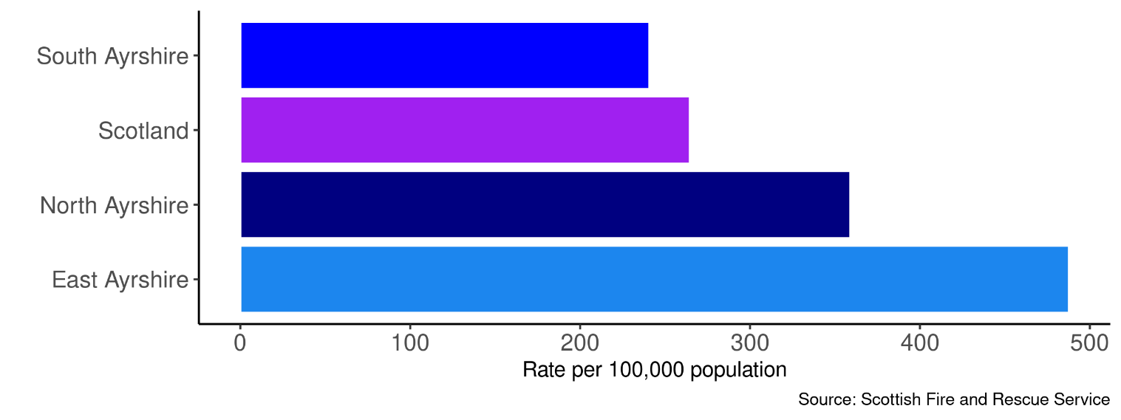

Environment

Figure 75: Total CO2 Emissions by HSCP

A time trend of the total CO2 emissions from 2005 to 2019 for North Ayrshire, East Ayrshire and South Ayrshire is shown below in Figure 75. The latest figure for North Ayrshire in 2019 was 834.9 (kT), which was higher than emissions observed for East (505.2 kT) and South Ayrshire (502.2 kT). The total CO2 emissions from North Ayrshire decreased by 42.5% over a 14-year period. Note: (kT = 1,000 tons)

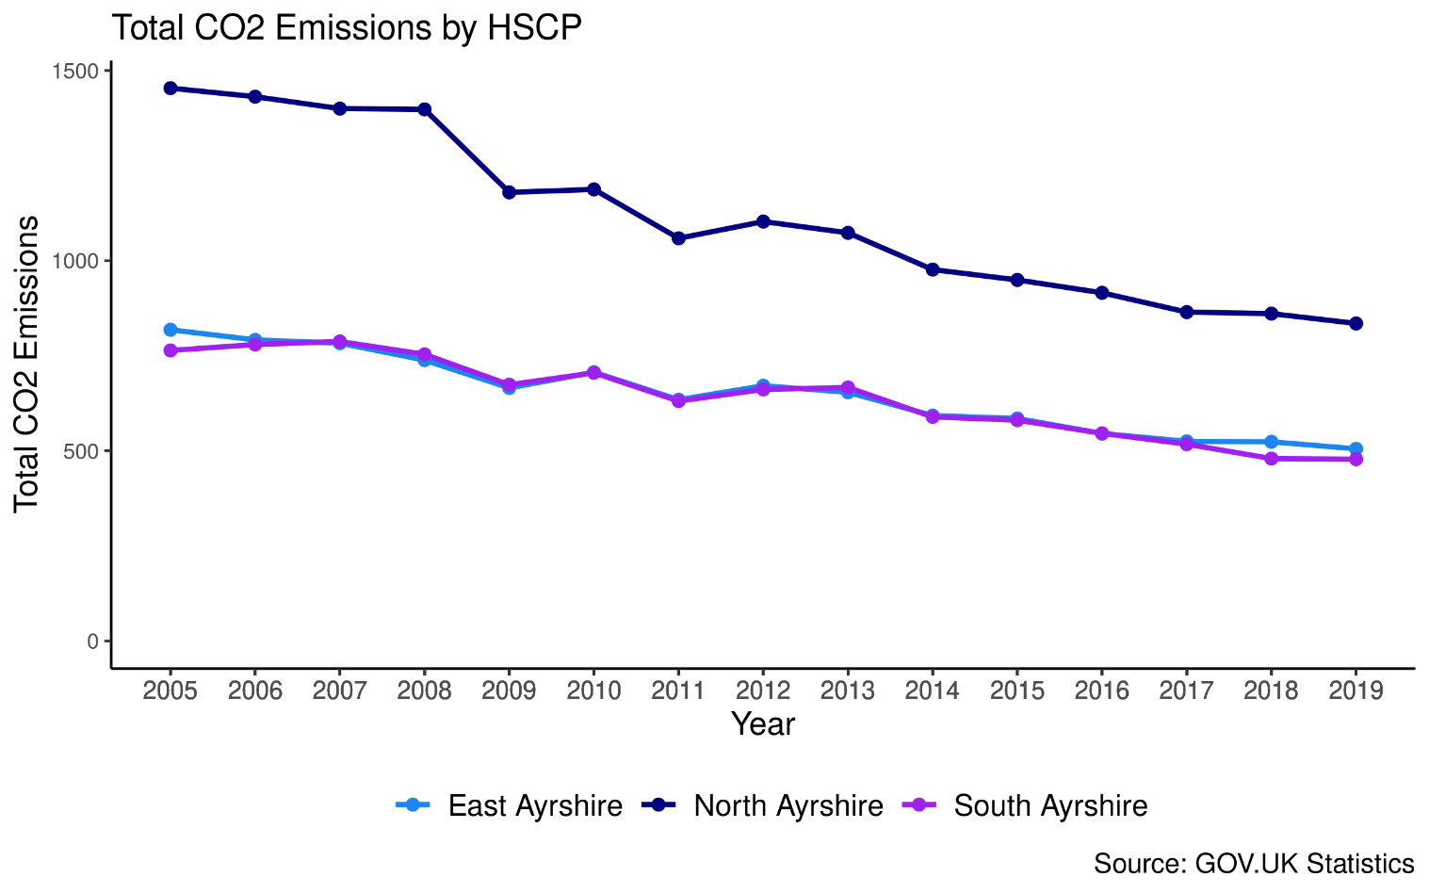

Figure 76: Total CO2 Emissions by Source

In 2019, the highest source of CO2 emissions in North Ayrshire was from industry sources (329.5 kT) whilst the lowest was from public sector (23.1 kT).
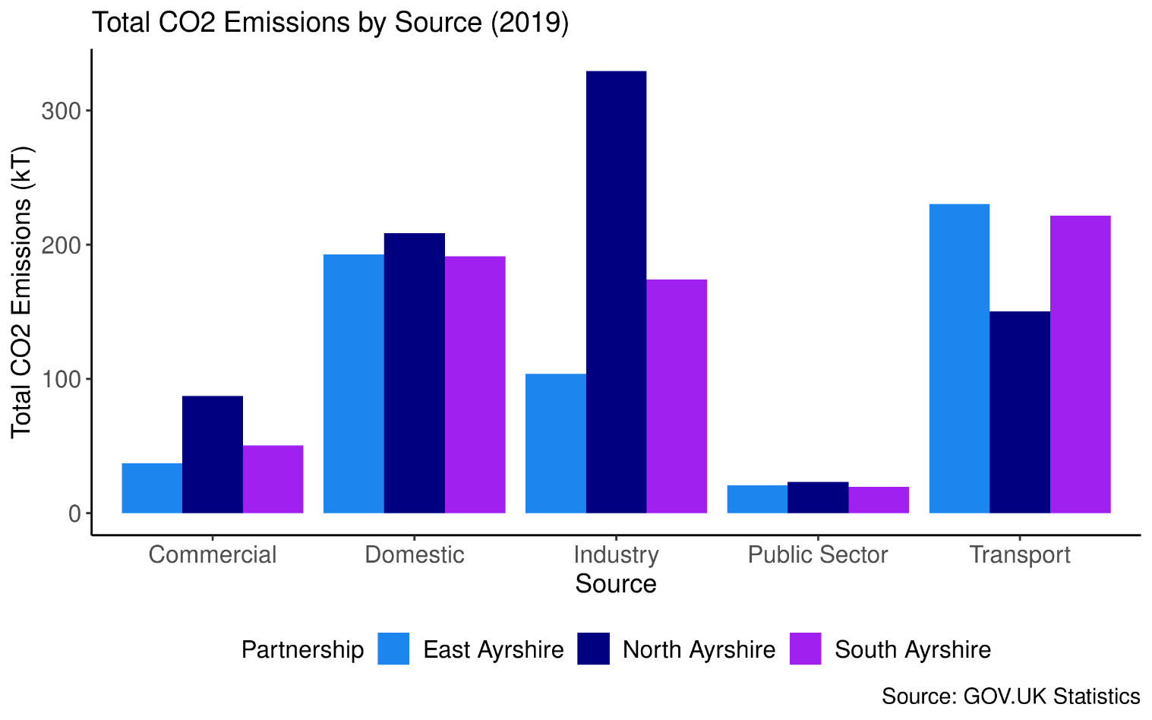

Economic

For the most recent time periods available, North Ayrshire had:
54.2% of Over 16’s are Economically Active
51.5% of 16+ in Employment
3.5% of people entitled to Attendance Allowance
3.2% of people entitled to carers allowances
3.5% receiving Pension Credit
6.9% claiming Personal Independence Payment (PIP)
11.2% were on Universal Credit.

Figure 77 shows the quarterly trend of Economic Activity for Over 16’s in North Ayrshire. The economic activity rate decreased from 56.8 in 2019-Q3 to 54.2% in 2020-Q3.

Economic Activity

Figure 77: Percentage of Economic Activity for Over 16’s

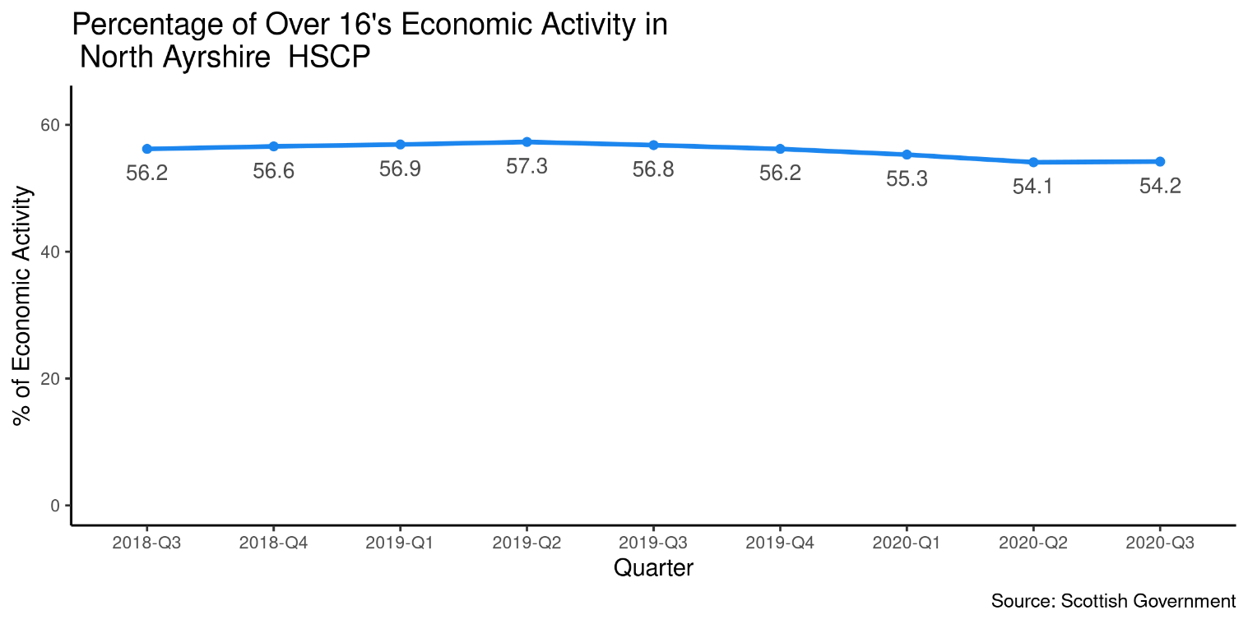

Employment

A trend of the percentage of population aged 16 years and over in Employment by HSCP is shown below in Figure 78. The percentage of the population over 16 in Employment in North Ayrshire was 51.5% in 2020-Q3 which was lower than South Ayrshire (52.4%) and East Ayrshire (56.6%).

Figure 78: Percentage of 16 years and Over in Employment

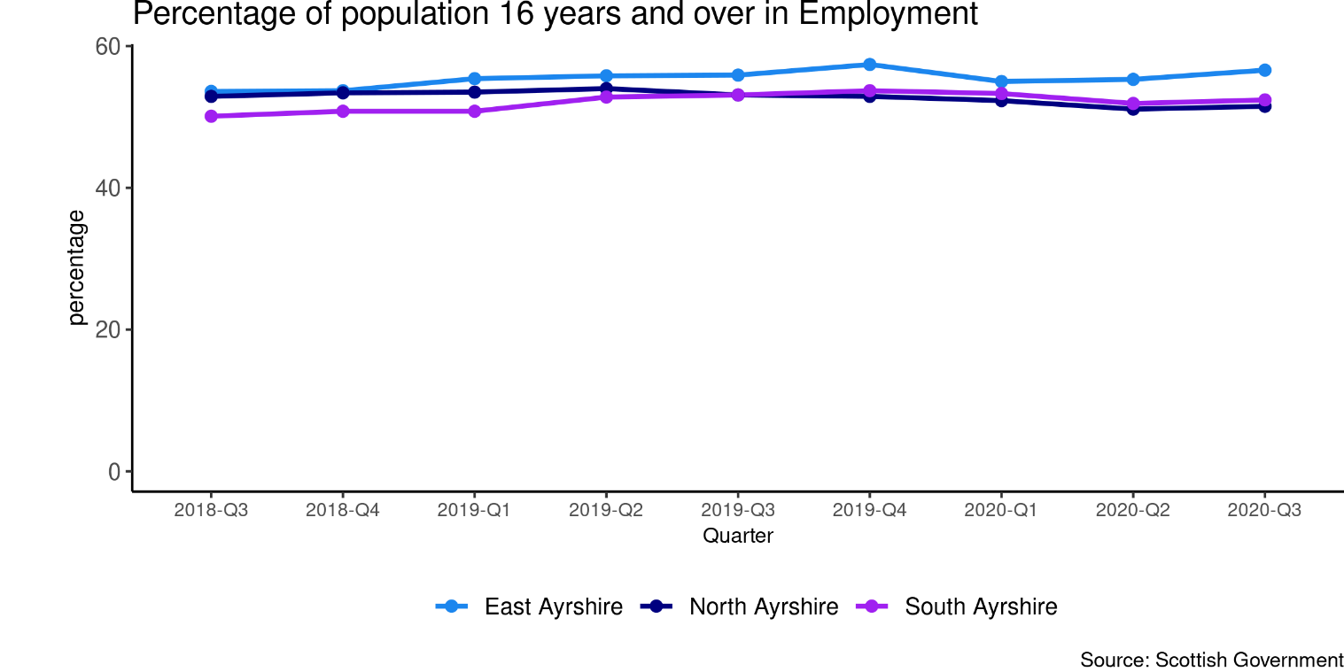

Benefits

As at May 2021, 3.5% of people in North Ayrshire were entitled to Attendance Allowance. The chart below compares the percentage by geography.

Figure 79: Percentage of Attendance Allowance Entitlement Cases – As at May 21
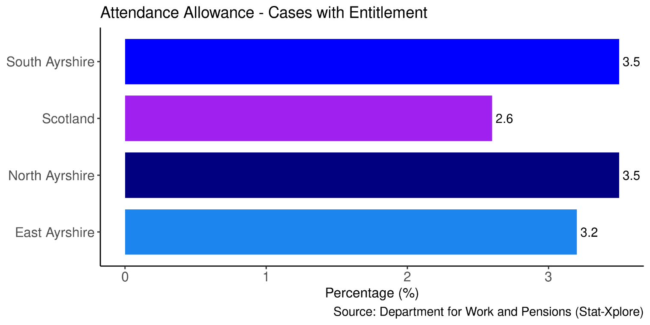
The percentage of people entitled to carers allowances is currently higher in North Ayrshire than compared to Scotland, South Ayrshire and East Ayrshire. With 3.2% in North Ayrshire entitled to Cares Allowance in May 21.

Figure 80: Percentage of Carers Allowance Entitlement Cases - As at May 21

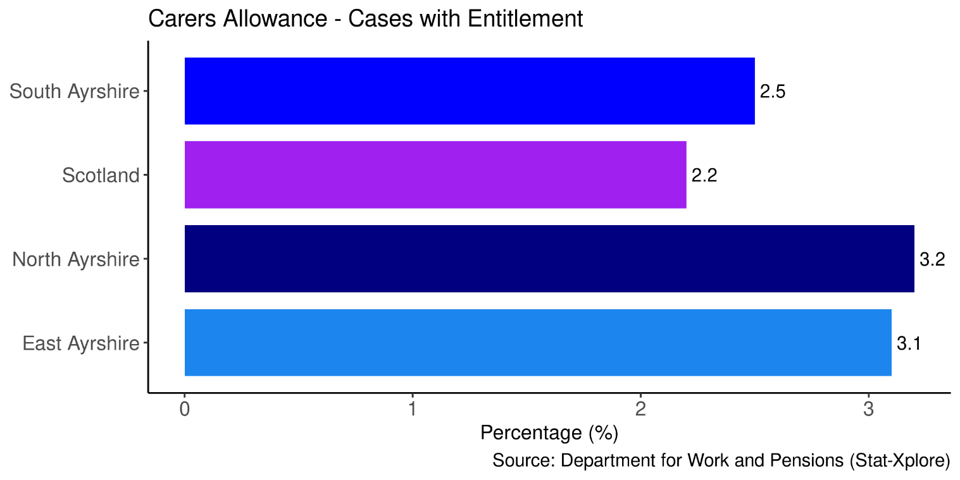

A comparison of areas receiving Pension Credit at the most recent time period (May 2021) is available below. This shows that North Ayrshire has a higher percentage (3.5%) than Scotland (2.4%), East Ayrshire (3.1%) and South Ayrshire (2.8%)

Figure 81: Percentage of Pension Credit Caseloads - As at May 21

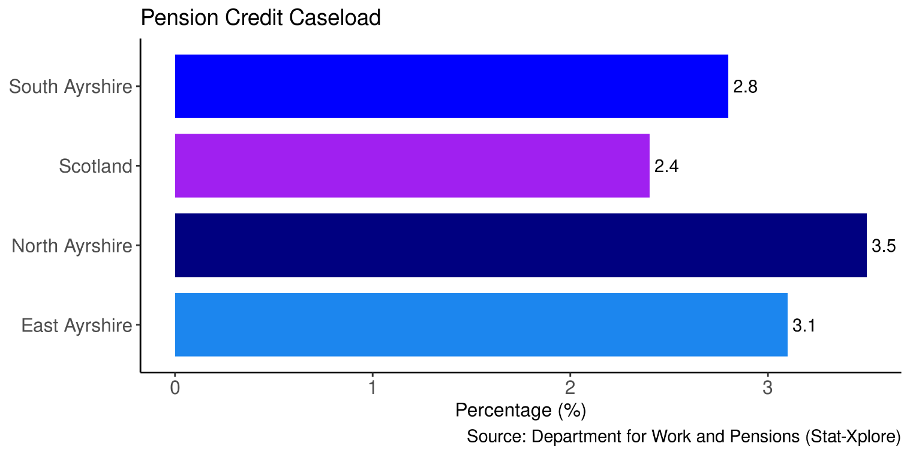

As at October 2021 6.9% of people in North Ayrshire were claiming Personal Independence Payment (PIP).

Figure 82: Percentage of Personal Independence Payment - As at May 21

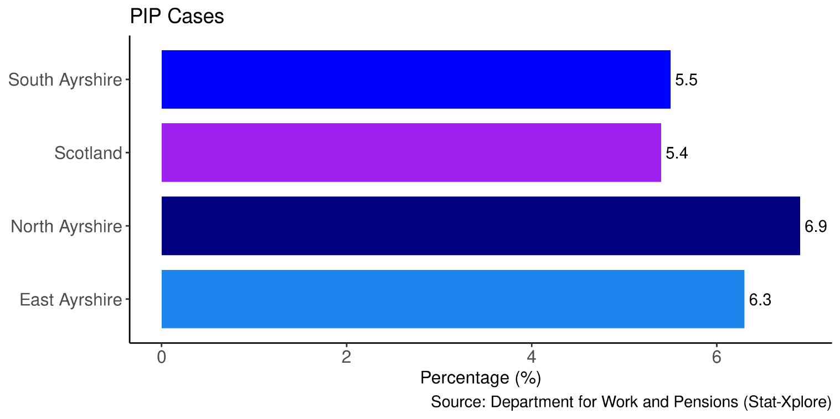

As at October 2021 11.2% in North Ayrshire were on Universal Credit. This is higher than South Ayrshire (8.9%), East Ayrshire (11%) and Scotland (8.3%).

Figure 83: Percentage of People on Universal Credit- As at October 21

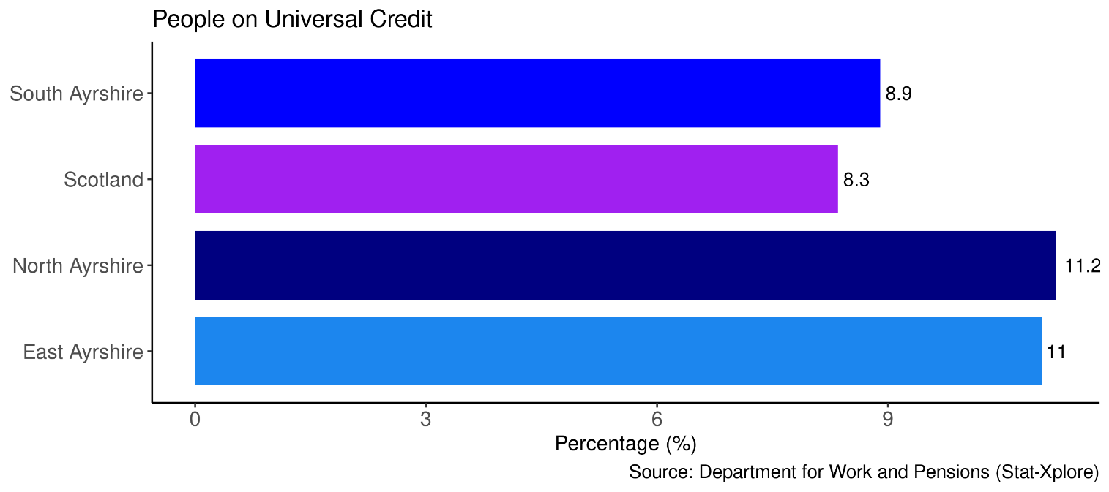

Footnotes
- To explore how the population in North Ayrshire is expected to change in the future, the percent changes in population projection to 2025 for North Ayrshire by age group and gender were calculated from the NRS Local Authority Population Projections.
- Care Home Data included in the Services Map and Table was sourced from the Care Inspectorate. GP Practice data from April 2020, and Hospital and A&E data was sourced from Public Health Scotland Open Data. Only services that are within the physical boundary of the HSCP or Locality are included in the map and table, so there may be services outside North Ayrshire which people may use but are not shown.
- The data used in General Health and Lifestyle & Risk factors sections (except for long-term conditions) of this locality profile are taken from ScotPHO. There may be more recent data available for the indicators elsewhere.
- Data taken from ScotPHO is often reported using the European Age-Sex Standardised Rate per 100,000. This allows for comparisons across different areas to be made. For more information on how these rates are calculated, please refer to www.isdscotland.org/Products-and-Services/GPD-Support/Population/Standard-Populations/
- Physical long-term conditions data comes from the Source Linkage Files, and the conditions are identified using ICD-9 and ICD-10 codes in the diagnosis fields. Please note that the Source Linkage Files data only contains information on people who have had contact with the NHS through either inpatient admissions, outpatient attendances, daycase attendances, A&E attendances or through prescribed items, the data does not show all service users in Scotland who have been diagnosed with an LTC as not all of these individuals will have used these services. Also note that LTC rates are based on an adjusted population indicator in the Source Linkage Files so that population sizes are closer to the official estimates.

Page Break

Appendices

Appendix 1: Indicator Definitions

Indicator | Definition
% last 6 months of Life Spent in a Community Setting | The percentage of time spent by people in their last 6 months of life in the community. Community includes care home residents as well as those living in their own home. Considers all hospital activity (e.g. geriatric long stay (GLS), mental health, acute). Inpatient activity with a care home location code recorded in SMR is included within the Community percentage for all years presented. This activity represents beds funded by the NHS which are located within a care home.
A&E Attendances | Attendance rates to A&E departments for patients by residence per 100,000 population. Includes all ages.
Alcohol-related hospital admissions | General acute inpatient and day case stays with diagnosis of alcohol misuse in any diagnostic position (ICD-10 code: E24.4, E51.2, F10, G31.2, G62.1, G72.1, I42.6, K29.2, K70, K85.2, K86.0, O35.4, P04.3, Q86.0, R78.0, T51.0, T51.1, T51.9, X45, X65, Y15, Y57.3, Y90, Y91, Z50.2, Z71.4, Z72.1). All rates have been standardised against the European standard population (ESP2013) and 2011-based population estimates.
Alcohol-specific deaths | Alcohol related deaths (based on new National Statistics definition): 5-year rolling average number and directly age-sex standardised rate per 100,000 population. (ICD-10 codes from the primary cause of death: E24.4,F10,G31.2,G62.1,G72.1,I42.6,K29.2,K70,K85.2,K86.0,Q86.0,R78.0,X45,X65,Y15).
Bowel Screening Uptake | Bowel screening uptake for all eligible men and women invited (aged 50-74): 3-year rolling average number percentage. Eligible men and women are posted a guaiac-based faecal occult blood test kit (FOBT) which should be completed at home. This involves collecting 2 samples from each of 3 separate bowel movements. The kit is returned in a pre paid envelope to the central screening centre in Dundee and tested for hidden traces of blood in the stool. Individuals who have a positive FOBT result are referred to their local hospital for assessment and, where appropriate, offered a colonoscopy as the first line of investigation.
Cancer Registrations | New cancer registrations: 3 year rolling average number and directly age-sex standardised rate per 100,000 population. All rates have been standardised against the European standard population (ESP2013) and 2011-base population estimates. ICD10: C00-C96 excluding C44 (principal diagnosis only).
Children looked after by local authority | Children looked after by the local authority; number and rate per 1,000 children aged 0-17 years.
Child protection register | Children on the child protection register; number and rate per 1,000 children under 16 years.
Death, aged 15-44 | Deaths from all causes (ages 15-44 years), 3 year rolling average number and directly age sex standardised rate per 100,000 population. All rates have been standardised against the European standard population (ESP2013). Deaths assigned to year based on death registration date.
Delayed Discharges | Number of days people aged over 18 spend in hospital when they are ready to be discharged per 100,000 population. This has been separated into two indicators – one for acute specialty and one for mental health specialty stays.
Drug-related hospital admissions | General acute inpatient and day case stays with diagnosis of drug misuse in any diagnostic position (ICD10: F11-F16, F18, F19, T40.0-T40.9), 3-year rolling average number and directly age-sex standardised rate per 100,000 population. All rates have been standardised against the European standard population (ESP2013) and 2011-based population estimates.
Drug-related Deaths | Number of drug-related deaths: actual number and european age sex standardised rate per 100,000 population, single years.
Emergency Admissions | Rate of acute emergency (non-elective) admissions of patients of all ages per 100,000 population. This has been separated into two indicators – one for acute specialty and one for mental health specialty stays.
Fall Admissions | Rates of emergency admissions (non-elective) of patients of all ages where a fall has been logged as an ICD-10 code (searched for in all diagnostic positions) – acute specialties only.
Healthy Life Expectancy (HLE) | Healthy life expectancy (HLE) is an estimate of the number of years lived in ‘very good’ or ‘good’ general health, based on how individuals perceive their state of health at the time of completing the annual population survey (APS).
Life expectancy, females | Estimated female life expectancy at birth in years, multi-year average (over 3 years for NHS Boards and Local Authorities, 5 years for Intermediate zones) Mortality data are based on year of registration. They also include non-Scottish residence so the number of deaths match those produced by NRS.
Life Expectancy, males | Estimated male life expectancy at birth in years, multi-year average (over 3 years for NHS Boards and Local Authorities, 5 years for Intermediate zones) Mortality data are based on year of registration. They also include non-Scottish residence so the number of deaths match those produced by NRS.
Physical Long-Term Conditions | Health conditions that last a year or longer, impact a person's life, and may require ongoing care and support. The LTCs presented are: Arthritis, Atrial Fibrillation, Cancer, Coronary Heart Disease, Chronic Obstructive Pulmonary Disease (COPD), Cerebrovascular Disease, Dementia, Diabetes, Epilepsy, Heart Failure, Liver Failure, Multiple Sclerosis, Parkinson's, and Renal Failure.
Population prescribed drugs for anxiety/depression/psychosis | Estimated number and percentage of population being prescribed drugs for anxiety, depression or psychosis.
Potentially Preventable Admissions (PPA) | Emergency admissions (non-elective) of patients of all ages where specific diagnoses are assigned as preventative - please see complete list of ICD-10 codes included in Appendix 2.
Readmissions (28 day) | The rate of readmissions of all adults (18+) within 28 days of an emergency admission per 1,000 discharges. This has been separated into two indicators – one for acute specialty and one for mental health specialty stays.
Unscheduled Bed days | Rate of acute unscheduled bed days of patients of all ages per 100,000 population. Takes the bed days spent only within the year of measurement – stays that overlap financial years will have their respective days counted either side. This has been separated into two indicators – one for acute speciality and one for mental health specialty stays.
Unscheduled Care in Mental Health Hospitals | Mental health admission data is taken from SMR04, which holds records on patients receiving inpatient care in mental health (psychiatric) facilities. Episodes beginning with a transfer have also been included in these figures, as well as emergency admissions as many of these episodes will have started as unplanned acute admission. Therefore the initial unscheduled admission need not have been to a mental health long stay speciality.
Mothers Breastfeeding at 6-8 week review | Number of babies reported by parent as being exclusively breastfed at 6-8 week review; 3-year rolling average number and percentage of all babies with a valid feeding status recorded at 6-8 week review.
Mothers smoking during Pregnancy | Women with known smoking status at 1st antenatal booking appointment who are recorded as a 'current smoker': 3-year rolling average number and percentage of all women with a known smoking status at first booking (those with a smoking status of 'unknown' have been excluded).
Teenage Pregnancies | Pregnancies in under 20s; 3-year rolling average number and crude rate per 1,000 females aged 15-19 years.
6in1 Immunisation | Immunisation uptake at 24 months for 5 in 1 (Diphtheria, Pertussis, Tetanus, Polio, Hib) and 6-in-1 (from 1st October 2017), which also protects against Hepatitis B: 3-year rolling average number and percentage of children of this age.
24 months MMR Immunisation | Immunisation uptake at 24 months for - MMR (measles, mumps and rubella): 3-year rolling average number and percentage of children of this age.
Primary 1 Children with no obvious dental caries | Number and percentage of Primary 1 children receiving a letter 'C' (no obvious decay experience but should continue to see the family dentist on a regular basis) at basic inspection.
Primary 1 Children with healthy weight | Number and percentage of Primary 1 children (with a valid height and weight recorded) whose BMI is between the 5% and 95% of the 1990 UK reference range for their age and sex.

Page Break

Appendix 2: Conditions included as Potentially Preventable Admissions (PPAs)
Condition | ICD10 codes included | Comments
Ear Nose And Throat | H66, J028, J029, J038, J039, J06, J321 | NA
Dental | K02, K03, K04, K05, K06, K08 | NA
Convulsions And Epilepsy | G40, G41, R56, O15 | NA
Gangrene | R02 | NA
Nutritional Deficiencies | E40, E41, E43, E550, E643, M833 | NA
Dehydration And Gastroenteritis | E86, K522, K528, K529 | NA
Pyelonephritis | N10, N11, N12 | NA
Perforated Bleeding Ulcer | K250, K251, K252, K254, K255, K256, K260, K261, K262, K264, K265, K266, K270, K271, K272, K274, K275, K276, K280, K281, K282, K284, K285, K286 | Excludes episodes with following main OPCS4 codes: S06, S57, S68, S70, W90, X11
Cellulitis | L03, L04, L080, L088, L089, L980 | NA
Pelvic Inflammatory Disease | N70, N73 | NA
Influenza And Pneumonia | J10, J11, J13, J181 | NA
Other Vaccine Preventable | A35, A36, A370, A379, A80, B05, B06, B161, B169, B26 | NA
Iron Deficiency | D501, D508, D509 | NA
Asthma | J45, J46 | NA
Diabetes Complications | E100, E101, E102, E103, E104, E105, E106, E107, E108, E110, E111, E112, E113, E114, E115, E116, E117, E118, E120, E121, E122, E123, E124, E125, E126, E127, E128, E130, E131, E132, E133, E134, E135, E136, E137, E138, E140, E141, E142, E143, E144, E145, E146, E147, E148 | NA
Hypertension | I10, I119 | Exclude episodes with following main OPCS4 codes: K01 - K50, K56, K60 - K61
Angina | I20 | Exclude episodes with main OPCS4 codes: K40, K45 K49, K60, K65, K66
COPD | J20, J41, J42, J43, J44, J47 | J20 only included if secondary diagnosis has one of J41 - J44, J47
Congestive Heart Failure | I110, I50, J81 | Exclude episodes with following main OPCS4 codes: K01 - K50, K56, K60 - K61

