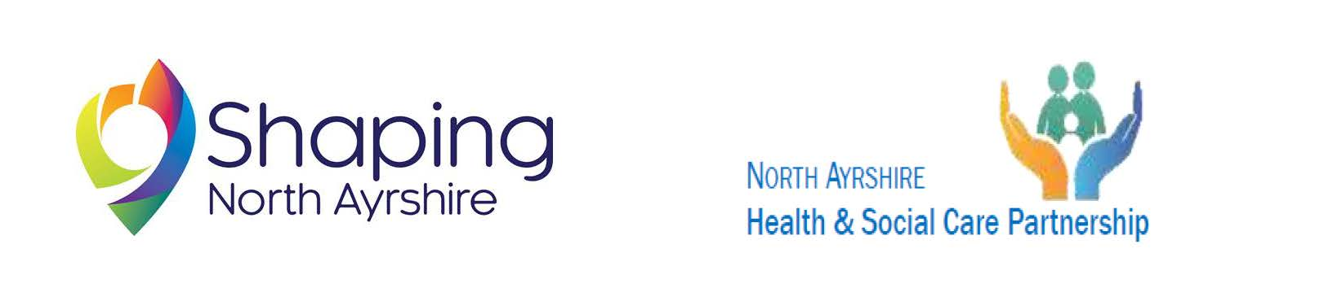

North Ayrshire Community Planning Partnership
Guidance for Completing the Application Forms 20/21
Youth PB, Locality PB and Arts and Culture PB

We will always receive more applications than we have funding for, therefore, not everyone can be successful. Applications will be short-listed by Locality/Youth steering groups after the closing date. However, there are a range of alternative funding sources that you may be able to access. Please refer to the North Ayrshire Council or The Ayrshire Community Trust websites for more information.

We will not fund:
- Any political or religious activities (applications can be accepted from faith groups if they are for local community work).
- Routine maintenance or repairs.
- Routine running cost (salaries / electricity / rates / rent / insurance / etc.) – unless in relation to Covid-19 recovery and renewal.
- Applications from schools (these are the responsibility of the local authority). However, Parent Councils and Associations can apply for extra activities over and above the normal learning and teaching if they enhance and benefit the local community.
- More than one application per group in the financial year (March – April).
Note: If applying for more than one PB Fund, you need to be able to demonstrate the benefits and we will share with all the short-listing groups.

The following guidance aims to help you complete the application/s and understand what our short-listing panel, which includes locality planning partnership representatives or Youth Representatives, will look for in your application.

Question 1: Please Tick which locality your project will benefit.

Question 2: Please select which of the themes you will be focussing on – please select the most relevant theme/s

Question 3: If you are applying as an individual please insert your name. If you are applying on behalf of a group please insert the group’s name. These details will be included in the summary for the short-listing panels.

Question 4: Please tell us the main purpose of your group – what do you do?

Question 5: This summary will be included in the ‘promotional summary’, to help local people/young people decide how to vote. Please include why you feel your proposal is important and why it should be supported by the community/young people.
For example: “We would like to develop an outside fitness and activity trail. This will promote an active and healthy way of learning and encourage the children in our community to have fun while exercising and improve community wellbeing. We hope to….”. Please stick to 100 words

Question 6: Please tell us how much money you are applying for – each fund has a maximum amount, you can apply up to that amount (just apply for what you need)

Question 7 & 8: Please tell us about any other funds you have to add to this project

Question 9: Please tell us if you have applied for one of the other 2 funded themes available (this will be shared with all the short-listing panels)
Question 10: Please list details about how you will spend the money. For example: Arts & crafts materials - £150.
Provide approximate figures in the cost columns.
(We will ask for your feedback on how the project/idea has gone, approximately 12 months after the funds have been provided. This will require you to complete an evaluation form, which is a condition of the grant award)

Question 11: Please take this opportunity to tell us more about your idea. Please expand on the 100-word summary you provided in question five. Include things like a start date and an end date. Tell us how your idea allows local people to participate in society / community life. What will the added benefit be? For example:
“Our community needs more space for people to spend time outside and people want to be more active and learn about their environment……. Our group wants to learn about gardening and develop a community garden on the waste ground next to our building which is full of litter and dog fouling. These improvements will allow older people to walk around and enjoy this area. We will start the group in May and continue until last week in September.”

Question 12: Please let us know in your own words what difference your project/idea will make and if there are other people from the community/young people involved in the bid.
For example: “We have consulted with the local community …..”; “Due to my/our local knowledge and word of mouth ….”; “Other groups have informed us that there is a need for this….”.
What will the impact be and how will you show this? For example: “We will use questionnaires/survey monkey to ask people about the benefit of the project/idea”.

Question 13: Please tell us whether the proposed activity is flexible enough to take place within local and national guidance on COVID-19 recovery - should these still be in place?
Tell us how you have incorporated Covid-19 restrictions and guidance into the planning of your project.

Question 14 & 15: Please tell us if your group is open to all. If no please explain why, if yes please explain how you ensure this

Question 16: Please tell us how many people your project will benefit

Question 17: Please let us know if you would be able to spend successful funds within 12 months

Question 18: Please tick the relevant box

Question 19: Please tick the relevant box. If yes is ticked we will need to see evidence of this.
Question 20: Please tick the relevant box. If yes is ticked we will need to see evidence of this.

Question 21: Please complete contact details. This MUST include either an e-mail address or a telephone number.

Don’t forget we are here to help if you have any questions you can email us at participatorybudgeting@north-ayrshire.gov.uk or youthpb@north-ayrshire.gov.uk or give us call on 01294 475900

